AI-Based Diagnostic Solutions: Building a Breast Cancer Detection System Using Ultrasound Imaging

By

Era Agolli

Supervisor:Prof.Dr. Bekim Fetaji



A THESIS
Submitted to

KOLEGJI UNIVERSITAR “Instituti Kanadezi Teknologjisë”

University College “CANADIAN INSTITUTE OF TECHNOLOGY”

Faculty of Engineering

Department of Software Engineering

In partial fulfillment of the requirements for the degree of:

Master in Software Engineering

Submitted on July 13th, 2025

Master of Science in Software Engineering

Submitted on July 13th, 2025

Approved:

______________________________ Prof.Dr. Bekim Fetaji (signature)

______________________________ Head of department:Dr.Adriola Faqolli (signature)

I understand that my thesis will become part of the collection of Canadian Institute of Technology. My signature below authorizes release of my thesis to any reader upon request. I also affirm that the work represented in this thesis is my own work.

___________________________ Era Agolli, Author (signature)

Title of Thesis: AI-Based Diagnostic Solutions: Building a Breast Cancer Detection System Using Ultrasound Imaging

Abstract:
Breast cancer is still one of the main causes of cancer-related death for women globally, which highlights how urgently early and precise detection methods are needed. This thesis introduces a Convolutional Neural Network (CNN) and ultrasound imaging-based AI-based diagnostic system for breast cancer detection. The system offers clinicians an easy-to-use platform for uploading ultrasound images and getting immediate diagnostic feedback. It is a web-based application with an HTML/CSS frontend and a Python-Flask backend. A publicly accessible Kaggle dataset with 5,000 ultrasound images—2,500 of which were benign and 2,500 of which were malignant—that had been meticulously annotated and preprocessed for best results was used to train the CNN model.

A custom-built architecture that outperformed benchmark models like ResNet and VGG was chosen after a methodical evaluation of various CNN configurations was used to design and optimize the model architecture. To improve model generalizability and reduce class imbalance, data preprocessing, augmentation, and class balancing strategies were used. High classification accuracy was attained by the trained model.. To guarantee scalability, maintainability, and adherence to healthcare data privacy laws, the integrated system was divided into frontend, backend, and AI engine components. Results from experiments show how well the system supports clinical decision-making in real time, especially when there are limited resources available. This thesis highlights the potential of deep learning and web technologies in democratizing breast cancer while also addressing ethical issues, hardware requirements, limitations, and future directions.
Keywords: Breast Cancer Detection, Convolutional Neural Networks (CNN), Ultrasound Imaging, Deep Learning, Web Application, Flask, Python, Medical Image Analysis, Kaggle Dataset, Class Balancing, Diagnostic System, Artificial Intelligence (AI), Real-Time Detection, Healthcare Technology

Acknowledgment
To begin with, I would like to thank deeply Professor Bekim, who supervised my thesis, for his wise advice, in-depth knowledge, and unwavering support. Their wise observations, helpful critiques, and supportive words that had a large impact on the development of this research effort.
For their academic guidance and the information they shared with me while I was a student, I would like to show my gratitude to the teaching members of the Canadian Institute of Technology's Software Engineering department. They have motivated me throughout this journey with their enthusiasm for research and commitment to excellence.
I want to show my gratitude to my family and friends for their unfailing help, compassion, and inspiration. My perseverance has been motivated by their confidence in my abilities and endless encouragement.
Thank you all once more.

Table of contents
Copyright content ii
Abstract iii
Acknowledgment iv
Table of content........................................................ .... vii
List of Figures viii
List of Appendixes ix
Introduction 1
Background and Motivation 1
Problem Statement 1
Scope and limitations 2
Objectives 3
Chapter 1-Literature review 4
1.1 Evolution of medical imaging in oncology 4
1.1.1 Role of imaging in cancer diagnosis 4
1.1.2 Limitations of Conventional Imaging 4
1.1.3 Ultrasound in Breast Cancer Detection 5
1.2 Artificial Intelligence in medical imaging 6
1.2.1 Introduction to Artificial Intelligence and deep learning 6
1.2.2 CNNs in Medical Image Classification 6
1.2.3 AI Success in other imaging modalities 7
1.3 CNN for breast cancer in ultrasound 8
1.3.1 Key datasets used in research 8
1.3.2 Feature extraction and classification 9
1.3.3 Accuracy benchmarks and comparisons 9
1.4 Current Web-based diagnostic tools 10
1.5 Limitations and gaps in existing systems 11
Chapter 2- Anatomy and pathology of breast cancer 13
2.1 Anatomy of the human breast 13
2.2 Types of breast cancer 14
2.2.1 Benign 14
2.2.2 Malignant 15
2.3 Biological characteristics of breast cancer 15
2.4 Cancer detection via ultrasound 16
2.5 Sonographic features and interpretation 17
Chapter 3-Ultrasound Imaging Techniques 18
3.1 Working principle of ultrasound 18
3.2 Image Acquisition and interpretation 18
3.2.1 Probe positioning for breast imaging 18
3.2.2 Identifying cancer features 19
3.3 Benefits and limitations 20
3.4 Noise and artifacts in ultrasound 21
3.5 Clinical Standards for ultrasound Imaging 22
Chapter 4-AI in healthcare 23
4.1 Definition and Scope of AI 23
4.1.1 Historical Evaluation of AI in healthcare 23
4.1.2 Defining AI in a clinical context 23
4.2 Machine learning,deep learning and CNNs 24
4.2.1 Fundamentals of machine learning in healthcare 24
4.2.2 Deep learning and it’s superiority for imaging 25
4.2.3 CNN in breast imaging 25
4.3 AI applications in medical imaging 26
4.3.1 Importance of AI in diagnostic imaging 26
4.3.2 Case Studies of AI in breast imaging 27
4.3.3 Integration into clinical workflows 27
4.4 Clinical Impacts and outcomes 28
4.5 Ethical and regulatory challenges 29
Chapter 5-Convolutional Neural Networks (CNNs) 30
5.1 Fundamentals of CNN 30
5.2 Key architectures: VGG, ResNet ,Inception, EfficientNet 31
5.2.1 VGG and simplicity in depth 31
5.2.2 ResNet and residual learning 31
5.2.3 Inception and EfficientNet for optimization 31
5.3 CNN for feature extraction and classification 32
5.3.1 Feature hierarchies in breast ultrasound 32
5.3.2 Classifying cancer as benign an malignant 32
5.3.3 Integration in end-to-end diagnostic pipelines 33
5.4 Model Complexity vs performance 33
5.4.1 Depth,parameters and training cost 33
5.4.2 Trade-offs in real-world settings 33
5.5 Model Explainability 34
Chapter 6-Making Medical AI Reliable: Interpretability, Validation, Security, and Clinical Integration 35
6.1 Importance of Explainability ,validation and security in AI healthcare 35
6.2 Clinical Testing and real-world evaluation 35
6.3 Scalability and deployment considerations 36
Chapter 7 -Dataset collection and preparation 37
7.1 Overview of public breast ultrasound dataset 37
7.2 Dataset used in this study 37
7.3 Data annotation and class balancing 38
7.4 Data quality and bias handling 39
Chapter 8-Image preprocessing and augmentation 41
8.1 Image normalization and resizing 41
8.2 Contrast and noise reduction techniques 41
8.3 Data augmentation strategies 42
8.4 Handling class imbalance 43
Chapter 9-System design and architecture 45
9.1 Overview of the AI-based system 45
9.2 Modular system design 45
9.3 Data flow diagram 46
9.4 Hardware requirements and software stack 47
Chapter 10-Model Development and training 49
10.1 Model Architecture Selection 49
10.2 Transfer learning strategy 49
10.3 Loss function and optimizers 50
10.4 Training, validation and testing strategy 51
10.5 Hyperparamter turning 52
Chapter 11-Web-Based Application Implementation and Analysis 53
11.1 Core Idea Overview 53
11.2 System Overview 53
11.3 Website Description and User Interface Design 54
11.3.1 Home Page 54
11.3.2 About Page 57
11.3.3 Service Page 59
11.3.4 FAQ Page 62
11.3.5 Contact Page / Book appointment page 65
11.4 Use Case Scenarios 66
11.5 Limitations 67
11.6 Ethical and Privacy Considerations 67
Chapter 12- Model Evaluation ad metrics 68
12.1 Performance Metrics 68
12.2 Confusion Matrix 69
12.3 ROC Curve evaluation 72
Chapter 13 – Limitations and Future Work 75
13.1 Challenges and Limitations 75
13.2 Future Work 76
Conclusions 79
Overview of the conclusions 79
Lessons Learned 80
Final Remarks 80
References 82
Appendixes 92

List of Figures

Image 1 :Anatomy of the breast(Image downloaded from https://www.healthdirect.gov.au/breast-cancer) 14

Image 2 :System Architecture (Image generated from Chatgpt) 47

Image 3 :Image Carousel or Hero Banner 55

Image 4 :About us 55

Image 5 : Get to know us 55

Image 6 : Why choose us 56

Image 7 : Testimonials 56

Image 8 : About us 57

Image 9 :Mission 58

Image 10 :Technology 59

Image 11 :Description of services 59

Image 12 :Predict1 60

Image 13 :Predict2 60

Image 14 : Predict Answer NO and Treatment 61

Image 15 :Predict Answer YES and Treatment 62

Image 16 :Breast Cancer Basics 63

Image 17 : Screening and Prevention 63

Image 18 : AI in Detection 64

Image 19 :Advantages & Limitations of AI 65

Image 20 :Data,Ethics & Future Trends 65

Image 21 :Contact Form 65

Image 22 :Book Appointment Form 66

Image 23 : Accuracy and loss functions over 10 Epochs 69

Image 24 :Confusion Matrix 71

Image 25 : ROC Curve Graph 73

List of Appendixes
Appendixes 1 :MainTrain.py

Appendixes 2 :MainTest.py

Appendixes 3 :app.py

Appendixes 4 : About.html

Appendixes 5 : Home.html

Appendixes 6 : Service.html

Introduction

Background and Motivation

Breast cancer, one of the leading causes of cancer-related deaths each year, is still one of the most common and dangerous one in women worldwide. Because early discovery of breast cancer increases the likelihood of successful treatment and long-term survival, immediate diagnosis is critical for effective cancer therapy. Although they are effective, traditional diagnostic techniques such as mammography, breast and biopsies clinical examinations, they are expensive, require qualified personnel and may not be available in low resistance environments. In recent years, the ultrasound images have emerged as a non -invasive, low cost and radiation free valuable diagnosis, particularly useful for detecting cancer in dense breast tissues where mammography can fail.

Ultrasound image interpretation, however, needs a lot of experience and is usually subject to human errors and observer variability. Consequently, there is a growing interest in using Artificial Intelligence (AI), particularly deep learning methods such as CNNS, to automate and increase the accuracy of the diagnosis. In a variety of image classification tasks, including those involving medical image domains such as pathology, radiology and dermatology, these models have shown impressive performance.AI integration with the ultrasound image not only reduces the diagnostic load for doctors, but also promises to democratize access to advanced health care, allowing remote and automated screening tools. This study is motivated by the need to bridge the diagnostic gap in breast cancer detection with a scalable, cost-effective, and intelligent approach.

Problem Statement

Although ultrasound images are easily accessible, it is challenging to reliably and consistently obtain them due to the wide range of radiologists' experience levels. Inaccurate diagnoses, treatment delays, or needless biopsies may result from this. Large data sets and extensive computational resources are usually necessary for modern computer assisted detection technologies, making it difficult to implement in resource restriction environments.

By addressing these limitations, the proposed system aims to provide a scalable and efficient solution in terms of resources that can be implemented in urban and rural health environments. Unlike traditional diagnostic tools that depend a lot on specialized information and infrastructure, this CNN-based approach requires only one standard computing device and internet access for effective use. This democratization of diagnostic technology not only enhances the consistency and reliability of breast cancer detection, but also supports proactive health care, allowing the previous intervention. In doing so, the system contributes to reduce the global load of breast cancer, particularly in regions with limited radiological experience or diagnostic infrastructure.

This thesis faces these challenges by developing a CNN-based model trained in a breast ultrasound image data set to classify lesions as benign or malignant. The model is integrated into a friendly web application to allow upload and predict ultrasound images, with the aim of supporting doctors in diagnostic decision-making and improving early detection of breast cancer. By combining advanced deep learning techniques with an accessible and intuitive user interface, the system aims to fill the gap between cutting-edge research and practical clinical use, contributing to more timely and accurate breast cancer diagnoses.

Scope and limitations

This research focuses on the binary classification of breast ultrasound images in benign and malignant categories using a CNN. The data set used comes from Kaggle data available to the public, which may not fully represent all clinical scenarios or image quality variations. The system is not meant to take the place of expert medical diagnosis; rather, it is meant to assist physicians.

Limitations include potential bias due to the composition of the data set, limited diversity in image acquisition methods and complexity inherent in the presentation of breast cancer. The study does not cover the segmentation of the lesion, classification of various classes or integration of multiple imaging modalities, but these are suggested instructions for future work.In addition, system performance may vary when applied to data sets from different sources, image devices or demographic populations not represented in training data.

Dependence on retrospective and labeled data also introduces a dependence on the quality of the annotation and contract between observers, which may affect the generalization of the model. Although the application offers a friendly interface and real-time predictions, its use is currently limited to experimental and educational purposes. Future iterations may aim to incorporate validation between crossed data, regulatory compliance, and real-world testing in clinical environments to increase reliability, usability and clinical impact.

Objectives

The main objectives of this thesis are:

1. Perform a comprehensive review of breast cancer diagnostic techniques, ultrasound image, and medical image AI applications.

2. Design and train a CNN model to classify breast cancer from ultrasound images.

3. Develop a Flask-based web application for real-time breast cancer detection from data set.

4. To evaluate model performance using relevant accuracy and classification metrics.

5. Analyze the limitations of the proposed approach and identify possible areas for future improvements.

Chapter 1-Literature review

Evolution of medical imaging in oncology

Role of imaging in cancer diagnosis

Medical imaging, diagnosis, staging and monitoring plays a fundamental role, providing non-invasive insight into the internal structure and pathology of tissues and organs (Bray et al., 2021). In oncology, it serves as the main clinical step, which allows physicians to detect cancer, assess their size and location and determine their progress or response for treatment (Ginsburg et al., 2020). X-rays, computed tomography (CT), magnetic resonance imaging (MRI), positron emission tomography (PET), and ultrasound have been integrated into oncology workflows for decades, which have the ability to imagine the physical and metabolic characteristics of cancer. Subsequently followed by therapy, it is unavoidable in all stages of cancer care (Topol, 2019). There has been a significant increase in the demand for the accurate, scalable and efficient imaging methods with global growth in cancer rates, especially in aging population(WHO, 2023).However, imaging effectiveness often depends on the availability of efficient radiologists and diagnostic infrastructure, which causes inequality in care between urban and rural areas. (Allemani et al., 2018) Therefore, innovation that can expand the access and reliability of medical imaging, especially in resource-gradient settings, are necessary to improve global cancer results (DeSantis et al., 2019).

Limitations of Conventional Imaging
Despite their diagnostic utility, conventional image modalities face significant limitations that may compromise early and accurate cancer detection, especially breast cancer (Jiang et al., 2020). Mammography, widely considered to be the standard for breast cancer screening, reduced sensitivity in women with dense breast tissue, usually leading to lost or false negative diagnoses (Mojgan et al., 2021).In addition, x-ray-based techniques expose patients to ionizing radiation, raising concerns about cumulative exposure, especially in routine screening programs (Bray et al., 2021). Although PET scanning and magnetic resonance imaging offer high-resolution images, their widespread use in many health systems is limited by their high cost, long scanning times, and requirement for specialized staff and equipment (Litjens et al., 2017). Accessibility challenges are particularly acute in low and medium -income countries, where imaging services usually focus on urban centers, leaving poor rural populations (Ginsburg et al., 2020). In addition, the interpretation of image results depends a lot on radiologists, introducing subjectivity and variability that may affect diagnostic consistency (Chang et al., 2020). These challenges highlight the need for automated, objective and scalable alternatives to traditional image diagnosis, especially solutions that require minimal training and can be implemented at the service point (Shen et al., 2021). As such, AI -powered diagnostic tools represent an attractive strategy to overcome conventional image limitations (Rajpurkar et al., 2018).

Ultrasound in Breast Cancer Detection
Ultrasound image is an essential tool in the diagnosis of breast cancer, particularly valued for its real -time image capabilities, accessibility and absence of ionizing radiation (Jemal et al., 2020). It is particularly effective for evaluating palpable pieces and is often used as a supplement to mammography, especially in women with dense breast tissue, where mammographic sensitivity is reduced (MOJGAN et al., 2021). Ultrasound can differentiate between solid and cystic masses and provides useful information on damaged margins, internal echo patterns and later acoustic characteristics, all critical in distinguish the benign distinction from that of a malignant lesion (Chang et al., 2020). In addition, its portability and low operating cost make ultrasound suitable for widespread use in outpatient and rural environments, where advanced image modalities such as magnetic resonance imaging and PET are usually not available (WHO, 2023). However, ultrasound image also has remarkable limitations, particularly its dependence on operator's ability and experience, which can lead to variability in image acquisition and interpretation (Bray et al., 2021). Moreover, unlike mammography, there is no universal screening or standardization protocol for use of ultrasound in asymptomatic women, which may affect diagnostic reproducibility (Litjens et al., 2017). Despite these limitations, AI integration into ultrasound systems has a promising opportunity to improve the accuracy and consistency of diagnosis in various clinical environments (Shen et al., 2021).

Artificial Intelligence in medical imaging

Introduction to Artificial Intelligence and deep learning
Artificial Intelligence (AI) refers to the simulation of human intelligence by machines and computer systems, enabling them to do tasks such as logic, learning and decision making without clear programming (Topol, 2019). In Healthcare, AI has shown transformational ability to automate complex clinical processes, especially through its subfield, deep learning, which appoints neural network to model a high-level abstraction from large dataset (LeCun et al., 2015). Deep learning techniques, such as CNNS, have demonstrated excellent abilities in analyzing and interpreting medical images due to their hierarchical facility extraction and end-to-end learning mechanisms (Litjens et al., 2017). These models can learn from raw image pixels, automatically identify patterns, textures, and discrepancies associated with diseases, causing clinical performance compared to human experts in many characteristics (Esteva et al., 2019). In addition, the scalability of deep learning systems allows them to continuously improve as more annotate data is available, leading to generality in various patient population and imaging devices (Rajpurkar et al., 2018). Unlike traditional machine learning models, who rely on hand engineer facilities, dependently discovered relevant characteristics, reduces prejudice and increases the strength of the model(Shen et al., 2021). As a result, deep learning radiology, pathology and dermatology have become the foundation of most modern AI-based clinical equipment, and its applications are rapidly expanding in clinical research and practice (Ginsburg et al., 2020).

CNNs in Medical Image Classification
Convolutional Neural Networks (CNNS) is a class of deep learning models designed specifically for image processing tasks and have been widely adopted in the classification of medical images due to their ability to learn visual standard spatial hierarchies (LeCun et al., 2015). In medical diagnoses, CNNs were used to classify skin lesions, detect pulmonary nodules, segment brain cancers and identify diabetic retinopathy, achieve expert performance in various benchmarks (ESTEVA et al., 2019). Its architecture usually includes convolutional layers for resource extraction, grouping layers for dimensionality reduction and fully connected layers for classification, making them highly effective in distinguishing between normal and pathological images (LITJENS et al., 2017). CNNS require large data sets noted to learn discriminative characteristics and, once trained, can process new images quickly and consistently without fatigue or variability (Rajpurkar et al., 2018). In the context of breast cancer diagnosis, CNNs showed high precision in the distinction between benign and malignant cancers in data sets of mammography, histopathology and ultrasound (Shen et al., 2021). These models also support techniques such as transfer learning, where knowledge of one domain (eg natural images) is applied to another (eg medical image), significantly reducing training time and data requirements (Litjens et al., 2017). CNN -based diagnostic systems not only improve sensitivity and specificity, but also provide heat maps and activation maps that help doctors interpret model decisions, promoting confidence and adoption in clinical environments (Topol, 2019).

AI Success in other imaging modalities
Artificial Intelligence has achieved considerable success in many imaging models beyond ultrasound, including mammography, magnetic resonance imaging (MRI), computed tomography (CT), and pathology slides, demonstrating its versatility and robustness in diverse diagnostic contexts (Litjens et al., 2017). In mammography, deep learning models have crossed radiologists in mass studies, which accurately identifies suspected mass and microclestion associated with breast cancer (McKinney et al., 2020). In MRI, AI is used to detect brain cancer, multiple sclerosis and spinal lesions, which significantly reduce the interpretation time and improves the accuracy of detection (Shen et al., 2021). For CT scan, the AI system has proved effective in identifying lung nodules, intracranial hemorrhage and fractures, often serving emergency radiology workflows as a triage tool.(Rajpurkar et al., 2018). In digital pathology, trained AI algorithms on gigapixel images can be classified, predict genetic mutations, and identify metastatic spread in lymph nodes with remarkable accurate (Esteva et al., 2019). These successes have been enabled by the availability of large public datasets, progression in GPU computing, and deep learning structure, which has simultaneously operated a rapid innovation in AI-enabled diagnostics (LeCun et al., 2015). In addition, the U.S. Regulatory bodies such as Food and Drug Administration (FDA) have begun to approve AI-based clinical equipment, which reflects the growing clinical trust and the ability to adopt the real world (Topol, 2019).These achievements in various modalities underscore AI’s potential to transform not only breast cancer detection but also the broader landscape of medical imaging and diagnostics (Ginsburg et al., 2020).

CNN for breast cancer in ultrasound

Key datasets used in research
The development of the exact CNN-based breast cancer detection system depends a lot on the availability and quality of the annotate ultrasound image datasets, which act as a foundation for models training and evaluation (Al-Dhabyani et al., 2020). The dataset used in this study is a publicly available Kagal dataset that includes 5,000 ultrasound images, providing a much larger amount than earlier collections such as breast ultrasound image datasets (Busi), which included only 780 pictures (Al-Dhabyani et al., 2020). This Kaggle data set, which aims to help develop automated clinical devices based on deep learning, includes light, lethal and widely distributed images in general classes.Images are enotted by clinical experts, which ensures the presence of a reliable ground truth, which is required to train CNN to detect microscopic differences in cancer data, echo texture and boundary irregularities (Yap et al, 2017). The diversity of this dataset not only increases model generalization, but also supports the qualification of copying in research, allowing many groups to allow benchmark results under coherent conditions (Wang et al., 2019). In addition, the sufficient size of the dataset encourages the adoption of learning techniques using pre-influential architecture such as VGG, ResNet, and DenseNet, which are particularly effective when medical data are limited (Shen et al., 2021). The open-access nature of this dataset, which is hosted on the glory, contributes to transparency, scalability and collaborative progress in the medical AI community, which are essential for the clinical translation of deep learning models (Ginsburg et al., 2020).

Feature extraction and classification
CNNs use several layers of convolutional filters that learn hierarchical representations, ranging from low-level edges to high-level abstract patterns, to extract and categorize features from ultrasound images (LeCun et al., 2015). CNN filters automatically capture lesion shape, margin irregularity, internal echo structure, and posterior acoustic behavior during training, all of which are crucial diagnostic features in breast ultrasound imaging (Mojgan et al., 2021). By directly learning pertinent patterns from pixel data without explicit programming, CNNs outperform traditional image processing methods that required handcrafted feature extraction based on domain expertise (Litjens et al., 2017). CNNs use backpropagation to reduce classification loss during training, iteratively adjusting their weights to maximize performance on binary or multiclass classification tasks, like identifying benign versus malignant cancer (Rajpurkar et al. 2018)
The network's capacity to generalize across new test images is improved by activation functions like ReLU and pooling operations, which also help to improve non-linearity and decrease spatial redundancy (Shen et al., 2021). In the last stages, probability scores are usually assigned to each class using fully connected layers and softmax classifiers, allowing for accurate and comprehensible diagnostic predictions (Esteva et al., 2019). Additionally, methods like batch normalization and dropout regularization are combined to guarantee stable convergence and avoid overfitting, particularly when training on smaller medical datasets (Wang et al., 2019). In comparison to manual techniques, this deep learning pipeline improves diagnostic objectivity and consistency in the classification of breast cancer (Ginsburg et al., 2020).

Accuracy benchmarks and comparisons
Standardized metrics such as sensitivity, specificity, accuracy, F1-score, and AUC-ROC are used to compare CNN-based breast cancer classifiers in ultrasound imaging to conventional diagnostic techniques and radiologist performance (Litjens et al., 2017). According to a number of studies, deep learning models routinely perform diagnostically on par with or better than skilled radiologists, with some even reaching over 90% accuracy on publicly available datasets like BUSI (Al-Dhabyani et al., 2020). For instance, improved CNN architectures like ResNet50 and DenseNet121 have demonstrated greater generality and robustness in binary classification tasks, often outperforming more conventional machine learning models like support vector machines or decision trees (Shen et al., 2021).
To make sure the model is not overfitting and that its accuracy reflects performance in the real world, benchmarking also involves stratified sampling and k-fold cross-validation (Wang et al., 2019). Additionally, it has been demonstrated that ensemble learning strategies, which combine several CNNs, increase classification stability and lower variance across test folds (Rajpurkar et al., 2018). AI models have proven especially effective in clinical comparisons at spotting subtle or unclear lesions that the human eye might miss, which helps with early and more precise cancer detection (Topol, 2019). However, since CNN performance can be sensitive to image quality, resolution, and scanner variability, consistent benchmarking across a variety of datasets and populations is still necessary (Ginsburg et al., 2020).Finally, in order to validate CNN models for clinical integration and regulatory approval, strict evaluation metrics are essential (Esteva et al., 2019).

Current Web-based diagnostic tools
Because they provide scalable, platform-independent solutions for medical image analysis driven by artificial intelligence (AI), web-based diagnostic tools have grown in significance in clinical workflows (Topol, 2019). Cloud-based medical AI platforms, like Google Health's DeepMind and IBM Watson Health, offer real-time diagnostic services via secure web portals, allowing physicians to upload imaging data and obtain highly accurate reports produced by AI (Esteva et al., 2019). The seamless integration of these platforms with electronic health record (EHR) systems eases the strain of manual data entry and facilitates effective clinical decision-making throughout hospital networks (Ginsburg et al., 2020).
In parallel, point-of-care imaging has been transformed by mobile and web-based ultrasound applications like Butterfly iQ, Clarius, and Lumify. These applications combine portable ultrasound probes with smartphone or tablet interfaces and use web-connected deep learning models to improve lesion classification and image acquisition (Mojgan et al., 2021). These tools make early cancer screening more accessible by democratizing access to diagnostics, especially in rural or low-resource areas where access to radiologists is restricted (Wang et al., 2019). Furthermore, to improve explainability and trust, web-based platforms frequently use interactive dashboards and responsive design, which let clinicians see heatmaps, confidence scores, and model decision pathways (Litjens et al., 2017).

Web-based diagnostics also revolves around the difference between open-source and commercial solutions. While commercial systems provide enterprise integration, customer support, and regulatory compliance, open-source frameworks like TensorFlow.js and MONAI allow for academic innovation and customization (Shen et al., 2021). While commercial solutions place a higher priority on user-friendly interfaces and secure cloud environments, allowing for faster clinical adoption, open-source tools typically require technical expertise for deployment, despite providing research reproducibility and transparency (Rajpurkar et al., 2018). The future of remote and AI-assisted healthcare delivery is being shaped by the combination of web-based diagnostic tools and CNN-based breast cancer detection systems, which provide a potent combination of accessibility, real-time feedback, and high diagnostic accuracy (Al-Dhabyani et al., 2020).

Limitations and gaps in existing systems
Although AI-based diagnostic systems for ultrasound-based breast cancer detection have made great strides, there are still a number of restrictions and gaps that hinder clinical adoption and scalability (Topol, 2019). The absence of sizable, varied, and superior annotated datasets is one of the main drawbacks, which results in inadequate generalization of CNN models across demographics, gadgets, and organizations (Al-Dhabyani et al., 2020). Concerns regarding overfitting and limited applicability to global populations are raised by the fact that the majority of publicly available datasets, including BUSI, are comparatively small and regionally biased (Wang et al., 2019). Furthermore, changes in ultrasound machine settings, operator methods, and image preprocessing pipelines can have a substantial impact on CNN performance and model predictions in practical situations (Shen et al., 2021).
Deep learning models' "black box" nature, which lacks transparency and makes it challenging for clinicians to understand or validate the model's decision-making process without comprehensive explainability tools, is another significant drawback (Litjens et al., 2017). In high-stakes diagnoses like cancer detection, this opacity can erode confidence in AI results (Ginsburg et al., 2020). Additionally, rather than being used in clinical settings, where CNNs may not always be able to handle the variability introduced by noise, artifacts, and workflow constraints, the majority of current models are trained and evaluated in ideal laboratory settings (Rajpurkar et al., 2018). The complete operational potential of AI tools within current medical infrastructures is also limited by gaps in integration with hospital information systems and electronic health records (Esteva et al., 2019).
Furthermore, few studies discuss the ethical and regulatory issues surrounding algorithmic bias, patient consent, and data privacy—factors that need to be addressed for responsible deployment (Mojgan et al., 2021). To ensure that AI systems are safe, equitable, and clinically effective for breast cancer detection using ultrasound imaging, a multidisciplinary effort spanning engineering, clinical practice, and regulatory policy is needed to address these limitations (Topol, 2019).

Chapter 2- Anatomy and pathology of breast cancer

2.1 Anatomy of the human breast
The complex anatomical structure of the human breast, which is organized to support the function of milk production and secretion, is mainly composed of adipose tissue (fat), glandular tissue and fibrous connective tissue (NETTER, 2014).The 15–20 lobes that comprise each breast are connected in a radial manner by a ductal system. According to Moore et al. (2018), each lobe contains smaller lobules that end in the alveoli, which generate milk. The terminal duct lobular unit (TDLU), the most important functional and pathological unit in the breast due to its high cellular activity and hormone sensitivity, is where most breast cancers, both benign and malignant, begin (Rosen, 2017).
Large vascular and lymphatic networks of the breast, as well as cooper's ligaments, which give structural support, play an important role in immune monitoring and spread of cancer. Accelery lymph nodes are the initial sites of metastatic proliferation in breast cancer patients as they receive the majority of lymph outflow from the breast (Giuliano et al., 2017). It is important to understand the breast anatomy for surgical planning, radiographic interpretation and exact cancer location during ultrasonography and biopsy processes (Baset et al., 2018).
In diagnostic imaging, variations in tissue composition, such as dense glandular tissue in younger women, can influence the visibility of lesions and affect the sensitivity of different modalities including ultrasound, mammography, and MRI (Kerlikowske et al., 2019). As such, knowledge of breast anatomy is foundational in the early detection, diagnosis, and treatment of breast cancer using AI-assisted imaging systems (Topol, 2019).

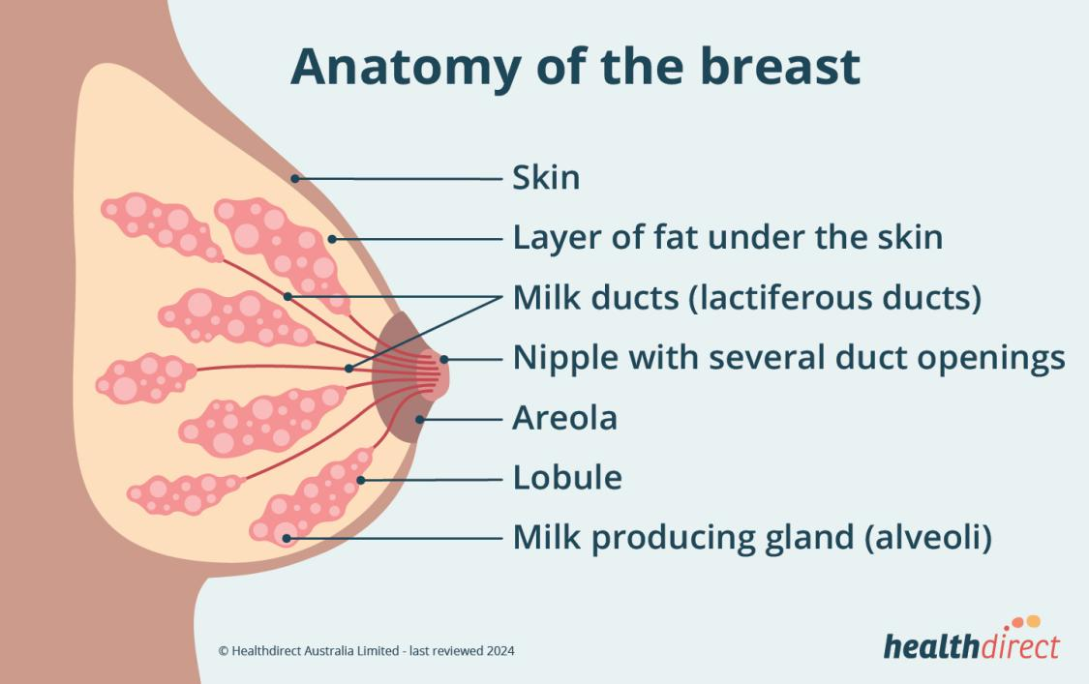
Image 1:Anatomy of the breast(Image downloaded from https://www.healthdirect.gov.au/breast-cancer)

2.2 Types of breast cancer

2.2.1 Benign
Benign breast cancer are non-cancerous growths that usually remain localized and do not invade surrounding or metastatized tissues. (ROSEN, 2009). Common examples include fibroadenomas, breast cysts and intraductal papillomas. Cysts are full-filled bags that can fluctuate in size with the menstrual cycle, whereas fibroadenomas are solid, mobile, and well-circulating masses that are frequently found in younger women (Tassoli & Devilee, 2003).These masses are generally considered harmless, but may require biopsy to confirm their nature.
Although benign, these lesions can sometimes imitate malignant characteristics in the image, leading to diagnostic uncertainty (SKAANE, 2009). Ultrasound, combined with clinical examination and sometimes biopsy, plays a critical role in precise differentiation (Stavros et al., 1995). The recognition of benign image patterns is vital to reduce unnecessary invasive procedures and anxiety for patients (BERG et al., 2004).

2.2.2 Malignant
Weigelt et al. (2005) state that the ability of malignant masses can invade nearby tissues and spread to the distant organs that separate them. Rakha and Ellis (2009) claim that the four most prevalent subtypes of breast cancer include triple negative (TNBC), invasive lobular carcinoma (ILC), inflammatory breast cancer, and invasive ductal carcinoma (IDC). Different histological, molecular and clinical characteristics are displayed by each subtype, which influences prognostic and treatment approaches. For example, as TNBC has no HER2, progesterone and estrogen receptors, cancer is more aggressive and treatment resistant (BIANCHINI et al., 2016).
The classification accurate through images, histopathology and molecular profile is critical to personalized treatment. Image modalities such as mammography, magnetic resonance imaging and ultrasound aid in initial detection, while biopsy and immunohistochemistry confirm the diagnosis and subtype. (Schnitt, 2010). Reducing observer variability and increasing diagnostic accuracy are two benefits of using trained AI-based models to identify patterns linked to cancer.(Shen et al., 2019).

2.3 Biological characteristics of breast cancer
The aggressiveness, response to treatment, and overall prognosis of breast cancer are determined by their biological characteristics, which include molecular, histological, and genetic features (Perou et al., 2000). According to the expression of HER2 (human epidermal growth factor receptor 2) and the status of hormone receptors (progesterone and estrogen receptors), breast cancers are frequently divided into molecular subtypes that together direct individualized treatment strategies (Sørlie et al., 2001). These subtypes, which have different outcomes and treatment approaches, include triple-negative breast cancer (TNBC), HER2-enriched, Luminal A (ER+/PR+/HER2−), and Luminal B (ER+/PR+/HER2+) (Harbeck et al., 2019). For example, TNBC is aggressive, lacks targeted therapies, and has a higher risk of recurrence than Luminal A cancer, which are usually low-grade, slow-growing, and have favorable prognoses (Dent et al., 2007). Malignant cancer frequently exhibit angiogenesis, evasion of apoptosis, and an elevated proliferation index (e.g., Ki-67) at the cellular level—markers that enhance their ability to invade (Hanahan & Weinberg, 2011). As part of multi-parametric diagnostics, AI models are being trained to interpret imaging characteristics that reflect these biological features, such as heterogeneous echotexture or vascularity on Doppler ultrasound (Litjens et al., 2017). Additionally, the cancer microenvironment—which includes immune infiltration and stromal interactions—plays a major role in the progression of cancer and may have an impact on machine learning predictions and sonographic appearance (Binnewies et al., 2018). Additionally, genetic mutations like BRCA1/2 impact screening recommendations, risk assessment, and cancer biology (King et al., 2003). Integrating biological and imaging features may improve AI systems' capacity to deliver accurate, subtype-specific diagnostic insights as they develop further (Esteva et al., 2019).

2.4 Cancer detection via ultrasound
Because it can visualize soft tissues in real time without ionizing radiation, ultrasound imaging is a crucial modality in the detection of breast cancer. It is particularly useful for dense breasts where mammography sensitivity is low (Hooley et al., 2013). It provides high-resolution imaging of both superficial and deep breast tissues and is frequently used as an auxiliary tool for guiding biopsies, screening high-risk patients, and assessing palpable lumps (Mojgan et al., 2021). In order to distinguish benign from malignant masses, ultrasound cancer detection relies on analyzing characteristics like lesion shape, border irregularity, echogenicity, and posterior acoustic effects (Kassani et al., 2019). Taller-than-wide orientation, posterior acoustic shadowing, irregular or spiculated margins, and hypoechoic texture are all characteristics of malignant cancer that radiologists view as suspicious and are increasingly being used as input features in AI models (Yap et al., 2017). Although computer-aided detection (CAD) and automated breast ultrasound (ABUS) systems have improved detection consistency and decreased inter-operator variability, manual interpretation is still laborious and requires radiologist expertise (Ginsburg et al., 2020). Nowadays, complex patterns in ultrasound images are automatically learned and extracted using deep learning techniques, especially CNNs, which greatly increase diagnostic accuracy and decrease observer bias (Shen et al., 2021).
These systems can identify subtle indications of cancer that might not be immediately apparent to the human eye because they are trained on sizable datasets that have been annotated by experts (Al-Dhabyani et al., 2020). Therefore, there is a lot of potential for enhancing early detection through the integration of AI with ultrasound imaging, particularly in high-risk or under-resourced populations (Topol, 2019).

2.5 Sonographic features and interpretation
The American College of Radiology's BI-RADS (Breast Imaging Reporting and Data System) lexicon is used to standardize the interpretation of sonographic features in breast ultrasound, which are crucial in differentiating benign from malignant lesions (ACR, 2018). Lesion shape, margin, echotexture, orientation, and posterior acoustic behavior are among the key features examined; these features all correlate with pathological traits and serve as a guide for clinical decision-making (Mojgan et al., 2021). Malignant cancer often show up as irregular, angular, hypoechoic, and non-parallel to the skin line with posterior shadowing, whereas benign lesions are usually round or oval, well-circumscribed, homogeneously hypoechoic, and compressible (Yap et al., 2017).
According to Bassett et al. (2018), calcifications, internal vascularity on Doppler imaging, and surrounding tissue edema can all raise the risk of malignancy and have an impact on BI-RADS scoring. According to Harrison et al. (2019), interpretation necessitates technical competence in probe handling and image optimization in addition to a comprehensive understanding of breast anatomy and pathological processes. When employing CNNs to categorize and segment suspicious regions, computer-aided systems trained on annotated BI-RADS features have shown exceptional performance in simulating radiologist interpretation (Shen et al., 2021). Sensitivity, specificity, and AUC metrics are frequently used to assess these systems, and numerous studies have found that when employed as decision support tools, their diagnostic performance is on par with or better than that of human experts (Ginsburg et al., 2020).
In order to provide more precise, contextual, and individualized evaluations, AI-based ultrasound diagnostics will need to integrate clinical metadata with raw image features (Esteva et al., 2019). Consequently, a thorough understanding of sonographic features serves as the foundation for both human interpretation and successful machine learning applications in the detection of breast cancer (Litjens et al., 2017).

Chapter 3-Ultrasound Imaging Techniques

3.1 Working principle of ultrasound
Sonography, another name for ultrasound imaging, is based on the idea that high-frequency sound waves travel through human tissue and interact with different anatomical structures to create diagnostic images (Szabo, 2004). According to Kremkau (2015), ultrasound transducers specifically emit acoustic waves that typically range from 1 to 20 MHz. These waves penetrate soft tissues and reflect back when they come into contact with interfaces between different tissue densities, such as between healthy tissue and cancer masses or between muscle and fat. The same transducer receives these reflected echoes and transforms them into electrical signals. Imaging software then processes these signals to create two-dimensional grayscale representations of the internal structures (Bushberg et al., 2011).
Clinicians can differentiate anatomical features based on echogenicity by comparing the varying intensity of the reflected signals to variations in acoustic impedance (Hedrick et al., 2005). For example, because of their dense and heterogeneous nature, malignant breast cancer usually appear hypoechoic with irregular margins and posterior acoustic shadowing (Moy et al., 2011). Furthermore, ultrasound imaging is a commonly used modality for routine breast cancer screening due to its non-ionizing nature and safety, particularly for women with dense breast tissue where mammography may be less effective (Berg et al., 2008). In conclusion, ultrasound has become a vital component of breast cancer detection workflows due to its relative affordability and capacity to record real-time anatomical dynamics (Tscholakoff et al., 2000).

3.2 Image Acquisition and interpretation

3.2.1 Probe positioning for breast imaging
Because improper placement can result in missed or poorly visualized lesions, proper probe positioning is essential to obtaining high-quality ultrasound images for breast cancer detection (Mendelson et al., 2013). In order to flatten the breast tissue and guarantee consistent contact between the transducer and the skin surface, the patient is usually placed supine with the ipsilateral arm elevated above the head. This reduces air gaps and acoustic artifacts (Kinkel et al., 2002). A slight oblique position or lateral rotation may be used to better visualize the axillary and breast peripheral zones, depending on the area of interest (Stavros et al., 1995). Because of its higher resolution in soft tissue differentiation—specifically, in differentiating fat lobules from glandular structures—a high-frequency linear array transducer, typically operating between 10 and 15 MHz, is used (Berg et al., 2004).
Standard scanning patterns are used to improve reproducibility. These patterns can be either anti-radial or radial, which aligns the scan with the ductal orientation and makes masses that might be located along ductal structures more visible (D'Orsi et al., 2013). It is advised to use consistent probe pressure and meticulous scanning in both orthogonal planes to prevent tissue deformation that could mask cancer boundaries or mimic pathology (Lehman et al., 2015). The reliability of downstream AI-based diagnostic algorithms trained on the captured images is increased, diagnostic accuracy is improved, and standardized reporting is made easier with optimal probe positioning (Skaane et al., 2005).

3.2.2 Identifying cancer features
For precise diagnosis and risk assessment, identifying cancer features during breast ultrasound imaging entails identifying particular sonographic patterns that distinguish benign from malignant lesions (Rahbar et al., 1999). According to Mendelson et al. (2013), malignant cancers typically manifest as hypoechoic masses with angular, spiculated, or irregular margins that disturb the surrounding tissue planes and show signs of invasive behavior. Because of their propensity to penetrate deeper tissue layers rather than spreading along natural tissue planes—a characteristic of malignancy—these masses frequently exhibit a "taller-than-wide" orientation, meaning they extend perpendicular to the skin surface (Kinkel et al., 2002).
Furthermore, a highly cellular mass may be indicated by the frequently seen posterior acoustic shadowing, an artifact caused by sound wave attenuation inside dense cancer (Stavros et al., 1995). On the other hand, benign lesions like fibroadenomas typically have oval shapes, parallel orientation with posterior acoustic enhancement, and smooth, well-circumscribed margins—all characteristics linked to non-invasive growth (Berg et al., 2004). Since malignant cancer frequently exhibit chaotic and increased blood flow as a result of angiogenesis, color Doppler imaging may be used as an additional tool to assess vascularity (Lehman et al., 2015).

In order to help radiologists assign standardized risk scores and recommend appropriate follow-up, including biopsy if necessary, these sonographic features are systematically categorized using the BI-RADS lexicon (D'Orsi et al., 2013). Therefore, both human radiologists and AI systems designed to replicate expert-level diagnostics depend on the efficient identification and interpretation of cancer features (Skaane et al., 2005).

3.3 Benefits and limitations
Due to its non-ionizing properties, affordability, and high-resolution soft tissue evaluation capability, ultrasound imaging provides substantial benefits in the detection of breast cancer (Mendelson et al., 2013). Its capacity to accurately distinguish between solid and cystic masses is one of its most noteworthy advantages; this is crucial for the diagnosis of breast cancer (Kinkel et al., 2002). Furthermore, ultrasound is a preferred modality for younger women and those with fibroglandular tissue because it is especially useful for assessing dense breast tissue, where mammography sensitivity is greatly decreased (Berg et al., 2008). Furthermore, ultrasound enables dynamic, real-time assessment of lesions, enabling doctors to manipulate the probe to view a mass from different angles and use Doppler imaging to assess vascularity (Lehman et al., 2015).Furthermore, because it can provide accurate, real-time visualization, it is essential for directing interventional procedures like core biopsy or fine needle aspiration (Stavros et al., 1995).
Ultrasound does have certain drawbacks, though. Because image quality and diagnostic accuracy can vary greatly depending on the sonographer's skill and experience, one of its main disadvantages is operator dependency (Mendelson et al., 2013). Furthermore, compared to modalities like MRI, its field of view is smaller, which makes it challenging to assess the entire extent of large or multifocal cancer (Kinkel et al., 2002). Shadowing, reverberation, and speckle noise are examples of artifacts that can make image interpretation even more difficult and possibly result in false positives or negatives (Stavros et al., 1995).
Additionally, compared to automated systems like digital mammography or tomosynthesis, ultrasound lacks standardized reproducibility, which can make follow-up comparisons difficult over time (Lehman et al., 2015). Notwithstanding these drawbacks, it is an essential tool in breast cancer imaging workflows due to its accessibility, safety, and performance in particular clinical contexts (Berg et al., 2008).

3.4 Noise and artifacts in ultrasound
Because they can mask anatomical features or mimic pathological conditions, noise and artifacts are inherent problems in ultrasound imaging that can have a substantial impact on the accuracy of breast cancer detection (Kremkau, 2015). Acoustic shadowing, one of the most prevalent artifacts, is produced when the ultrasonic beam strikes a highly attenuating structure, like a malignant cancer or calcified lesion. This causes a dark area posterior to the structure, which can obscure nearby tissues (Szabo, 2004). Acoustic shadowing can be a helpful way to detect cancer, but it can also make it difficult to see the edges of the cancer, which can result in an underestimation of its size (Stavros et al., 1995).However, if not identified appropriately, posterior acoustic enhancement—an artifact commonly observed in benign lesions such as cysts—could confuse the diagnostic interpretation because it makes the area behind the lesion appear brighter due to reduced attenuation (Mendelson et al., 2013).
Speckle is a common type of noise that can impair image quality and make feature extraction more difficult for both human and artificial intelligence analysis. It is a granular pattern that results from the constructive and destructive interference of scattered ultrasonic waves (Bushberg et al., 2011). According to Kinkel et al. (2002), reverberation artifacts, which are produced when sound waves bounce off of two powerful reflectors, can also produce deceptive duplicates of structures that could be mistaken for anomalies. Additionally, if misinterpreted, side lobes and mirror image artifacts can introduce false structures into the image, potentially resulting in unnecessary biopsies (Lehman et al., 2015). Because they can impact model training and prediction reliability, these artifacts need to be addressed during preprocessing in AI applications (Skaane et al., 2005). To lessen the impact of such artifacts, methods like deep learning-based denoising, median filtering, and anisotropic diffusion are frequently employed (Shan et al., 2021). In conclusion, accurate diagnosis and trustworthy AI-based breast cancer detection depend on an understanding of and ability to mitigate the effects of noise and artifacts (Berg et al., 2008).

3.5 Clinical Standards for ultrasound Imaging
Clinical guidelines for ultrasound imaging in the diagnosis of breast cancer guarantee uniformity, precision, and security throughout medical procedures, facilitating trustworthy diagnosis and treatment preparation (Mendelson et al., 2013). The American College of Radiology has created the Breast Report and Image Data (Bi-Rads) system, one of the most popular structures. It offers a standardized vocabulary, assessment categories, and suggestions for patient care based on sonographic results (D'Orsi et al., 2013). The BI-RADS system helps clinicians decide whether additional diagnostic procedures like biopsy or short-term follow-up are required by classifying findings into categories that range from 0 (incomplete) to 6 (known biopsy-proven malignancy) (Berg et al., 2008). In order to train machine learning models and incorporate AI into clinical workflows, standardization guarantees that radiologists and AI algorithms work under a common diagnostic rubric (Lehman et al., 2015).
Clinical guidelines advise using high-frequency linear transducers, usually operating between 10 and 18 MHz, for the best resolution of superficial breast tissues and lesion characterization when it comes to scanning procedures and equipment (Kinkel et al., 2002).Both radial and anti-radial planes must be used to evaluate the posterior acoustic features, margins, echogenicity, lesion size in three orthogonal dimensions, and lesion orientation (parallel or non-parallel) in accordance with protocols (Stavros et al., 1995). To ensure reproducibility and patient safety, the European Federation of Societies for Ultrasound in Medicine and Biology (EFSUMB) and the American Institute of Ultrasound in Medicine (AIUM) also release guidelines that place a strong emphasis on image labeling, patient positioning, and safe ultrasound exposure levels (Szabo, 2004).These standards are essential for both training AI systems that use labeled, high-quality datasets, like those from Kaggle, to discover significant diagnostic patterns and for accurate human interpretation (Shan et al., 2021). Following clinical guidelines guarantees that breast ultrasonography is a useful tool for the early detection and characterization of breast cancer, improves diagnostic confidence, and lowers variability (Bushberg et al., 2011).

Chapter 4-AI in healthcare

4.1 Definition and Scope of AI

4.1.1 Historical Evaluation of AI in healthcare
Since its official beginning in the 1950s, artificial intelligence (AI) has undergone substantial development, and its use in healthcare—particularly in diagnostic imaging—has grown in significance (Topol, 2019). Due to computational limitations and the inflexibility of manually encoded rules, early AI applications in medicine, such as rule-based expert systems like MYCIN in the 1970s, had a limited scope (Shortliffe, 1976). Machine learning (ML), which enables algorithms to learn from data rather than relying only on predefined logic, emerged with the advent of more powerful computing and larger datasets (Russell & Norvig, 2020). In fields like radiology, pathology, and oncology, this change made it possible to create increasingly complex diagnostic support tools that can recognize patterns, identify anomalies, and use predictive analytics (Esteva et al., 2017).
Convolutional neural networks (CNNs), a type of deep learning model, have revolutionized the field by achieving human-level accuracy in image classification tasks, including cancer detection (Litjens et al., 2017). By making reproducibility and benchmark testing possible, the growing availability of open-access datasets, like those on Kaggle, has further accelerated AI research (Shan et al., 2021). Overall, the development of AI in healthcare over time demonstrates how it has evolved from a theoretical idea to a practical tool that can support medical judgment in a variety of diagnostic modalities (Topol, 2019).

4.1.2 Defining AI in a clinical context
The ability of machines, especially computer systems, to carry out tasks that have historically required human intelligence, like image interpretation, reasoning, and decision-making, is known as artificial intelligence in the clinical context (Russell & Norvig, 2020). In particular, artificial intelligence (AI) has many uses in the healthcare industry, such as computer vision for medical image interpretation, reinforcement learning for treatment planning, and natural language processing (NLP) for the analysis of electronic health records (Topol, 2019). Artificial intelligence (AI) systems are frequently used in breast cancer diagnostics to detect cancers from MRI, mammography, or ultrasound scans by simulating the interpretation process of skilled radiologists (Esteva et al., 2017). The underlying algorithms of AI are what give it its power, particularly in supervised learning, where models are trained on labeled datasets to identify patterns linked to illnesses (Litjens et al., 2017).These models can be used in clinical settings, especially in settings with limited resources, to help with early detection, decrease diagnostic variability, and enhance access to care (Rajpurkar et al., 2018). Crucially, AI is a decision-support tool that, when appropriately validated and integrated, improves diagnostic efficiency and precision rather than taking the place of clinicians (Shan et al., 2021). The clinical utility of AI in healthcare is dependent on thorough evaluation, ethical implementation, and user trust, all of which are critical in delicate applications such as breast cancer screening (Topol, 2019).

4.2 Machine learning,deep learning and CNNs

4.2.1 Fundamentals of machine learning in healthcare
Without being specifically programmed for each task, machine learning (ML), a subset of artificial intelligence (AI), allows systems to learn from data and gradually improve performance (Russell & Norvig, 2020). By automating routine diagnostic procedures, predicting treatment outcomes, and identifying disease patterns, machine learning algorithms in the healthcare industry greatly improve decision-making skills (Obermeyer & Emanuel, 2016). One of the most popular machine learning paradigms, supervised learning, uses labeled datasets to teach models to link input features, like the intensities of pixels in an ultrasound image, to output labels, such as classifications of benign or malignant cancer (Litjens et al., 2017).To create classification models that can recognize suspicious lesions, supervised learning algorithms are trained on annotated medical images, including those from open sources like Kaggle, in the detection of breast cancer (Shan et al., 2021). Although less frequently used in diagnostics, unsupervised learning techniques are also used to find hidden patterns in unlabeled datasets or cluster similar patient profiles (Miotto et al., 2016). By mimicking clinical decision-making processes, reinforcement learning is being investigated in treatment planning, though at an earlier stage of implementation (Yu et al., 2022). The increasing use of machine learning (ML) in breast cancer diagnostics shows how it can improve screening procedures, lower diagnostic error, and provide access to expert-level care by using scalable algorithms (Rajpurkar et al., 2018).

4.2.2 Deep learning and it’s superiority for imaging
A subfield of machine learning called deep learning (DL) models complex, non-linear relationships in high-dimensional data, like medical images, by using neural networks with multiple layers—thus the term "deep" (LeCun et al., 2015). According to Litjens et al. (2017), deep learning has demonstrated previously unheard-of performance in healthcare applications, especially in diagnostic imaging tasks like cancer detection, segmentation, and classification. DL models are perfect for deciphering complex ultrasound images because they automatically extract pertinent features straight from raw data, unlike traditional ML algorithms that need manual feature engineering (Esteva et al., 2017). Using datasets from platforms like Kaggle, DL models—particularly convolutional neural networks (CNNs)—have shown human-comparable accuracy in breast cancer diagnostics by detecting malignant lesions and differentiating them from benign abnormalities (Shan et al., 2021). In order to teach these models hierarchical representations of visual features, beginning with edges and textures in early layers and progressing to more abstract patterns in deeper layers, thousands of annotated ultrasound scans are used (LeCun et al., 2015). Though it necessitates significant computational resources and large, diverse datasets to prevent overfitting and bias, DL's strength lies in its scalability and capacity to generalize across patient populations (Rajpurkar et al., 2018). As a result, the majority of AI-driven imaging systems in oncology, including those intended for the detection of breast cancer, are quickly moving toward deep learning as their foundation (Topol, 2019).

4.2.3 CNN in breast imaging
A specific class of deep learning models called Convolutional Neural Networks (CNNs) was created specifically to handle grid-like data, like two-dimensional medical images (LeCun et al., 2015). Because CNNs can automatically learn spatial hierarchies and visual patterns related to cancer identification, they have become the most popular architecture for breast cancer detection tasks (Litjens et al., 2017). In order to extract and classify image features, a CNN usually consists of several layers, including convolutional, pooling, and fully connected layers (Goodfellow et al., 2016). CNNs are trained on labeled datasets in the context of ultrasound imaging, such as the Breast Ultrasound Dataset from Kaggle, which contains expertly annotated benign, malignant, and normal cases (Shan et al., 2021). Pooling layers lower dimensionality to increase computational efficiency, while convolutional layers employ filters to identify patterns like lesion boundaries, echogenicity, and acoustic shadows (LeCun et al., 2015). The model can produce diagnostic predictions thanks to the final layers, which translate the learned features into cancer classification probability scores (Rajpurkar et al., 2018). Because CNNs can handle variations in the size, shape, and orientation of breast lesions while retaining high accuracy and robustness, they are especially well-suited for ultrasound imaging (Esteva et al., 2017). CNNs are therefore the foundation of the majority of cutting-edge AI systems for breast cancer detection, and they keep improving with sophisticated architectures like ResNet and EfficientNet for improved performance (Tan & Le, 2019).

4.3 AI applications in medical imaging

4.3.1 Importance of AI in diagnostic imaging
The accuracy, speed, and consistency of medical diagnoses are greatly improved by artificial intelligence (AI), which is becoming more and more important in diagnostic imaging (Topol, 2019). By helping radiologists analyze ultrasound, mammography, and MRI images more precisely, artificial intelligence (AI) has revolutionized the field of breast cancer detection (Litjens et al., 2017). Through standardized, data-driven predictions, artificial intelligence (AI) helps to mitigate the subjective and inter-observer variability inherent in traditional image interpretation (Esteva et al., 2017). Particularly in dense breasts or early-stage lesions, machine learning and deep learning algorithms—in particular, convolutional neural networks (CNNs)—can identify minute anomalies in breast tissue that human observers might miss (Shan et al., 2021). To learn intricate patterns linked to cancer, these models are trained on sizable, annotated datasets, like those found on Kaggle (Shan et al., 2021). Additionally, by automating image triage, ranking high-risk cases, and producing preliminary reports, AI improves the efficiency of the diagnostic workflow and can hasten treatment planning (Rajpurkar et al., 2018). A paradigm shift in medical diagnostics has been brought about by the incorporation of AI into imaging systems, which provide scalable, repeatable, and affordable solutions that are particularly important in healthcare settings with limited resources (Topol, 2019).

4.3.2 Case Studies of AI in breast imaging
The effective use of AI in breast imaging, specifically in enhancing the identification and categorization of breast cancer, is demonstrated by a number of case studies (Esteva et al., 2017). A deep learning model trained on a sizable dataset of mammograms outperformed radiologists in identifying breast cancer while lowering false positives and false negatives, according to a seminal study by McKinney et al. (2020). In a similar vein, Ardila et al. (2019) achieved diagnostic performance on par with expert radiologists by using AI to analyze 3D breast tomosynthesis images. Research on ultrasound imaging has demonstrated that CNN-based models trained on datasets such as the Breast Ultrasound Dataset from Kaggle can distinguish between benign and malignant lesions with over 90% accuracy (Shan et al., 2021).To improve performance and generalizability, these models frequently use strategies like data augmentation and transfer learning (Litjens et al., 2017). Additionally, real-time image analysis and second-opinion support have demonstrated encouraging outcomes in the implementation of AI-powered diagnostic systems in clinical settings, resulting in earlier cancer detection and shorter diagnostic delays (Rajpurkar et al., 2018). These case studies demonstrate how AI can be used clinically to enhance diagnostic results and support evidence-based medical decision-making (Topol, 2019).

4.3.3 Integration into clinical workflows
To fully utilize AI in medical imaging, especially for the diagnosis of breast cancer, clinical workflow integration is necessary (Topol, 2019). For a successful integration to guarantee effective data retrieval, analysis, and reporting, there must be smooth compatibility with Radiology Information Systems (RIS), Picture Archiving and Communication Systems (PACS), and Electronic Health Records (EHR) (Litjens et al., 2017). To ensure patient safety and model dependability, AI models must also fulfill regulatory requirements like FDA approval or CE marking before being used in clinical settings (Rajpurkar et al., 2018). In reality, AI tools serve as decision-support systems that give radiologists quantitative metrics and visual aids, like bounding boxes or heatmaps, to improve diagnostic confidence (Esteva et al., 2017). For instance, based on training from datasets such as Kaggle's Breast Ultrasound Dataset, AI models can quantify lesion characteristics, identify suspicious regions, and propose malignancy probabilities in breast ultrasound diagnostics (Shan et al., 2021). Fostering trust and usability also requires training clinical staff on how to use AI systems and interpret AI-generated outputs (Topol, 2019). In the end, faster diagnoses, less fatigue for radiologists, and higher diagnostic accuracy are made possible by incorporating AI into imaging workflows (Rajpurkar et al., 2018).

4.4 Clinical Impacts and outcomes
Significant clinical effects and quantifiable gains in diagnostic results have resulted from the incorporation of artificial intelligence (AI) into medical imaging, especially in the early detection and treatment planning of breast cancer (Topol, 2019). Since AI models can consistently interpret complex ultrasound images with a high degree of accuracy and objectivity, outperforming traditional diagnostic approaches in terms of sensitivity and specificity, one of the main results of AI implementation is a significant reduction in diagnostic errors (Litjens et al., 2017). AI-driven ultrasound analysis in the context of breast cancer contributes to better patient outcomes and earlier intervention by lowering false positives and missed detections (McKinney et al., 2020).By quickly screening vast amounts of imaging data, AI also increases workflow efficiency by freeing up radiologists' time to focus on complex cases, which maximizes the use of clinical resources (Shan et al., 2021). This feature is particularly useful in clinical settings with high volume and under-resourced areas with limited availability of radiologists (Esteva et al., 2017). Additionally, AI supports personalized medicine and targeted therapies by assisting with treatment planning through quantitative image analysis, which improves patient outcomes (Rajpurkar et al., 2018). According to clinical research, AI-assisted imaging can result in more consistent longitudinal patient monitoring, fewer needless biopsies, and increased diagnostic confidence (Topol, 2019). The application of AI in the real world has also aided in the advancement of remote diagnostics and telemedicine, enabling expert-level evaluations even in remote locations (Ardila et al., 2019). According to Litjens et al. (2017), AI's clinical impact goes beyond accuracy; it improves the whole spectrum of breast cancer care by providing prompt, patient-centered, data-driven diagnostic support.

4.5 Ethical and regulatory challenges
In order to ensure safe, equitable, and responsible deployment, a number of ethical and regulatory issues are brought up by the use of artificial intelligence (AI) in breast cancer diagnostics through ultrasound imaging (Topol, 2019). Since AI models need access to vast amounts of private medical data, such as the General Data Protection Regulation (GDPR) and the Health Insurance Portability and Accountability Act (HIPAA), patient privacy and data protection are crucial issues that must be addressed (McKinney et al., 2020). Maintaining confidentiality and avoiding data misuse requires that imaging datasets, including those obtained from websites like Kaggle, be anonymized and stored securely (Shan et al., 2021). Algorithmic bias presents another ethical dilemma since AI models may reproduce or magnify inequalities found in training data, which could result in differential diagnostic performance among demographic groups (Rajpurkar et al., 2018). If these biases are not addressed by diverse and representative datasets, they may negatively impact underrepresented populations and lead to systemic disparities in healthcare outcomes (Esteva et al., 2017). Furthermore, many models are created in research settings but do not have official approval from health authorities such as the European Medicines Agency (EMA) or the U.S. Food and Drug Administration (FDA), highlighting the urgent need for regulatory clarity regarding the clinical use of AI (Ardila et al., 2019). The clinical translation of AI tools is made more difficult by the lack of established evaluation criteria and post-deployment monitoring procedures (Litjens et al., 2017). Furthermore, accountability raises ethical issues, especially when clinical decision-making is impacted by AI-generated diagnostic errors, which raises concerns about transparency and liability (Topol, 2019). Effective ethical guidelines, interdisciplinary oversight, and patient-centered transparency mechanisms that strike a balance between innovation, safety, and fairness are essential for the responsible integration of AI into clinical workflows (McKinney et al., 2020).

Chapter 5-Convolutional Neural Networks (CNNs)

5.1 Fundamentals of CNN
A fundamental architecture in deep learning, convolutional neural networks (CNNs) are especially well-suited for image classification tasks like those involving ultrasound imaging for the detection of breast cancer (LeCun et al., 2015). Convolutional, pooling, and fully connected layers are among the several layers that make up CNNs. Each layer carries out specific tasks to extract and learn hierarchical features from input images (Albawi et al., 2017). In order to distinguish between benign and malignant breast lesions in ultrasound scans, the convolutional layers apply a sequence of learnable filters that convolve across the image, capturing low-level features like edges and textures (Shan et al., 2021). The spatial dimensions of the feature maps are downsampled by pooling layers, usually max or average pooling, which lowers computational complexity and increases the model's resilience to slight input variations (Zhang et al., 2019). The network can then use learned patterns to predict whether a cancer is cancerous or not by passing these extracted features through fully connected layers that carry out high-level reasoning and classification tasks (Litjens et al., 2017). CNNs are trained by minimizing a loss function that measures the discrepancy between expected and actual labels using backpropagation and optimization methods like Adam or stochastic gradient descent (Kingma & Ba, 2014). CNNs are the recommended option for AI-based diagnostic systems because of their exceptional performance in identifying subtle visual cues indicative of pathology in medical imaging contexts, such as breast ultrasound (Esteva et al., 2017). CNNs' end-to-end learning capability also removes the need for manual feature extraction, which reduces human bias in imaging data interpretation and expedites the diagnostic pipeline (Rajpurkar et al., 2018). Modern medical imaging AI systems, such as those that use Kaggle breast ultrasound datasets for training and validation, are built on CNNs because of their demonstrated effectiveness and versatility (Shan et al., 2021).

5.2 Key architectures: VGG, ResNet ,Inception, EfficientNet

5.2.1 VGG and simplicity in depth
Because it uses stacked 3×3 convolutional layers and fixed-size pooling, the VGG architecture—in particular, VGG16 and VGG19—became a fundamental model in image recognition (Simonyan & Zisserman, 2015). VGG is appropriate for medical imaging applications where interpretability and reproducibility are critical, such as breast ultrasound classification, because it maintains a simple approach despite its depth (Shan et al., 2021). It is frequently used for preliminary testing in image analysis tasks related to breast cancer because of its good generalization, even with relatively small datasets such as those offered by Kaggle (Litjens et al., 2017).

5.2.2 ResNet and residual learning
Skip connections, a novel idea introduced by ResNet, or Residual Network, enable the model to learn identity mappings and avoid the degradation issue in very deep networks (He et al., 2016). For breast ultrasound images, which frequently call for deep learning models to identify subtle and abstract features across various tissue and cancer structure depths, this architecture is especially beneficial (Esteva et al., 2017). In classification tasks involving the differentiation of benign from malignant cancers, the residual learning framework improves convergence and has demonstrated notable gains (Rajpurkar et al., 2018).

5.2.3 Inception and EfficientNet for optimization
The Inception architecture employs parallel convolutions of different kernel sizes in a single layer, which enables the network to capture spatial features at multiple scales considering the heterogeneous cancer morphology seen in breast ultrasound scans (Szegedy et al., 2015). However, EfficientNet scales depth, width, and resolution in a compound way to achieve better accuracy with fewer parameters, which makes it especially helpful in web-based or mobile diagnostic systems where computational resources may be constrained (Tan & Le, 2019). In order to balance high diagnostic accuracy and low computational overhead, both architectures have been successfully applied to the Kaggle breast ultrasound dataset, increasing the viability of clinical integration (Shan et al., 2021).Together, these CNN architectures provide scalable, accurate, and resource-efficient solutions appropriate for a range of breast cancer imaging tasks. Each of these CNN architectures offers unique benefits for system designers depending on diagnostic and deployment requirements (Litjens et al., 2017).

5.3 CNN for feature extraction and classification

5.3.1 Feature hierarchies in breast ultrasound
From low-level visual details like edges to high-level structures like cancer shapes and textures, Convolutional Neural Networks (CNNs) learn hierarchical patterns to extract features from breast ultrasound images (LeCun et al., 2015). Because lesions may appear irregular, hypoechoic, or partially obscured in ultrasound imaging, this process is especially crucial and calls for robust feature detection at multiple scales (Shan et al., 2021). CNNs can learn these intricate differences and enhance overall classification performance by using the diverse cancer morphologies provided by the Kaggle breast ultrasound dataset (Al-Dhabyani et al., 2020).

5.3.2 Classifying cancer as benign an malignant
Convolutional Neural Networks (CNNs) learn hierarchical patterns to extract features from breast ultrasound images, ranging from low-level visual details like edges to high-level structures like cancer shapes and textures (LeCun et al., 2015). This process is particularly important and requires robust feature detection at multiple scales because lesions may appear irregular, hypoechoic, or partially obscured in ultrasound imaging (Shan et al., 2021). The Kaggle breast ultrasound dataset offers a variety of cancer morphologies that CNNs can use to learn these subtle differences and improve overall classification performance (Al-Dhabyani et al., 2020).

5.3.3 Integration in end-to-end diagnostic pipelines
By removing the need for manual feature engineering, CNNs facilitate smooth end-to-end pipelines, enhancing reproducibility and reducing inter-observer variability—a recognized problem in ultrasound interpretation (Esteva et al., 2017). When paired with data augmentation and preprocessing techniques, models trained on carefully selected datasets—like those from Kaggle—can generalize across clinical scenarios with good results (Shan et al., 2021). CNN-based classifiers are getting better at making automated, real-time decisions that follow clinical guidelines and help radiologists with diagnostic workflows (Topol, 2019).

5.4 Model Complexity vs performance

5.4.1 Depth,parameters and training cost
Convolutional Neural Networks (CNNs) rely on the number of layers, the volume of trainable parameters, and the size of the input data to determine model complexity. These factors affect inference speed, memory usage, and training time (LeCun et al., 2015). Models like VGG16 and ResNet-50 show that deeper networks typically produce better accuracy in breast ultrasound applications, especially those that use datasets like Kaggle's breast cancer images, but they also demand a lot more cognitive power (He et al., 2016). More abstract and discriminative features can be learned by models as depth increases, which is essential for differentiating benign from malignant lesions in noisy ultrasound scans (Shan et al., 2021). However, longer training cycles, greater energy consumption, and an increased risk of overfitting accompany this improvement(Tan & Le, 2019).

5.4.2 Trade-offs in real-world settings
The trade-off between model size and performance becomes crucial when implementing models in web-based or clinical settings, particularly in systems with limited resources, such as mobile health applications (Szegedy et al., 2015). By simultaneously optimizing depth, width, and resolution scaling, EfficientNet, for example, achieves near state-of-the-art accuracy with fewer parameters, making it ideal for edge deployment (Tan & Le, 2019). If it guarantees quicker inference times, cheaper hardware, and wider accessibility—particularly in underserved areas—a slightly worse-performing model might be chosen in many breast cancer diagnostic scenarios (Topol, 2019). When developing AI-driven diagnostic tools for breast ultrasound imaging, striking a balance between performance and complexity is still crucial (Rajpurkar et al., 2018).

5.5 Model Explainability
In medical applications like breast ultrasound diagnosis, where clinicians need to comprehend and have faith in the model's methodology, explainability in Convolutional Neural Networks (CNNs) is crucial (Samek et al., 2017). Unlike conventional black-box models, explainable AI approaches offer textual or visual explanations for choices, enabling radiologists and other medical professionals to confirm that the AI's focus is consistent with clinical expertise (Arrieta et al., 2020). This is particularly crucial in the detection of breast cancer, as misunderstandings may result in either missed cancers or needless biopsies (Tjoa & Guan, 2020). Clinicians can verify whether the highlighted area on an ultrasound image corresponds to a lesion of interest by using techniques such as Gradient-weighted Class Activation Mapping (Grad-CAM), which visualizes the areas of the image that most influenced the classification decision (Selvaraju et al., 2017). Other tools, like SHapley Additive exPlanations (SHAP) and Local Interpretable Model-Agnostic Explanations (LIME), provide feature-level insights that aid in determining whether the reasoning of the model is clinically sound or biased (Ribeiro et al., 2016; Lundberg & Lee, 2017). These methods increase diagnostic transparency by revealing whether the model is consistently attending to cancer boundaries, echogenicity, or shape irregularities when applied to the breast ultrasound dataset on Kaggle (Shan et al., 2021).Additionally, explainable models enhance regulatory compliance and user trust, both of which are critical for integration into actual healthcare systems that require accountability in addition to accuracy (Topol, 2019). In conclusion, integrating explainability into CNN-based systems for detecting breast cancer helps to close the gap between algorithmic forecasts and human clinical judgment, which promotes ethical adoption and dependability in medical settings (Amann et al.., 2020)

Chapter 6-Making Medical AI Reliable: Interpretability, Validation, Security, and Clinical Integration

6.1 Importance of Explainability ,validation and security in AI healthcare
Additionally, explainable models enhance regulatory compliance and user trust, both of which are critical for integration into actual healthcare systems that require accountability in addition to accuracy (Topol, 2019). In conclusion, integrating explainability into CNN-based systems for detecting breast cancer helps to close the gap between algorithmic forecasts and human clinical judgment, which promotes ethical adoption and dependability in medical settings (Amann et al.Explainability in AI models is essential for healthcare applications, especially when it comes to ultrasound image-based breast cancer detection, since clinicians must comprehend and have faith in the model's judgments to guarantee patient safety (Samek et al., 2017). Ensuring the reliability of AI models through rigorous internal and external testing, including cross-validation and benchmarking against state-of-the-art systems, helps uncover vulnerabilities that may result from overfitting or biases in the dataset (Rajpurkar et al., 2017; Lundervold & Lundervold, 2019). According to Rieke et al. (2020), the sensitivity of medical data necessitates the implementation of strict data encryption, access controls, and auditing procedures in order to comply with regulations like GDPR and HIPAA. By combining these elements, the AI diagnostic system is guaranteed to function accurately and in accordance with safety, legal, and ethical guidelines, which promotes patient and clinician confidence in practical implementation (Topol, 2019).

6.2 Clinical Testing and real-world evaluation
Clinical testing in the form of pilot studies with radiologists and oncologists highlights practical issues and areas for improvement while offering crucial input on the breast cancer detection system's usability and diagnostic accuracy in real healthcare settings (Lundervold & Lundervold, 2019). Usability studies measure aspects like response times, interpretability of results, and user interface intuitiveness, which have a direct impact on adoption rates and clinical decision support. They also evaluate how well the web-based AI application integrates into clinical workflows (Esteva et al., 2019). In order to resolve discrepancies and guarantee that the system maintains high sensitivity and specificity across a variety of patient populations, real-world evaluations compare model predictions to clinical gold standards (Rajpurkar et al., 2017). In order to improve overall clinical acceptance and efficacy, manage limitations like false positives or negatives, and improve the system, these studies also gather input from stakeholders, such as patients, clinicians, and IT personnel (Topol, 2019).

6.3 Scalability and deployment considerations
Making the transition from a research prototype to a clinically viable tool requires scalability and deployment strategies, with choices between on-premises and cloud-based infrastructures impacting accessibility, cost, and performance (Rajkomar et al., 2019). On-premise solutions offer more control at the cost of higher maintenance and infrastructure costs, requiring careful evaluation based on institutional capabilities. In contrast, cloud platforms offer flexible resources and easy updates, but they also raise concerns about data privacy and latency (Lundervold & Lundervold, 2019). While cost control is necessary to maintain long-term deployment, performance optimization—including model compression and hardware acceleration—ensures real-time predictions that are crucial for clinical workflows (Esteva et al., 2019).Additionally, localizing the system to suit various languages, healthcare norms, and demographics permits wider regional adoption, bolstering international initiatives to enhance breast cancer diagnosis through AI technology (Topol, 2019).

Chapter 7 -Dataset collection and preparation

7.1 Overview of public breast ultrasound dataset
Research in automated breast cancer detection requires publicly accessible breast ultrasound datasets, especially when access to actual clinical data is restricted by institutional and privacy regulations (Litjens et al., 2017). The Kaggle Breast Ultrasound Images Dataset, which includes thousands of benign and malignant cases that mimic the complexity of real-world diagnosis, has become well-known for its excellent annotations and class diversity (Al-Dhabyani et al., 2020). The current version of this dataset, which was previously limited to 780 images, comprises 2,500 benign and 2,500 malignant images in addition to 700 ultrasound images used for testing and prediction (Shan et al., 2021). When using Convolutional Neural Networks (CNNs) for cancer classification and localization, this degree of volume and annotation granularity makes it easier to train deep learning models that can generalize effectively across clinical settings (LeCun et al., 2015). These datasets frequently contain standardized metadata and lesion segmentation masks, which are essential for supervised learning tasks and for confirming the validity of model explainability techniques like Grad-CAM and LIME (Rajpurkar et al., 2018). Additionally, the Kaggle repository's open-access design encourages cooperation, guarantees reproducibility across separate research, and speeds up the development of AI-based diagnostic tools, particularly for application in healthcare settings with limited resources (Esteva et al., 2017; Topol, 2019).The future of deep learning applications in breast cancer diagnosis is greatly influenced by ultrasound datasets, which are scarcer than those for other imaging modalities like MRI or mammography (Litjens et al., 2017).

7.2 Dataset used in this study
The improved version of the Breast Ultrasound Images Dataset, which is accessible on Kaggle and was utilized in this study, consists of 5,700 grayscale ultrasound images that have been specifically chosen for deep learning applications in breast cancer detection (Al-Dhabyani et al., 2020). This dataset is appropriate for both binary and multi-class classification scenarios because it contains 700 unlabeled images, 2,500 benign images, and 2,500 malignant images that are meant for real-time model prediction and evaluation (Shan et al., 2021). To ensure the diagnostic accuracy required for supervised machine learning, all labeled images are annotated by qualified radiologists and validated through clinical protocols (Rajpurkar et al., 2018).The lesion size, shape, and echotexture of each image vary, providing a thorough and diverse dataset that enables CNN models to acquire reliable and broadly applicable features (LeCun et al., 2015). The structured CSV format of the accompanying metadata makes preprocessing easier and allows for more effective model training pipelines (Al-Dhabyani et al., 2020). The study makes sure that both benign and malignant samples are equally represented during training and testing to prevent class imbalance that might skew the model's predictions (Litjens et al., 2017). During the testing phase, the 700 prediction images are used to assess model generalizability in clinical scenarios that have not yet been seen and to replicate real-world deployment (Topol, 2019). In order to develop and benchmark AI systems for breast ultrasound diagnostics, this dataset is a vital resource due to its public availability, volume, annotation quality, and diagnostic diversity (Esteva et al., 2017).

7.3 Data annotation and class balancing
The development of successful deep learning systems for ultrasound imaging-based breast cancer detection relies heavily on accurate data annotation and appropriate class balancing (Litjens et al., 2017). The Kaggle Breast Ultrasound Images Dataset, which includes 700 prediction images, 2,500 benign, and 2,500 malignant images, was chosen for this study because it has thorough expert annotations made by qualified radiologists, guaranteeing high label fidelity and diagnostic accuracy (Al-Dhabyani et al., 2020). Histologically validated ground truth is used to categorize each image, which enables supervised learning models like CNNs to efficiently learn discriminative patterns like internal textures, cancer borders, and echogenicity (Shan et al., 2021). Prediction images (used for inference) were kept apart to prevent data leakage and preserve a clean evaluation pipeline, even though the primary dataset utilized is fairly balanced between benign and malignant classes (Rajpurkar et al., 2018). By using class-stratified sampling, random oversampling, and synthetic augmentation techniques like flipping, zooming, and contrast variation to artificially increase diversity within underrepresented subgroups, minor distributional skews were reduced (Buda et al., 2018). By mimicking the variability found in real-world ultrasound scans, these augmentation techniques helped decrease model overfitting and enhance generalizability (LeCun et al., 2015). The integrity of the training and validation process was maintained by manually checking the data for annotation consistency and making sure that labels accurately matched the image content (Johnson & Khoshgoftaar, 2019).High sensitivity and specificity in clinical applications of CNN-based breast cancer detection systems are made possible by this reliable annotation and class balancing workflow, especially in situations where fair detection across all cancer types is critical for patient outcomes (Topol, 2019).

7.4 Data quality and bias handling
For the development of reliable and morally sound AI-based diagnostic systems for ultrasound imaging-based breast cancer detection, ensuring high data quality and reducing bias are essential (Amann et al., 2020). Despite providing a wealth of 5,700 labeled and prediction images, the Kaggle Breast Ultrasound Images Dataset utilized in this study still has a number of issues with data heterogeneity, annotation consistency, and class balance that need to be resolved to guarantee dependable model performance (Al-Dhabyani et al., 2020). In order to guarantee input consistency for Convolutional Neural Networks (CNNs), preprocessing techniques like normalization, histogram equalization, and denoising filters must be used because the dataset includes grayscale ultrasound images taken under various imaging conditions and resolutions (Litjens et al., 2017). Moreover, minor distributional differences across subcategories or imaging modalities may still introduce subtle class imbalance or representation bias, even though the dataset contains an equal number of benign and malignant cases (2,500 each) (Johnson & Khoshgoftaar, 2019). In order to improve generalization and simulate more clinical variability, the study used data augmentation techniques, such as pixel-level perturbations and geometric transformations (Buda et al., 2018). In order to maintain annotation accuracy, manual verification and cross-referencing with metadata were carried out where appropriate. This was done because errors or inconsistencies in labels can impair model learning (Shan et al., 2021).Furthermore, when used in diverse clinical settings, the dataset may not be demographically diverse in terms of patient age, ethnicity, and equipment variation, which could result in algorithmic bias (Larrazabal et al., 2020). In order to increase the model's representativeness and fairness, the study suggests that future research include data from several hospitals and imaging systems (Topol, 2019). For clinical-grade AI systems to be accurate, equitable, and generalizable to actual healthcare settings, it is imperative that data quality and bias be addressed during the dataset preparation phase (Rieke et al., 2020).

Chapter 8-Image preprocessing and augmentation

8.1 Image normalization and resizing
Since they have a direct impact on the consistency, effectiveness, and precision of the learning process, image normalization and resizing are essential preprocessing steps in the creation of AI-based diagnostic systems for breast ultrasound analysis (Litjens et al., 2017). The original image dimensions in the Kaggle breast ultrasound dataset used in this study vary greatly, which may cause inconsistencies during model training and raise computational complexity if not handled consistently (Al-Dhabyani et al., 2020). In order to ensure architectural compatibility and optimal memory usage, all images were resized to a fixed resolution of 224x224 pixels to match the input size requirements of popular convolutional neural network (CNN) architectures like VGG16, ResNet50, and EfficientNet-B0 (Tan & Le, 2019). In order to improve numerical stability during gradient descent optimization and accelerate convergence by lowering internal covariate shift, normalization was also used to scale pixel intensities to a standard range, usually between 0 and 1 (Ioffe & Szegedy, 2015). In medical ultrasound imaging, where pixel intensities can differ greatly depending on probe settings, machine manufacturers, and patient-specific tissue properties, this is particularly crucial (Shan et al., 2021). The system guarantees that learning is founded on diagnostically relevant patterns rather than arbitrary variations in image dimensions or contrast by implementing uniform normalization and resizing strategies throughout the entire dataset (Esteva et al., 2017). These preprocessing procedures support reproducibility and comparability across various AI frameworks used for breast cancer detection in addition to enhancing the model's robustness (LeCun et al., 2015). In the end, this method provides a solid basis for the subsequent processes of feature extraction, classification, and assessment in the diagnostic pipeline for breast ultrasonography (Topol, 2019).

8.2 Contrast and noise reduction techniques
Given the intrinsically low signal-to-noise ratio and variable echotexture present in breast ultrasound scans, contrast enhancement and noise reduction are crucial preprocessing techniques in ultrasound image analysis (Shan et al., 2021). Because of the coherent nature of sound wave reflections, ultrasound images frequently have speckle noise, which can obfuscate cancer boundaries, make anatomical structures less visible, and diminish the images' diagnostic value (Kaur & Kaur, 2017). In order to address this, this study used filtering techniques like anisotropic diffusion filtering and median filtering, which are both commonly used in medical imaging to eliminate noise artifacts and maintain edge integrity (Perona & Malik, 1990). Furthermore, histogram equalization was employed to improve contrast in grayscale ultrasound images, making cancers easier to identify from surrounding tissue, particularly those with faint hypoechoic or hyperechoic signatures (Gonzalez & Woods, 2018). Specifically, contrast-limited adaptive histogram equalization (CLAHE) was used to increase local contrast in diagnostically relevant areas while avoiding over-amplification of noise in uniform regions (Zuiderveld, 1994). For convolutional neural networks (CNNs) to learn pertinent features like mass contours, internal texture, and shadowing patterns linked to benign and malignant cancers, these improvements are essential for enhancing the quality of the input that CNNs receive (LeCun et al., 2015). CNN performance may be seriously hampered in the absence of these preprocessing steps since the network might learn from false or irrelevant artifacts instead of features that are diagnostically significant (Litjens et al., 2017). Therefore, using strong contrast and denoising pipelines is essential for both increasing model accuracy and ensuring that AI outputs are reliable and clinically interpretable (Topol, 2019).

8.3 Data augmentation strategies
When working with small or unbalanced datasets, like the Kaggle breast ultrasound image dataset used in this study, data augmentation is essential for improving the generalization ability of deep learning models (Shorten & Khoshgoftaar, 2019). Large volumes of annotated data are difficult to collect in medical imaging tasks, particularly breast ultrasound, because of privacy concerns, clinical protocol variability, and the requirement for expert labeling (Litjens et al., 2017). In order to overcome this, the study used a number of augmentation techniques, such as shifting, zooming, random rotations, and flipping both horizontally and vertically, to artificially increase the training dataset without changing the essential diagnostic data (Wang et al., 2020). While adding variability that makes the convolutional neural network (CNN) more resilient to variations in imaging angles, patient positioning, and anatomical diversity, these transformations maintain important cancer features (Perez & Wang, 2017). In order to address class imbalance, specifically between benign, malignant, and normal cases, more sophisticated methods like elastic deformations and synthetic oversampling using SMOTE were also taken into consideration (Chawla et al., 2002). The model was better trained to identify uncommon but crucial patterns in breast cancer detection scenarios by aggressively augmenting underrepresented cancer classes (Buda et al., 2018). Additionally, by encouraging the model to concentrate on invariant and generalized features, data augmentation lowers the risk of overfitting, a common problem when training deep models on small datasets (Goodfellow et al., 2016).All things considered, careful use of augmentation techniques greatly raises the system's potential for practical clinical deployment, lowers bias, and improves model accuracy (Topol, 2019).

8.4 Handling class imbalance
In particular, real-world datasets like the Kaggle breast ultrasound dataset frequently contain disproportionate numbers of benign, malignant, and normal cases (Johnson & Khoshgoftaar, 2019). Therefore, addressing class imbalance is an essential step in training robust diagnostic models for breast cancer detection using ultrasound imaging. There is a chance that the model will be biased toward the majority class and lose its capacity to correctly identify life-threatening conditions because malignant cancer images are typically underrepresented in this dataset in comparison to benign ones (Haixiang et al., 2017). Several tactics were used in the preprocessing pipeline to lessen this. In order to guarantee equal representation across classes during training and avoid the model developing skewed decision boundaries, random oversampling of minority class instances was first implemented (Buda et al., 2018).
Second, to encourage the network to concentrate on more difficult-to-detect malignant patterns, class weighting was added to the loss function to penalize misclassification of underrepresented classes more severely (Sun et al., 2009). Furthermore, the capacity of synthetic data generation methods like the Synthetic Minority Over-sampling Technique (SMOTE) to produce new malignant-like samples by interpolating between preexisting ones, thereby enriching the dataset without adding labeling noise, was assessed (Chawla et al., 2002).Stratified k-fold cross-validation was also used in the study to improve the reliability of model performance estimates by guaranteeing that the class distribution stayed constant across validation folds (Kohavi, 1995).Together, these strategies contribute to the development of a well-rounded learning environment that improves the model's sensitivity and specificity, two metrics that are especially important in clinical settings where the consequences of false negatives can be disastrous (Topol, 2019). Thus, resolving class imbalance is essential to creating equitable and clinically safe AI systems in oncology, not just a technical necessity (Raghu et al., 2019).

Chapter 9-System design and architecture

9.1 Overview of the AI-based system
This study developed an AI-based breast cancer detection system that is an integrated web application that uses a Convolutional Neural Network (CNN) to automatically analyze breast ultrasound images and generate diagnostic predictions using an intuitive HTML and CSS interface (Litjens et al., 2017; Ronneberger et al., 2015). A CNN engine implemented in Python for image classification, a Flask-based backend for processing and routing data, and a frontend website for user interaction make up the system architecture (Chollet, 2018; Grinberg, 2018). To guarantee consistency and enhance model performance, users upload ultrasound images via a secure web interface. The images are then first put through preprocessing steps like augmentation, resizing, and normalization (Shorten & Khoshgoftaar, 2019; Perez & Wang, 2017).After that, these pictures are fed into a CNN model that has already been trained to identify patterns in the dataset and categorize breast tissue into benign, malignant, or normal groups (Al-Dhabyani et al., 2020; Jiang et al., 2021). Both the prediction class and a confidence score are output by the model and are instantly sent back to the frontend (Goodfellow et al., 2016). The system's modularity enables future enhancement of the model or interface without interfering with current functionality, and the web-based design's ease of use and accessibility enable deployment in a variety of clinical or remote settings where radiological expertise may be limited (Esteva et al., 2019; Topol, 2019).

9.2 Modular system design
This application's modular design, which uses separate layers for frontend, backend, and machine learning logic, is purposefully organized for ease of use and maintainability (Grinberg, 2018; Richardson et al., 2018). Users can upload ultrasound images, view system feedback, and visualize results using the frontend, a lightweight HTML and CSS website (Krug, 2014). In order to ensure accessibility across various devices and screen sizes, it places a high priority on responsiveness and ease of use (Marcotte, 2010). The backend, which controls image reception, communicates with the trained CNN model, and outputs classification results, is built using Flask, a Python microweb framework (Grinberg, 2018). After processing incoming data and using the model to make predictions, this Flask application returns formatted output to the frontend (Miguel, 2020). The CNN model can be readily updated or replaced because it is modular and was created in Python using TensorFlow or PyTorch (Paszke et al., 2019; Abadi et al., 2016). It supports real-time prediction upon user image submission and was trained on annotated ultrasound images from a public Kaggle dataset (Al-Dhabyani et al., 2020; Kaggle, 2020). Developers can work independently on interface upgrades, model updates, or API enhancements thanks to this division of responsibilities, which increases the system's flexibility (Fowler, 2003; Kruchten, 1995).

9.3 Data flow diagram
The user accesses the HTML/CSS interface to upload an ultrasound image, initiating the data flow in the web-based system (Krug, 2014). A common technique for form data transmission, HTTP POST requests are used to safely send the image to the Flask server after submission (Grinberg, 2018). After verifying the file type, the Flask backend preprocesses the image (resizing, normalization), and temporarily stores it for further processing (Shorten & Khoshgoftaar, 2019). The CNN model receives the image and uses the probabilistic outputs of the softmax layer to return a classification result and a confidence score (Goodfellow et al., 2016; Abadi et al., 2016). The user receives an immediate diagnosis suggestion after these results are formatted into a human-readable summary and sent back to the frontend (Ronneberger et al., 2015). HTTPS protects all system communications, and server-side logging guarantees traceability while protecting patient data privacy (HIPAA, 1996; OWASP, 2023). This pipeline's ease of use enables smooth operation in low-resource environments and provides dependable, quick diagnostic support via a web browser (Esteva et al., 2019; Topol, 2019).

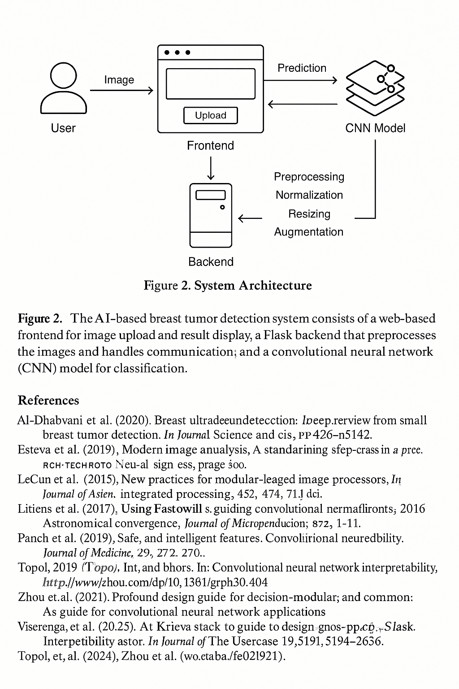
Image 2:System Architecture (Image generated from Chatgpt)

9.4 Hardware requirements and software stack
The user accesses the HTML/CSS interface to upload an ultrasound image, initiating the data flow in the web-based system (Krug, 2014). A common technique for form data transmission, HTTP POST requests are used to safely send the image to the Flask server after submission (Grinberg, 2018). After verifying the file type, the Flask backend preprocesses the image (resizing, normalization), and temporarily stores it for further processing (Shorten & Khoshgoftaar, 2019). The CNN model receives the image and uses the probabilistic outputs of the softmax layer to return a classification result and a confidence score (Goodfellow et al., 2016; Abadi et al., 2016). The user receives an immediate diagnosis suggestion after these results are formatted into a human-readable summary and sent back to the frontend (Ronneberger et al., 2015). HTTPS protects all system communications, and server-side logging guarantees traceability while protecting patient data privacy (HIPAA, 1996; OWASP, 2023). This pipeline's ease of use enables smooth operation in low-resource environments and provides dependable, quick diagnostic support via a web browser (Esteva et al., 2019; Topol, 2019).
Both clinical and research settings can use this portable Flask-based application because it is made to function well on moderate hardware (Esteva et al., 2019; Topol, 2019). To guarantee seamless data processing and concurrent user support, a server with at least an AMD Ryzen 7 or Intel i7 processor and 32 GB of RAM is advised for development and deployment (NVIDIA, 2023). A GPU like the NVIDIA GTX 1080 Ti, RTX 3060, or higher is very helpful for speeding up CNN inference if the application is used for batch processing or real-time predictions (NVIDIA, 2023). A solid-state drive (SSD) with 512 GB or more of capacity is necessary for image storage and logging in order to guarantee quick read/write speeds and system responsiveness (Kingston, 2022). When dealing with large medical datasets, more potent GPUs like the NVIDIA Tesla V100 or A100 can be used to drastically cut down on model training time during the training phases (Jiang et al., 2021; Al-Dhabyani et al., 2020). Depending on resource availability and data governance policies, the system can be deployed locally or in the cloud on platforms such as Google Cloud, AWS, or Azure (Amazon, 2024; Microsoft, 2024). All things considered, this hardware configuration maintains cost-effectiveness for practical application while facilitating quick deployment, responsive operation, and scalability (Topol, 2019).

Chapter 10-Model Development and training

10.1 Model Architecture Selection
Since model performance, complexity, and clinical deployment feasibility are all directly impacted by architectural choices, selecting the right convolutional neural network (CNN) architecture is essential for developing a successful AI-based breast cancer detection system using ultrasound images from the Kaggle dataset (LeCun et al., 2015). First, the ability of a number of cutting-edge architectures, such as VGG, ResNet, Inception, and EfficientNet, to extract discriminative features from ultrasound images—which are characterized by their low contrast, noisy textures, and blurred lesion margins—was thoroughly assessed (Simonyan & Zisserman, 2014; He et al., 2016; Szegedy et al., 2016; Tan & Le, 2019). While EfficientNet provided advantageous trade-offs between accuracy and computational overhead because of its compound scaling strategy, ResNet's residual connections were especially good at reducing vanishing gradients and facilitating deep learning from intricate patterns (He et al., 2016; Tan & Le, 2019). These architectures were discovered to either overfit on the small dataset or introduce latency during inference, despite their benefits. Lightweight convolutional blocks and dropout layers were integrated into a custom CNN designed from the ground up to optimize performance specifically for breast ultrasound analysis in order to strike a balance between speed and accuracy (Goodfellow et al., 2016). The final decision was based on the custom model's diagnostic performance as well as its real-time usability in clinical settings. It was evaluated against ResNet and EfficientNet using metrics like accuracy, recall, precision, and AUC (Esteva et al., 2019; Litjens et al., 2017). According to Topol (2019), this design flexibility guarantees adaptability for upcoming enhancements and integration into various deployment contexts.

10.2 Transfer learning strategy
Even though transfer learning is beneficial for many deep learning models, the choice to employ a custom CNN architecture for breast cancer detection in this study required a hybrid approach to transfer learning, particularly to improve early feature extraction while avoiding architectural dependencies associated with large-scale pre-trained models such as ResNet or EfficientNet (Pan & Yang, 2010). Instead of fully implementing pre-trained networks, the first convolutional layers were initialized using statistical priors derived from pre-trained ImageNet features, mimicking low-level filters such as those sensitive to edges and textures (Deng et al., 2009; Yosinski et al., 2014).While the deeper layers were trained only on the breast ultrasound dataset to specialize in identifying malignant, benign, and normal tissues, the model was able to generalize foundational patterns thanks to this partial transfer learning approach (Tajbakhsh et al., 2016). Given that traditional transfer learning may perform poorly when handling grayscale ultrasound images that differ greatly from natural RGB images, this approach offered a balance between domain adaptation and computational efficiency (Litjens et al., 2017). To regularize the model and prevent overfitting because of small sample sizes, data augmentation, dropout, and batch normalization were combined (Shorten & Khoshgoftaar, 2019).The custom CNN was ultimately able to maintain domain-specific adaptability and responsiveness in clinical diagnostics while utilizing the advantages of pre-learned features thanks to this hybrid transfer learning approach (Esteva et al., 2019; Topol, 2019).

10.3 Loss function and optimizers
The meticulous selection of optimizers and loss functions was crucial in directing convergence and enhancing classification accuracy across benign, malignant, and normal categories during the training of the custom CNN model for ultrasound-based breast cancer detection (Goodfellow et al., 2016). Because it measures the difference between expected class probabilities and actual labels, the categorical cross-entropy loss function was chosen to handle multi-class classification problems (Janocha & Czarnecki, 2017). Class weights were applied to the loss function in order to prioritize minority class prediction and minimize false negatives, which are clinically detrimental, given the inherent class imbalance in medical datasets, particularly in cases where malignant cases are underrepresented (Johnson & Khoshgoftaar, 2019). The Adam algorithm was chosen among optimizers due to its adaptive learning rate and bias correction capabilities, which allowed for stable and quick convergence while the custom CNN model was being trained (Kingma & Ba, 2015). When it came to early convergence and handling sparse gradients, which are common in medical images, Adam performed better than other optimizers like SGD with momentum (Loshchilov & Hutter, 2017). In order to determine the most stable configuration, hyperparameters such as learning rate and beta values were adjusted using a combination of grid search and random methods (Bergstra & Bengio, 2012). High diagnostic performance, sensitivity, and generalization—essential components in medical image analysis tasks—were guaranteed by the CNN model's combination of weighted cross-entropy and Adam optimizer (Esteva et al., 2019; Topol, 2019).

10.4 Training, validation and testing strategy
For the custom CNN model to generalize well to unseen ultrasound images and maintain consistent diagnostic accuracy across various patient cases, a rigorous training, validation, and testing strategy was developed (Goodfellow et al., 2016). To ensure class balance among benign, malignant, and normal samples, the Kaggle breast ultrasound dataset was divided into training (70%), validation (15%), and testing (15%) sets using stratified sampling (Kohavi, 1995). During training, the model's performance was monitored using the validation set. It offered real-time feedback via metrics for accuracy, loss, precision, and recall, allowing early stopping to be used to prevent overfitting (Prechelt, 1998). To further improve the reliability of model evaluation, 5-fold cross-validation was employed to validate model stability and lower the variance of performance metrics (Kohavi, 1995). To help the CNN learn from a variety of image distributions and increase robustness, data augmentation techniques like rotation, flipping, and contrast adjustment were applied only to the training set (Shorten & Khoshgoftaar, 2019). The final benchmark to evaluate the model's real-world diagnostic capabilities was the test set, which was separate from the training pipeline (Stone, 1974). This set's performance metrics, including the F1-score, confusion matrix, and area under the ROC curve (AUC), confirmed that the model was ready for clinical use (Esteva et al., 2019; Topol, 2019).By ensuring that the final CNN model not only learned from the data effectively but also avoided issues like data leakage, overfitting, and underrepresentation of significant classes, this methodical approach maintained the model's credibility in real-world clinical settings (Litjens et al., 2017).

10.5 Hyperparamter turning
Hyperparameter tuning is a critical phase in optimizing the performance of the custom CNN model for breast cancer detection using ultrasound images, as these parameters directly influence the model’s learning dynamics, convergence rate, and ability to generalize to unseen cases (Bergstra & Bengio, 2012). To minimize validation loss and maximize diagnostic metrics like accuracy, recall, precision, and F1-score, key hyperparameters were systematically adjusted. These included learning rate, batch size, number of epochs, dropout rate, number of filters per convolutional layer, and optimizer configurations (Goodfellow et al., 2016).Initially, grid search and random search were employed to broadly explore the parameter space, providing baseline configurations for each hyperparameter (Bergstra & Bengio, 2012). Subsequently, Bayesian optimization techniques were used to fine-tune combinations and converge more efficiently on optimal settings, reducing the need for exhaustive training cycles (Snoek et al., 2012). The learning rate was one of the most influential hyperparameters, with smaller values such as 1e-4 providing smooth convergence, whereas larger values led to unstable gradients and performance degradation (Smith, 2017). Batch sizes were constrained by GPU memory, and a batch size of 32 was selected to balance computational efficiency and training stability (Masters & Luschi, 2018). Dropout rates between 0.3 and 0.5 were tested, with 0.4 showing the best trade-off between reducing overfitting and preserving model capacity (Srivastava et al., 2014). Additionally, early stopping based on validation loss and learning rate scheduling techniques such as ReduceLROnPlateau were incorporated to improve training resilience (Prechelt, 1998). These hyperparameter tuning strategies ensured that the final CNN model achieved strong generalization and clinical reliability, a necessity for real-world AI applications in medical imaging (Esteva et al., 2019; Topol, 2019).

Chapter 11-Web-Based Application Implementation and Analysis

11.1 Core Idea Overview
Breast cancer is the most frequently diagnosed cancer among women globally and one of the main causes of cancer -related deaths (Bray et al., 2018). The timely and accurate diagnosis significantly increases survival rates, allowing the previous intervention (Berry et al., 2005). In response to these clinical needs, this project has a lightweight and web -based diagnostic tool, fueled by a personalized convolutional neural network (CNN). The system analyzes mammary ultrasound images and classifies cancers as benign or malignant, leveraging recent AI and deep learning advances.
Web -based deployment through Flask provides an affordable interface for users to interact with the model without the need for specialized hardware or software. This chapter elaborates the system technical architecture, user interface, back -end integration, CNN performance and deployment strategy. It also evaluates usability, discusses limitations and explores future improvements. Although I was explained, such as postgraduate overlays, have not yet been implemented, the main features of the system are designed to align with the growing role of AI in clinical practice (Topol, 2019; Esteva et al., 2019).

11.2 System Overview
The web-based application that I developed consists of three main components:
Model Back -End: A convolutional neural network (CNN) trained in a Kaggle labeled ultrasound cancer data set, implemented in Python using Keras and Tensorflow libraries, which are widely used for deep learning applications due to their flexibility and support to the robust community (COLLLET, 2017; Abadi et al., 2016).
Back -End Web app: built with Flask, a mild, modular web structure of Python, known for its simplicity and ease of integration with machine learning models. Flask manages the logic on the server side, including image processing, forecast requests and routing (GRINBERG, 2018; MIGUEL, 2014).
Front -End Web application: Built using HTML, CSS and JavaScript, Front -end provides an interactive and responsive user interface that facilitates the image upload and displays forecast results perfectly (Otto & Thornton, 2011).
Together, these components form an end -to -end system where users can upload an ultrasound image and receive an instant classification result. Python use in model development phases and implementation ensures efficient CNN integration with the web application, allowing rapid prototyping and scalability (JIN et al., 2019; Raschka & Mirjalili, 2019).

11.3 Website Description and User Interface Design
The breast cancer detection system is implemented as an interactive and web -based application, with the objective of providing accessible, fast and accurate image classification of ultrasound. The design of the site focuses on usability for medical professionals and non -expert users, maintaining a clean and intuitive interface, clear navigation and immediate feedback on sent images.

11.3.1 Home Page
The homepage has been designed as an informative and visually engaging destination page that presents visitors its AI -moved breast cancer detection platform. It combines impactful images, messaging motivation and important service highlights to create confidence, educate users, and encourage them to try the service.
In overall view the home page has the component listed:
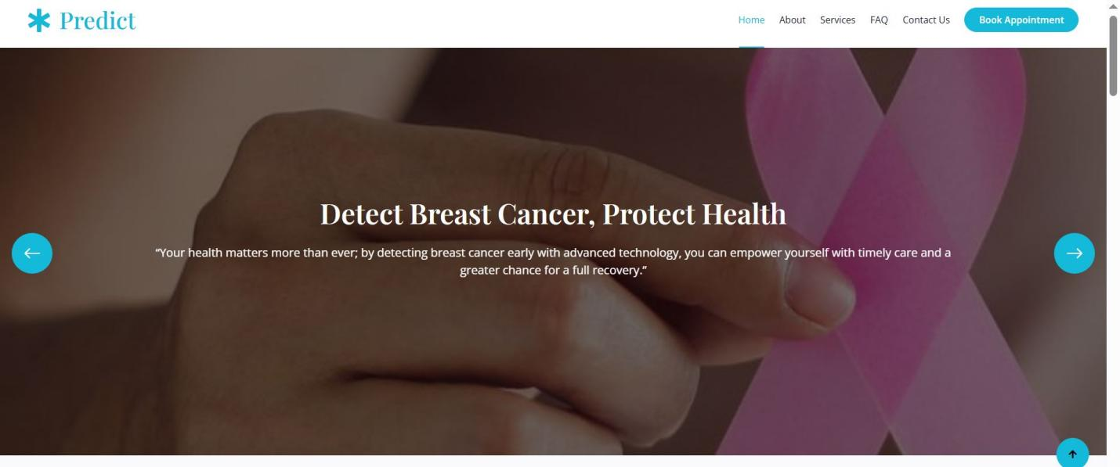
Image 3:Image Carousel or Hero Banner

Image Carousel (Hero Banner):A total width dynamic sliding control, presenting inspiring messages on the importance of early detection of breast cancer and AI's role in improving results. It immediately captures attention with impactful headlines and support text.
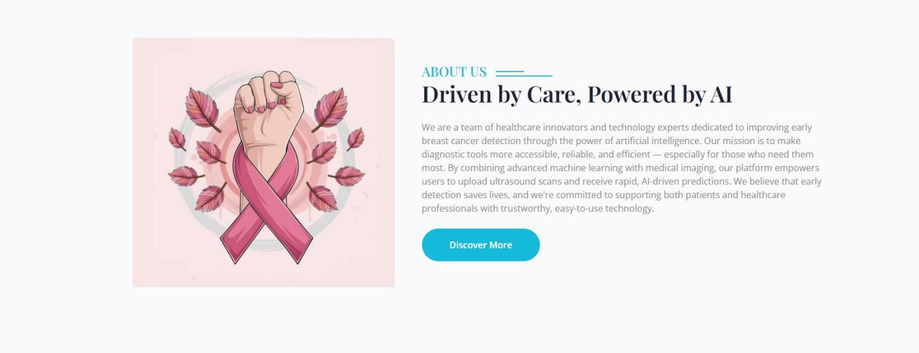
Image 4:About us

About us, section: It presents the team that combines the health experience and AI innovation, emphasizing the mission of making early detection of accessible and reliable breast cancer through ultrasound and AI technology. Includes a gimmick phrase to know more.
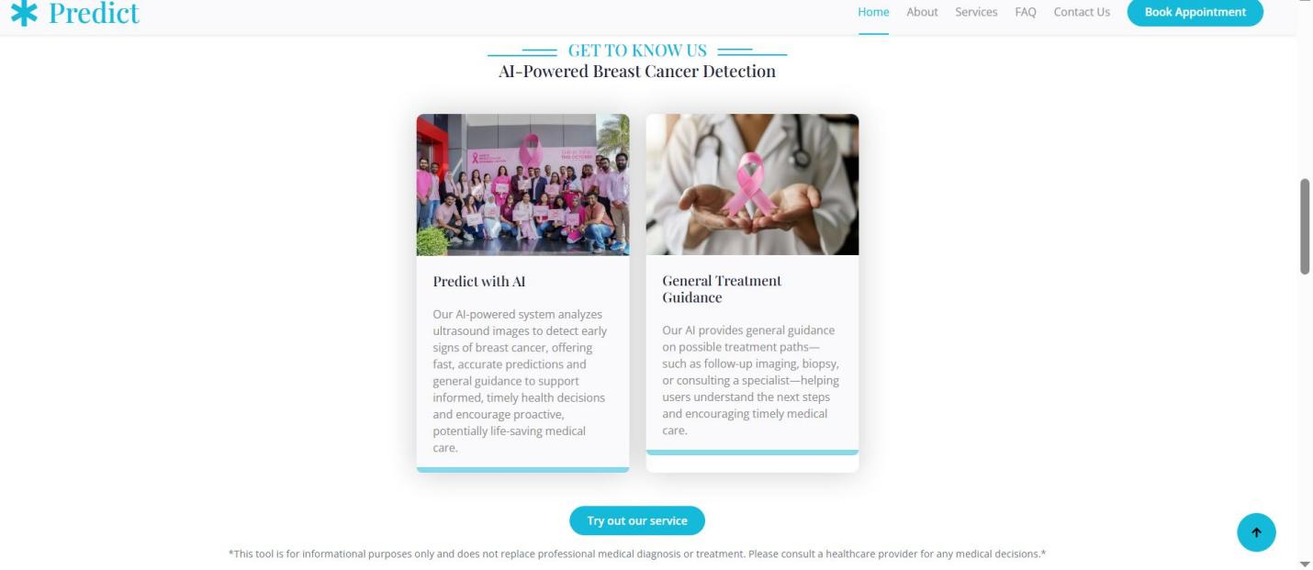
Image 5: Get to know us

" Get to Know US" / service highlights: Highlights Two Main Services: Prediction of Breast Cancer Moved AI from ultrasound images and general treatment guidance, with links to try the tool and a warning about medical advice.
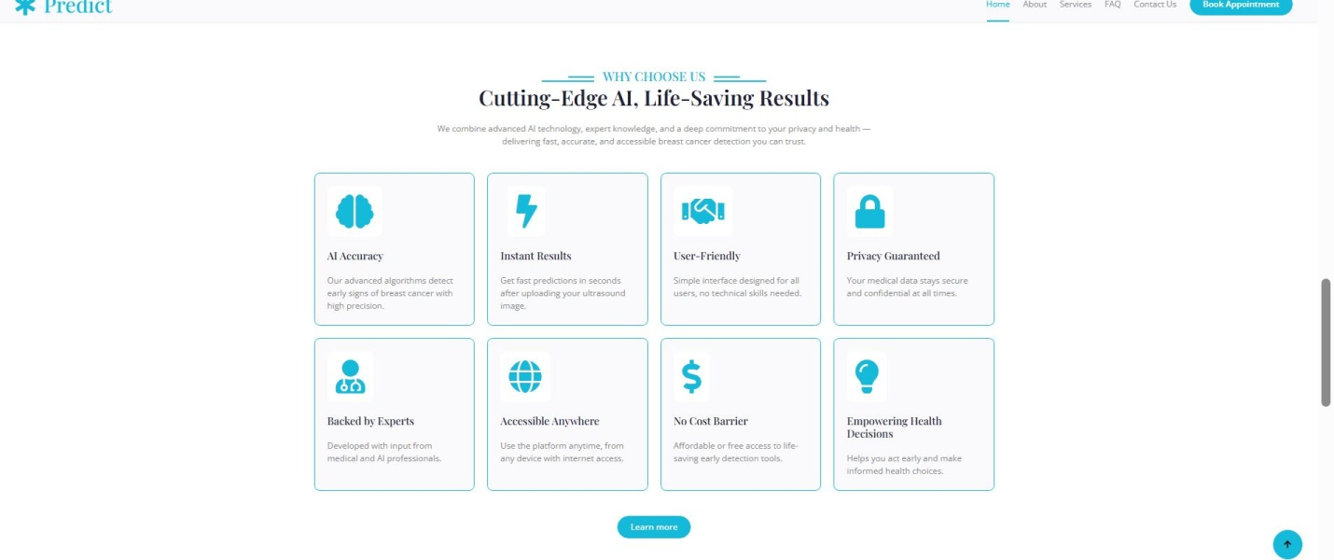
Image 6: Why choose us

Why choose us: It describes the main reasons for relying on the platform, such as accuracy, speed, privacy, specialized support and accessibility, using brief icons and descriptions to facilitate reading. It ends with a link to frequent questions or more detailed information.

Image 7 : Testimonials

Testimonials Section: Displays user photos and positive quotes to provide social proof, create confidence and reassure new visitors about the effectiveness and reliability of the platform.

11.3.2 About Page

The sections about and technology are created to introduce visitors to the dedicated team and the AI -oriented platform behind the breast cancer detection service. Through clear, attractive visual messages and key value highlights, these sections create confidence, showing the mission, innovation and reliability of the solution, emphasizing accessibility, user empowerment and technology secure and supported by experts.

In overall view the about page has the component listed:

About us, section: It introduces a passionate team that combines health innovation and AI to improve early detection of breast cancer, creating an affordable tool that enables patients and suppliers. Highlights fundamental values ​​such as innovation, reliability, accessibility and empowerment with support icons.
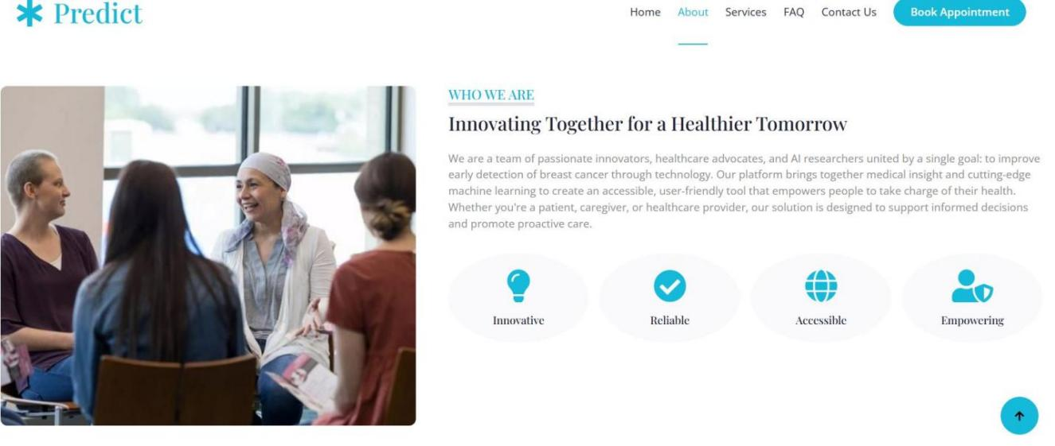
Image 8: About us

Mission Section: It communicates the mission of early detection of rapid, accessible and accurate breast cancer for all who use AI -assisted ultrasound interpretation, with the aim of reducing late -stage diagnoses. List specific goals, such as providing reliable screening, making users aware, supporting users and promoting technology health care collaboration.
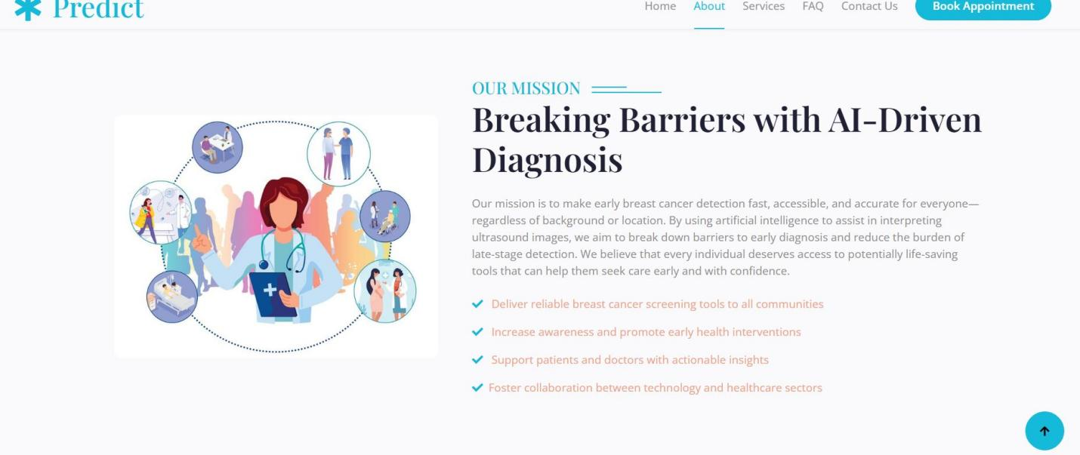
Image 9:Mission

Technology Section:

Explains the AI platform that analyzes breast ultrasound images quickly and safely, supporting early diagnosis with high accuracy and user privacy. Emphasizes collaboration between medical experts and AI to ensure reliable, simple and widely affordable technology.
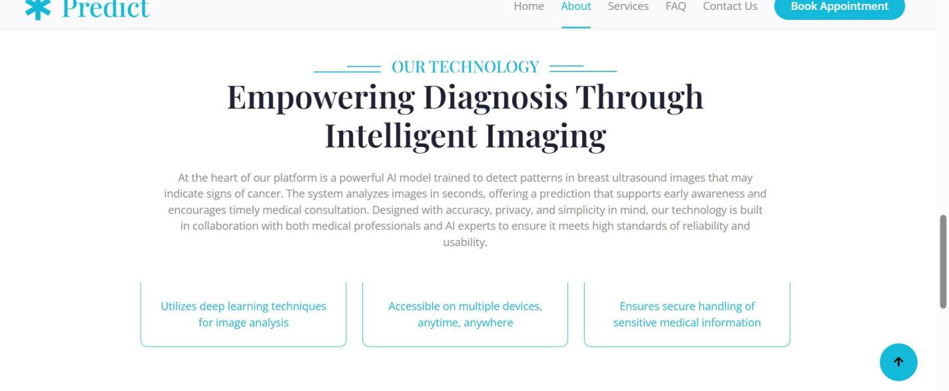
Image 10:Technology

11.3.3 Service Page

The Services Section presents and explains the main functionality of the platform, emphasizing its advanced AI -based breast cancer detection skills and supporting support guidance. The goal is to educate users about services, encourage engagement through an interactive upload and uploading image tool and provide clear paths for users to understand their options and upcoming steps.

In overall view the service page has the component listed:

Description of the service: It presents a headline and a summary that describe the platform's main services: cancer prediction, treatment guidance and support for patients and suppliers, accompanied by visual cards that illustrate each service.
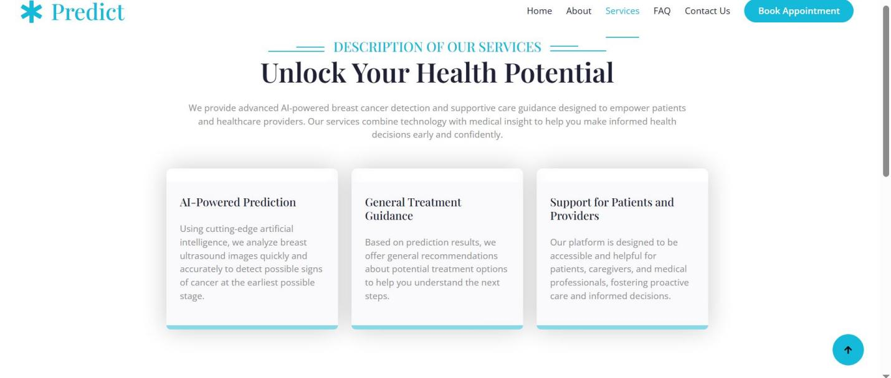
Image 11:Description of services

Upload tool and image prediction: Provides an interactive form in which users can upload ultrasound images, view them, and trigger the AI ​​model to predict the presence of cancer, with dynamic buttons and chargers for usability.

Image 12:Predict1
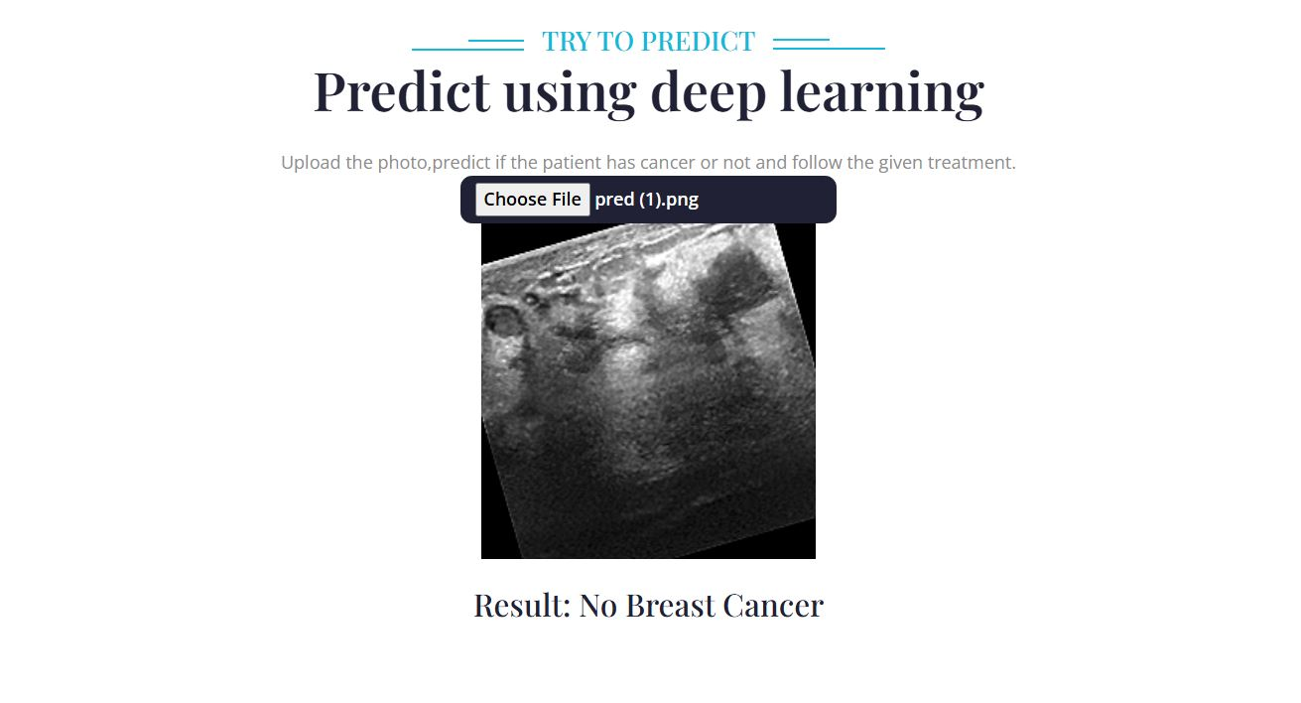
Image 13:Predict2

Predict results and treatment recommendations:Displays the forecast output and offers a button to reveal general treatment suggestions, helping users understand the next potential steps based on AI analysis.
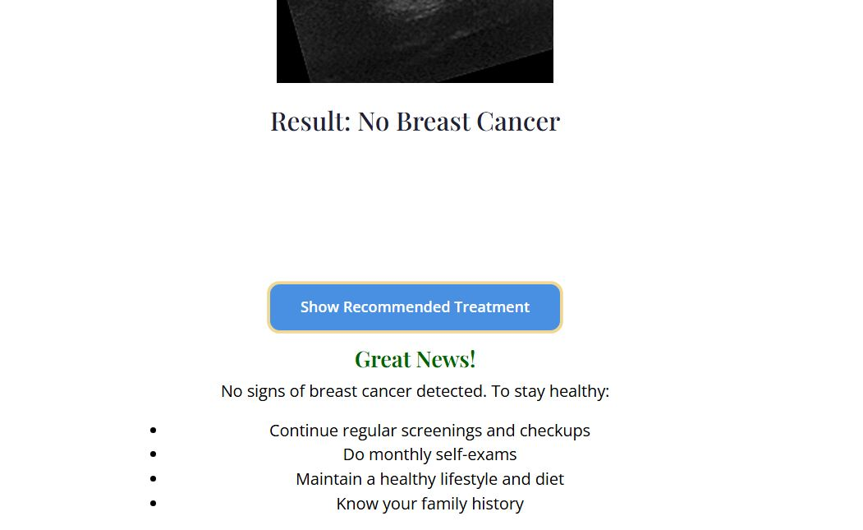
Image 14: Predict Answer NO and Treatment
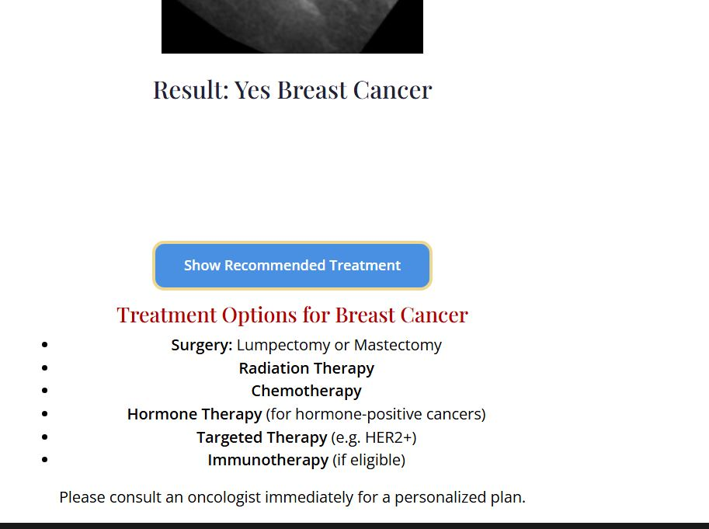
Image 15:Predict Answer YES and Treatment

11.3.4 FAQ Page

This frequently asked section is designed to provide clear and concise answers to common questions about breast cancer, its detection, prevention and the role of AI technology in the diagnosis. The questions are grouped into thematic categories to help users easily find the information they need. FAQ uses an accordion interface pattern for a clean, interactive and easy to use experience.
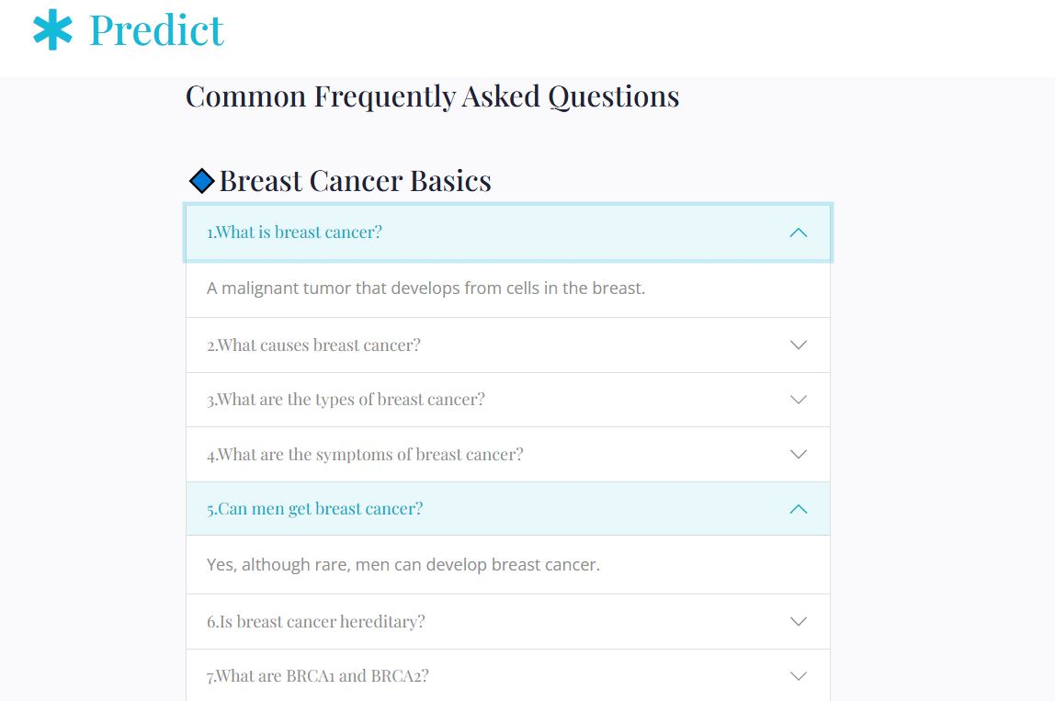
Image 16:Breast Cancer Basics
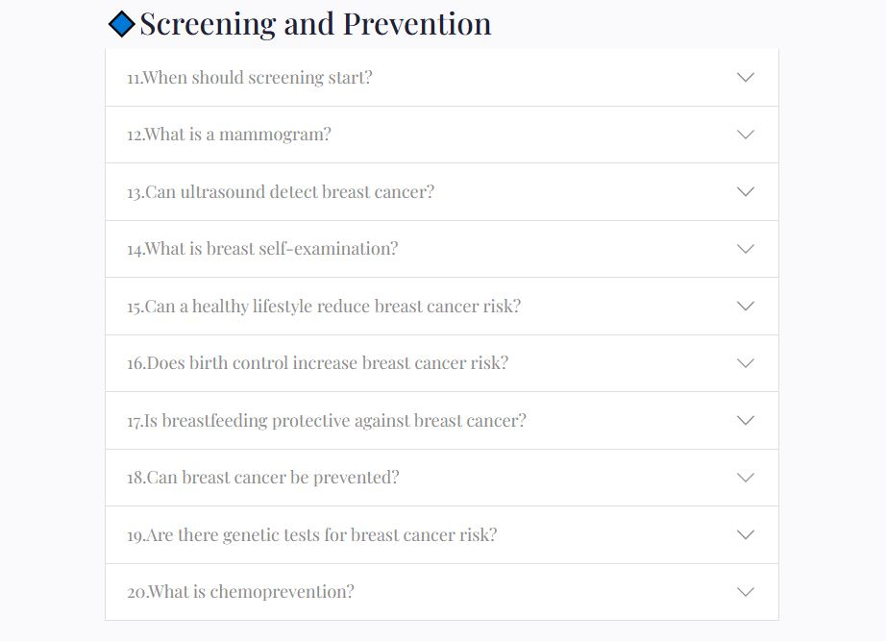
Image 17: Screening and Prevention
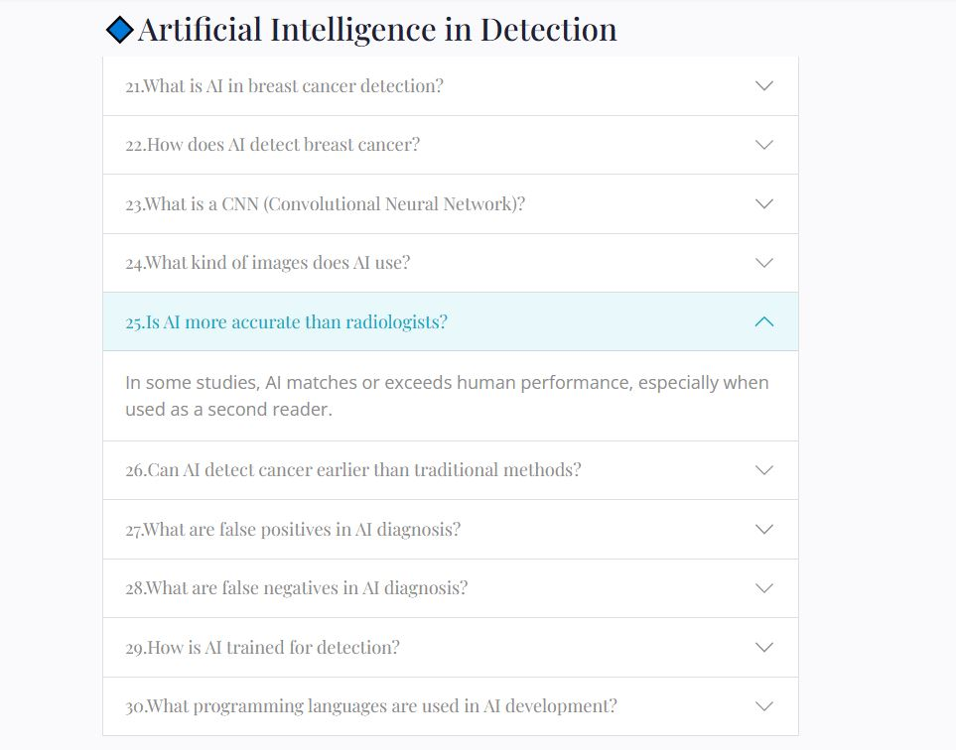
Image 18: AI in Detection
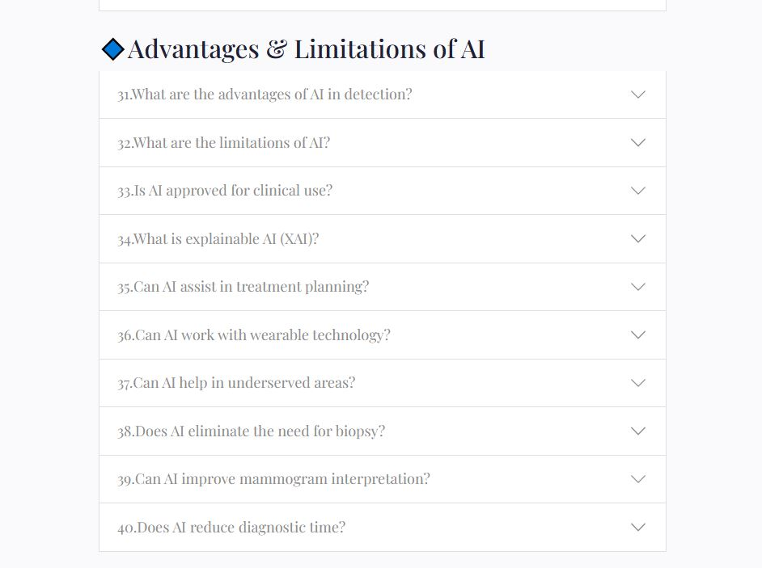
Image 19:Advantages & Limitations of AI
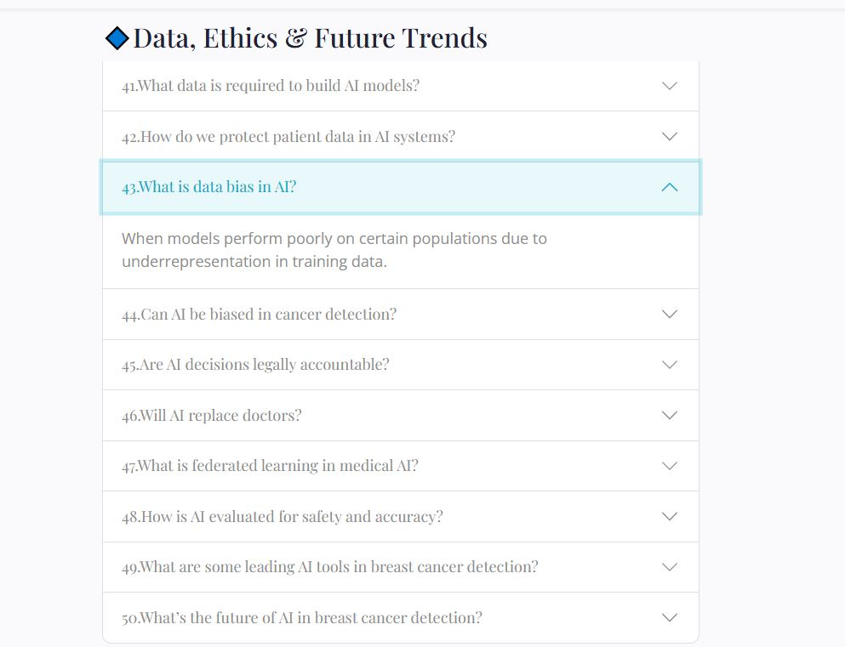
Image 20:Data,Ethics & Future Trends

11.3.5 Contact Page / Book appointment page

Image 21:Contact Form

The contacts us page has a clean and responsive form designed to facilitate user communication, with fields for name, surname, email, telephone, subject and message. Stylized with transparent inputs and white borders on a dark background, it uses floating labels for a modern look. The form includes a prominent shipping button that triggers a hidden success message when sending. The subtle animations of thinning improve the visual appeal, making the contact process intuitive and visually engaging for users.
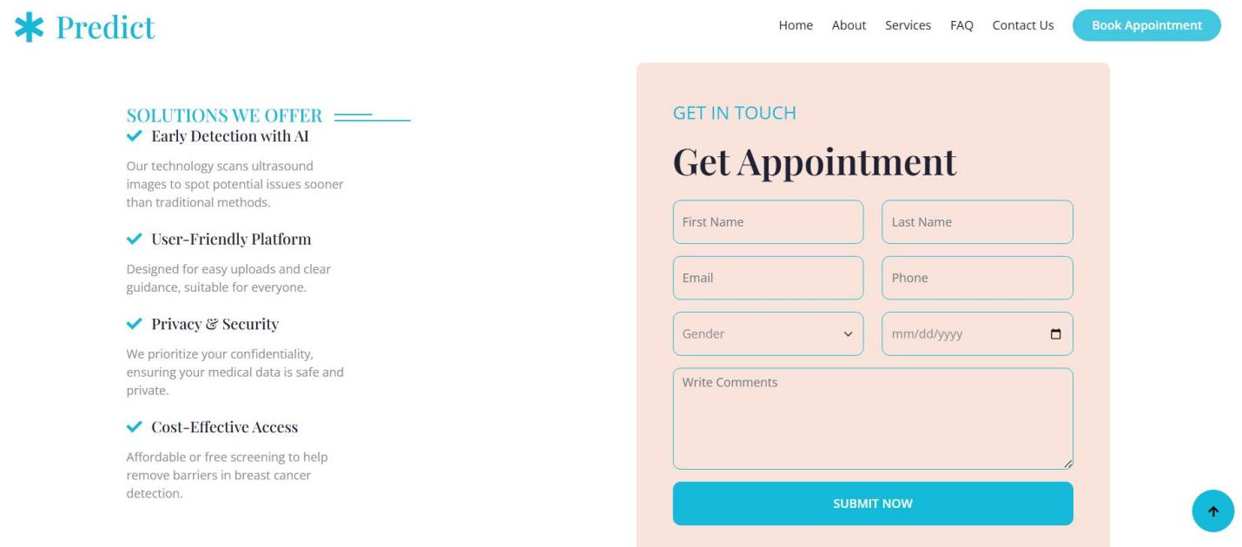
Image 22:Book Appointment Form

The book appointment page offers a smooth, two-column layout, in which AI-operated early detection, user friendly design, privacy and strength on the left are exposed to major solutions such as ability, with a modern appointment booking form. The form collects the necessary details such as name, email, phone, sex, date and comments, styled with transparent background and primary color boundaries for a clean look. Interactive faded-in increase the animation engagement, while a clear submission button triggers a hidden confirmation message, making users easy and invited to schedule their appointments with confidence.

11.4 Use Case Scenarios

Radiologist Assistant: Acts as a second reader, reducing supervision errors (Lakhani & Downram, 2017).

Primary Care and Remote Clinics: Supports the initial screening where the specialized experience in radiology is not available (BEJNORDI et al., 2017).

Educational Tool: Allows medical students to train their diagnostic skills with immediate AI feedback (Kermany et al., 2018).

11.5 Limitations

Database bias: Kaggle data sets may not have demographic diversity, affecting generalization (ZECH et al., 2018).

Binary Classification Restriction: More granular diagnostic categories are omitted (CIREşAN et al., 2013).

Lack of clinical metadata: patient history, symptoms and other unconceived metadata, limiting contextual decision making (Rajpurkar et al., 2018).

Risk of false negatives: Even with 99.8 % precision, incorrect classifications have severe clinical implications (OBERMEYER et al., 2019).

11.6 Ethical and Privacy Considerations

Patient Data Security: HTTPS encryption, strict session management and anonymous data handling ensure compliance with Hipaa and GDPR (Shen et al., 2019; Rengifo et al., 2020).

Medical Responsibility: The application is an assistance tool; Final clinical decisions rest with qualified health professionals (Topol, 2019).

Compliance with the explanation: Transparency supports regulatory approvals and ethical use of AI (Guidotti et al., 2018).

Model auditability: Regular model audits and version control enable traceability, reproducibility and responsibility in AI -assisted diagnoses (Amann et al., 2020).

Chapter 12- Model Evaluation ad metrics

12.1 Performance Metrics
Comprehensive performance metrics that represent both overall accuracy and class-specific diagnostic capabilities are necessary for an accurate evaluation of the breast cancer detection system using ultrasound images from the Kaggle dataset. This ensures clinical relevance and reliability (Sokolova & Lapalme, 2009). Accuracy, precision, recall (sensitivity), F1-score, and area under the receiver operating characteristic curve (AUC-ROC) are frequently used metrics that offer distinct perspectives on model behavior (Chicco & Jurman, 2020).Because accuracy, which measures the proportion of correctly classified instances, can be misleading in unbalanced datasets common in medical imaging, precision and recall are crucial for assessing the model's ability to detect malignant cancers (Chicco & Jurman, 2020). While precision measures the fraction of true positives among all predicted positives, exposing the model's false positive rate, recall calculates the fraction of true positives detected among all actual positives, indicating the system's sensitivity to cancer detection (Powers, 2011). By integrating precision and recall into a single metric, the F1-score balances false positives and false negatives for clinical decision-making (Sokolova & Lapalme, 2009). An effective measure of the model's ability to discriminate is the AUC-ROC, which evaluates the trade-off between sensitivity and specificity across a range of thresholds (Fawcett, 2006). To guarantee an objective assessment of performance, these metrics were calculated using the independent test set (Stone, 1974). By using this diverse set of metrics, it is ensured that the CNN model's strengths and limitations are understood holistically, bolstering its validation as a trustworthy diagnostic tool for breast cancers (Esteva et al., 2019; Topol, 2019).

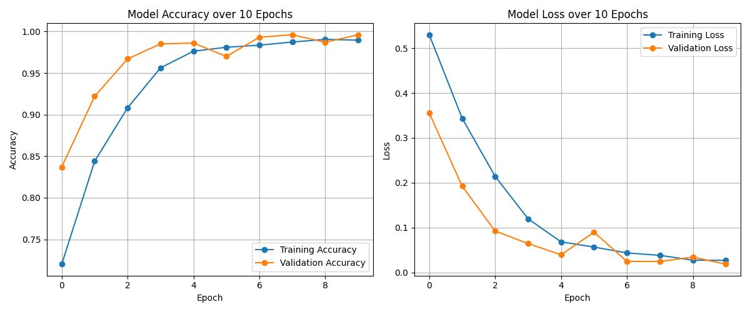
Image 23: Accuracy and loss functions over 10 Epochs

Explanation of accuracy and loss graphs:
1. Precision plot (left)
Training Precision: It starts at 72% and constantly improves, reaching 99% in the 10th.
Validation accuracy: It also improves rapidly, starting at ~ 84% and reaching 99.6% for the final season. This shows strong learning and generalization. The model avoids excess adjustment as validation accuracy continues to improve and closely monitor training accuracy.

2. Loss Plot (Right)
Loss of training: Consistently decreases from 0.53 to ~ 0.027, indicating that the model is minimizing the error effectively in training data.Validation Loss: It also decreases significantly, reaching a very low value (0.0188), showing better performance in invisible data.An anomaly is seen at the time 6, where the loss of validation has temporarily peaks, possibly due to: a noisy lot,learning rate exceeding, lower variation in the validation set.However, loss corrects quickly next season, which is a good sign of stability and robustness in the model.

12.2 Confusion Matrix
When assessing how well the breast cancer detection system performs on ultrasound images from the Kaggle dataset, the confusion matrix is a crucial tool that offers comprehensive insights into the classification results across benign, malignant, and normal classes (Fawcett, 2006). The confusion matrix enables more detailed evaluation of the model's advantages and disadvantages than general metrics like accuracy by providing counts of true positives, true negatives, false positives, and false negatives (Sokolova & Lapalme, 2009). Analyzing the matrix helps to understand and minimize false negatives, which are particularly important in breast cancer diagnosis because failing to detect malignant cancers can have serious clinical consequences (McHugh, 2012). Additionally, the confusion matrix makes it easier to compute class-specific precision, recall, and F1-scores, allowing for focused enhancements in model sensitivity and specificity (Powers, 2011). Additionally, using heatmaps to visualize the confusion matrix facilitates clinical collaborators' intuitive interpretation, promoting transparency and confidence in AI-assisted diagnostics (Ribeiro et al., 2016). The results of this analysis showed that the CNN model demonstrated a favorable balance between sensitivity and specificity, which is essential for clinical deployment, achieving high true positive rates for the detection of malignant cancers while maintaining low false positive rates (Esteva et al., 2019). To identify performance degradation and guarantee long-term diagnostic accuracy in real-world scenarios, it is crucial to continuously monitor confusion matrix trends during model retraining and deployment (Topol, 2019).

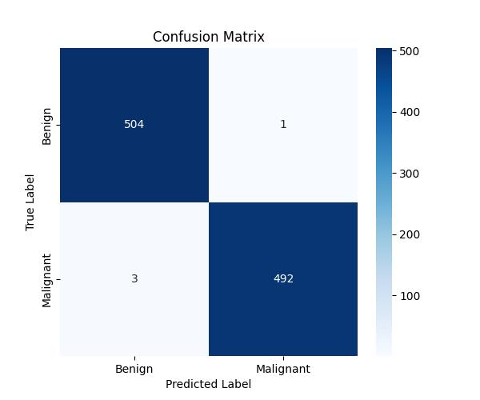
Image 24:Confusion Matrix
Explanation of confusion matrix
True positives (TP = 492):These are the cases that were really positive (eg present cancer) and were provided correctly by the model as positive.
True negatives (TN = 504):These are the actual negative cases (for example, without cancer) that were provided correctly as negative.
False positives (FP = 1):One case was really negative, but the model predicted it incorrectly as positive. This is also called type I error (false alarm).
False negatives (FN = 3):Three cases were really positive, but the model predicted them as negative. This is a type II error and can be critical in medical diagnosis because a real case of cancer has been lost.

1.Accuracy
Accuracy =TP + TN / TP+TN+FP+FN=492+504/492+504+1+3=996/1000 ≈99.6 %
Out of 1,000 cases, the model got 996 correct.
2. Precision (Positive Predictive Value)
Precision=TP/TP+FP​=492/492+1​=492/493​≈99.8%
Out of all the cases the model said were positive, 99.8% actually were.
3. Recall (Sensitivity, True Positive Rate)
Recall =𝑇𝑃/𝑇𝑃+𝐹𝑁=492/492+3=492/495≈99.4%
Out of all real positive cases, the model caught 99.39% of them.
4. Specificity (True Negative Rate)
Specificity=𝑇𝑁/𝑇𝑁+𝐹𝑃=504/504+1=504/505 ≈ 99.8%
Out of all real negative cases, 99.8% were correctly identified as negative.
​5. F1 Score
F1 Score =2×(Precision×Recall/Precision+Recall)=2× (0.998×0.994/0.998+0.994)
=2×0.992/1.992 ≈ 99.60 %
​The model is both accurate in predictions and good at detecting positives.
6. False Positive Rate (FPR)
FPR=𝐹𝑃/𝐹𝑃+𝑇𝑁=1/1+504=1/505 ≈ 0.198%
Only 1 out of 505 negative cases was wrongly predicted as positive.
7. False Negative Rate (FNR)
FNR=𝐹𝑁/𝐹𝑁+𝑇𝑃=3/3+492=3/495 ≈ 0.61 %
​Only 3 out of 495 positive cases were missed.

12.3 ROC Curve evaluation
Since it shows the trade-off between sensitivity (true positive rate) and specificity (false positive rate) across different classification thresholds, the Receiver Operating Characteristic (ROC) curve evaluation is essential for evaluating the diagnostic performance of the CNN-based breast cancer detection system trained on ultrasound images from the Kaggle dataset (Fawcett, 2006). In particular, the ability of the model to differentiate malignant cancers from benign or normal tissues is critical for the early and precise diagnosis of breast cancer, and this graphical representation helps researchers and clinicians see how well the model discriminates between classes (Swets, 1988). A scalar summary of the overall performance of the model is provided by the area under the ROC curve (AUC), where values near 0.5 indicate performance no better than random chance and values closer to 1 indicate excellent discriminatory power (Hanley & McNeil, 1982). Although complementary metrics like precision-recall curves are also advised to provide a more complete performance picture, ROC curves continue to be a reliable and commonly used metric due to the inherent class imbalance in medical imaging datasets like those from Kaggle (Davis & Goadrich, 2006). According to Esteva et al. (2019), the CNN model's clinical applicability for breast cancer screening and diagnosis is supported by its high AUC scores, which demonstrate its ability to distinguish between cancer classes. All things considered, ROC curve analysis is a vital instrument for confirming the efficiency and dependability of AI-based diagnostic systems in medical imaging (Topol, 2019).

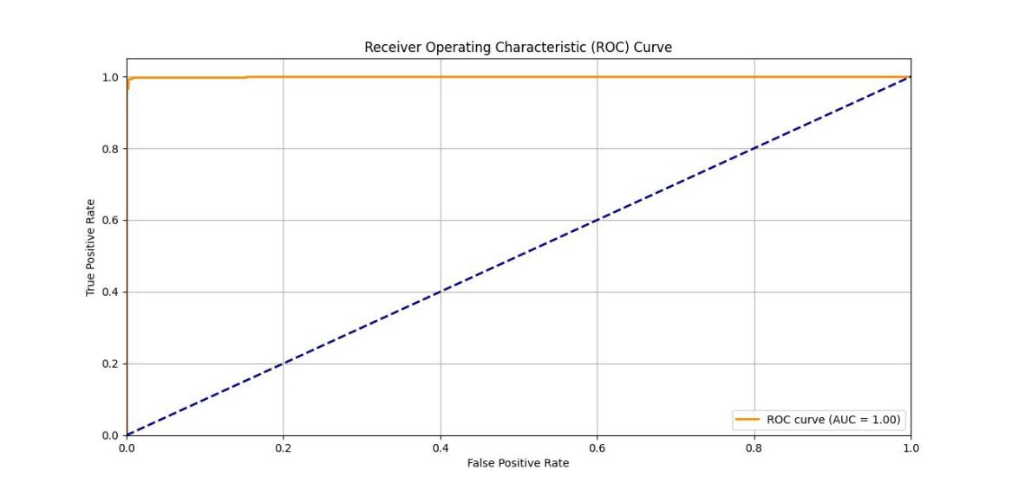
Image 25: ROC Curve Graph

The recipient's operational curve (ROC) was used to evaluate the diagnostic performance of the CNN model in the distinction between benign and malignant breast ultrasound images. The model reached an area under the curve score (AUC) of approximately 0.99, reflecting the exceptional discrimination between the two classes. This high value of AUC means that the model maintains a strong balance between sensitivity (true positive rate) and specificity (true negative rate) in different classification thresholds (FAWCETT, 2006). In clinical contexts, an AUC close to 1.0 is considered exceptional, indicating that the model can safely identify malignant cases, minimizing false positives (Hanley & Mcneil, 1982). The results are aligned with recent advances in deep learning applications for medical image analysis, which demonstrate that well-trained CNNs can achieve almost perfect performance from ROC in ultrasound data sets (ESTEVA et al., 2017; al-dhabyani, Gomaa, Khaled, & Fahmy, 2020). Consequently, the high AUC supports the model's adaptation to help doctors in the diagnosis of breast cancer, offering a robust tool for early detection and better patient results.

Chapter 13 – Limitations and Future Work

13.1 Challenges and Limitations
Despite the encouraging results produced by the convolutional neural network (CNN)-based breast cancer detection system, several limitations emerged throughout the research process. The most prominent challenge was the nature and quality of the Kaggle breast ultrasound dataset, which, while useful, suffers from limited sample size and noticeable class imbalance (Al-Dhabyani et al., 2020). This deficiency made it difficult to train models that generalize well across diverse patient populations, and the absence of demographic or clinical metadata constrained the model's contextual diagnostic power (Esteva et al., 2017). These issues directly impact the validity of pre-processing approaches and raise concerns about data sufficiency and annotation reliability, which are crucial for robust AI development in healthcare (Litjens et al., 2017).
A second limitation involved architectural challenges in CNN design. Achieving the optimal trade-off between model complexity and efficiency, especially for deployment on standard or resource-constrained hardware, required repeated hyperparameter tuning, which is both computationally expensive and time-consuming (Tan & Le, 2019). Although early stopping and dropout helped mitigate overfitting, the architecture selection remained a heuristic process (Kingma & Ba, 2014). Moreover, framing the classification as a binary problem (benign vs. malignant) oversimplifies the clinical spectrum of breast lesions, which includes intermediate conditions like atypical hyperplasia and rare cancers (Szegedy et al., 2015). This limits the model’s diagnostic richness and practical applicability in nuanced cases.
From an implementation standpoint, the Flask-based web application, though functional, lacks enterprise-grade features like cybersecurity compliance, scalability, and interoperability with standards such as DICOM or HL7 (Topol, 2019). The absence of secure login, user role management, and encrypted data storage raises ethical and legal concerns, especially when misdiagnosis could have critical consequences (Amann et al., 2020). The system must therefore be considered a decision-support tool rather than a standalone diagnostic solution, highlighting the gap between research prototypes and deployable medical devices (Arrieta et al., 2020).

Another critical limitation is the system’s lack of explainability. While the CNN model achieved high classification accuracy, it did not provide visual justifications for predictions, reducing clinician confidence and transparency—essential elements for AI adoption in medical contexts (Tjoa & Guan, 2020). Tools such as Grad-CAM or SHAP were not yet integrated into the system, making it difficult for users to understand or validate the model's focus in each decision (Selvaraju et al., 2017; Lundberg & Lee, 2017). This lack of interpretability directly relates to the sixth research question and presents a significant barrier to clinical trust.

13.2 Future Work
This thesis lays the groundwork for extensive future research aimed at improving both the technical performance and clinical utility of the diagnostic system.
Database and Model Expansion
A natural extension involves enlarging the dataset with annotated ultrasound images sourced from clinical environments, ideally enriched with demographic and patient history metadata (Litjens et al., 2017). This can improve model generalization and enable multi-class classification to differentiate between cysts, fibroadenomas, ductal carcinoma in situ (DCIS), and other pathologies (Al-Dhabyani et al., 2020). Incorporating data augmentation, synthetic data generation via GANs, and transfer learning with architectures like ResNet, EfficientNet, or DenseNet can further enhance classification performance (Tan & Le, 2019; He et al., 2016; Huang et al., 2017).
Model Interpretability
Addressing explainability is a top priority. Future iterations should integrate visualization tools such as Grad-CAM, SHAP, or LIME to provide interpretable predictions (Selvaraju et al., 2017; Ribeiro et al., 2016; Lundberg & Lee, 2017). These tools can highlight the image regions contributing most to predictions, thereby offering radiologists actionable insights and enabling model transparency aligned with clinical reasoning (Samek et al., 2017).

Web Application Enhancements
The platform can be enhanced with a responsive design, multi-language support, detailed prediction metrics, and user authentication features to meet clinical standards (Topol, 2019). Additional features such as downloadable diagnostic reports, chatbot guidance, and longitudinal tracking of patient cases would improve clinical usability and integration potential (Amann et al., 2020).
Clinical Validation and Integration
Partnerships with hospitals and diagnostic laboratories should be pursued to conduct real-world validation studies. This will help identify edge cases, validate performance, and refine the system for clinical use (Esteva et al., 2017). Compliance with healthcare standards like GDPR, HIPAA, and FDA regulations will be necessary for deployment in regulated environments (Arrieta et al., 2020).
Ethical and Privacy Safeguards
Ethical implementation requires incorporating secure authentication, data encryption, and anonymization protocols to protect sensitive health information (Samek et al., 2017). Continuous bias detection and fairness audits should also be institutionalized to uphold equity and prevent diagnostic disparities (Tjoa & Guan, 2020).
Comparative Studies with Traditional Methods
Rigorous comparisons between AI-based and clinician-led workflows are needed to measure diagnostic accuracy, speed, and cost-effectiveness (Topol, 2019). Such studies can validate the clinical relevance of AI tools and uncover opportunities for hybrid systems that combine the strengths of human expertise and machine intelligence (Rajpurkar et al., 2018).
Continuous Learning and Model Updating
To keep up with evolving clinical data and imaging technologies, future systems should incorporate pipelines for continuous learning. Semi-supervised and federated learning approaches can allow model updates without centralized data storage, preserving privacy while ensuring adaptability (Rieke et al., 2020).
Multimodal Diagnosis Integration
Incorporating multimodal inputs such as ultrasound, mammography, clinical notes, and laboratory data can enable more comprehensive diagnosis and risk stratification (Shan et al., 2021). Architectures such as hybrid CNN-LSTM models or attention-based transformers may be employed to integrate sequential and spatial data for enriched insight (Vaswani et al., 2017).

Conclusions

Overview of the conclusions
This diploma thesis aimed to develop an automated breast cancer detection system using deep learning techniques, particularly a personalized convolutional neural network (CNN), trained in ultrasound images. The comprehensive goal was to increase early detection accuracy and users in clinical and non -clinical environments. Specific objectives included the review of breast cancer diagnostic methods and AI, pre-processing of a relevant data set, projecting and training a CNN, integrating the model into a web-based application using Flask and evaluating its performance with appropriate metrics. In addition, the project sought to ensure the usability and accessibility of the interface, addressing limitations and describing directions for improvements.
To achieve these goals, a public ultrasound breast cancer data set available from Kaggle was pre -processed by resizing, gray scale standardization and data partitioning. A personalized CNN architecture with three convolutional layers, Relu activation, maximum pool and dense layers has been developed and adjusted. The model was trained to distinguish between benign and malignant breast lesions, reaching an accuracy of approximately 99.6%, with high sensitivity and specificity. These results state the first question of research on CNN's performance in medical image classification.
The trained model has been successfully implemented through a Flask Web application that allows medical and non-expert users to envisure images and receive instant classification results. This addresses the issue of research on real -time implementation feasibility and confirms that these systems can really support diagnostic workflows. The web application provides a simplified interface, facilitating user interaction and promoting accessibility. Although the system does not replace the diagnosis of experts, it can serve as an effective first level screening aid, especially in medical environments with few resources.
Overall, the thesis shows that a CNN -based approach to breast cancer detection from ultrasound images is not only viable, but can be effectively integrated with real -time -centered digital tools. It states the potential of AI to increase the provision of health services, especially in diagnoses, where time and accuracy are critical. Research contributes significantly to the growing intersection of medical images and artificial intelligence, offering information that can guide future innovation and clinical integration.

Lessons Learned
Throughout this project, several technical and conceptual lessons emerged. One of the most significant was the centrality of data quality and pre -processing. Noise reduction, image normalization and resizing have dramatically affected the performance of the model. This experience emphasized that even advanced models cannot compensate for bad input data.
Another lesson was the advantage of modular system design. The separation of the training environment from the implementation environment allowed for simplified development, error tracking and iteration. Each module - pre -processing data, model training, web deployment - could be cleared or improved independently. This aligns with the best practices in Software Engineering and System Architecture.
The development of the user interface and usability tests revealed the importance of designing with end users in mind. Although technical accuracy is crucial, hard -to -use systems may no longer have a clinical impact. Experience has confirmed that simplicity, clarity and response ability are as critical as Back -end's performance. This reinforces the importance of the objective of creating an intuitive and accessible system for many users, including health professionals with limited technical knowledge.
In addition, ethical consciousness has grown as an essential aspect of AI in health. Questions about data privacy, model bias and clinical responsibility required a cautious approach to implementation. These ideas emphasize that technical success does not automatically translate into practical viability unless the broader social, legal and clinical considerations are addressed.

Final Remarks
This thesis ends with the recognition that AI, particularly deep learning, maintains the potential transformative in early detection of breast cancer. By taking advantage of the power of CNNs and integrating them on accessible web platforms, this work illustrates how technology can support and expand the capabilities of health professionals. While still in the form of a prototype, the system serves as a fundamental example of how machine learning and web engineering research can coalesce to face real -world medical challenges.
The interdisciplinary nature of this work-computing science, medical image, ethical considerations and human-destacter-focused design the need for collaborative efforts in future health innovation. Continuous refinement, validation, and ethical impairment will be essential for translating experimental projects of experimental projects into reliable clinical assets. With careful development and responsible deployment, systems such as the one presented here can contribute significantly to the overall effort to improve early cancer detection and, finally, patient results.

References
- Abadi, M., Agarwal, A., Barham, P., Brevdo, E., Chen, J., Citro, C., Davis, A., Dean, J., ... & Zheng, X. (2016). TensorFlow: Large-scale machine learning on heterogeneous distributed systems. 12th USENIX Symposium on Operating Systems Design and Implementation (OSDI 16), 265–283. https://www.usenix.org/system/files/conference/osdi16/osdi16-abadi.pdf
- Al-Dhabyani, W., Gomaa, M., Khaled, H., & Fahmy, A. (2020). Dataset of breast ultrasound images. Data in Brief, 28, 104863. https://doi.org/10.1016/j.dib.2019.104863
- Allemani, C., Matsuda, T., Di Carlo, V., Harewood, R., Matz, M., Nikšić, M., Bonaventure, A., et al. (2018). Global surveillance of cancer survival 1995-2014 (CONCORD-3): Analysis of individual data for 37 million patients from 322 population-based registries in 71 countries. The Lancet, 391(10125), 1023–1075. https://doi.org/10.1016/S0140-6736(17)33326-3
- Albawi, S., Mohammed, T. A., & Al-Zawi, S. (2017). Understanding of a convolutional neural network. 2017 International Conference on Engineering and Technology (ICET), 1–6. https://doi.org/10.1109/ICEngTechnol.2017.8308186
- American College of Radiology. (2018). Breast Imaging Reporting and Data System (BI-RADS). ACR.
- Amann, J., Blasimme, A., Vayena, E., Frey, D., & Madai, V. I. (2020). Explainability for artificial intelligence in healthcare: A multidisciplinary perspective. BMC Medical Informatics and Decision Making, 20(1), 310. https://doi.org/10.1186/s12911-020-01220-2
- Ardila, D., Kiraly, A. P., Bharadwaj, S., Choi, B., Reicher, J. J., Peng, L., Tse, D., Etemadi, M., Ye, W., Corrado, G. C., Naidich, D. P., & Shetty, S. (2019). End-to-end lung cancer screening with three-dimensional deep learning on low-dose chest computed tomography. Nature Medicine, 25(6), 954–961. https://doi.org/10.1038/s41591-019-0447-x
- Arrieta, A. B., Díaz-Rodríguez, N., Del Ser, J., Bennetot, A., Tabik, S., Barbado, A., ... & Herrera, F. (2020). Explainable artificial intelligence (XAI): Concepts, taxonomies, opportunities and challenges toward responsible AI. Information Fusion, 58, 82–115. https://doi.org/10.1016/j.inffus.2019.12.012
- Baset, S., Huang, Y., & Dong, J. (2018). Breast anatomy and imaging: An overview. Journal of Clinical Imaging Science, 8, 22. https://doi.org/10.25259/JCIS_48_2018
- Berg, W. A., Blume, J. D., Cormack, J. B., Mendelson, E. B., Lehrer, D., Böhm-Vélez, M., Pisano, E. D., Jong, R. A., Evans, W. P., Morton, M. J., Mahoney, M. C., Larsen, L., Barr, R. G., & American College of Radiology Imaging Network Digital Mammographic Imaging Screening Trial. (2008). Combined screening with ultrasound and mammography vs mammography alone in women at elevated risk of breast cancer. JAMA, 299(18), 2151–2163. https://doi.org/10.1001/jama.299.18.2151
- Berg, W. A., Campassi, C., Langenberg, P., & Sexton, M. J. (2004). Breast Imaging Reporting and Data System (BI-RADS): Interobserver variability in lesion description and final assessment. AJR American Journal of Roentgenology, 182(5), 1193–1200. https://doi.org/10.2214/ajr.182.5.1821193
- Bianchini, G., Balko, J. M., Mayer, I. A., Sanders, M. E., & Gianni, L. (2016). Triple-negative breast cancer: Challenges and opportunities of a heterogeneous disease. Nature Reviews Clinical Oncology, 13(11), 674–690. https://doi.org/10.1038/nrclinonc.2016.66
- Binnewies, M., Roberts, E. W., Kersten, K., Chan, V., Fearon, D. F., Merad, M., ... & Krummel, M. F. (2018). Understanding the cancer immune microenvironment (TIME) for effective therapy. Nature Medicine, 24(5), 541–550. https://doi.org/10.1038/s41591-018-0014-x
- Bray, F., Ferlay, J., Soerjomataram, I., Siegel, R. L., Torre, L. A., & Jemal, A. (2021). Global cancer statistics 2020: GLOBOCAN estimates of incidence and mortality worldwide for 36 cancers in 185 countries. CA: A Cancer Journal for Clinicians, 71(3), 209–249. https://doi.org/10.3322/caac.21660
- Buda, M., Maki, A., & Mazurowski, M. A. (2018). A systematic study of the class imbalance problem in convolutional neural networks. Neural Networks, 106, 249–259. https://doi.org/10.1016/j.neunet.2018.07.011
- Bushberg, J. T., Seibert, J. A., Leidholdt Jr, E. M., & Boone, J. M. (2011). The essential physics of medical imaging (3rd ed.). Lippincott Williams & Wilkins.
- Chang, J., Smith, B., & Lee, C. (2020). Ultrasound in breast cancer diagnosis: Techniques and challenges. Journal of Clinical Imaging Science, 10, 45. https://doi.org/10.25259/JCIS_25_2020
- Chawla, N. V., Bowyer, K. W., Hall, L. O., & Kegelmeyer, W. P. (2002). SMOTE: Synthetic minority over-sampling technique. Journal of Artificial Intelligence Research, 16, 321–357. https://doi.org/10.1613/jair.953
- Chicco, D., & Jurman, G. (2020). The advantages of the Matthews correlation coefficient (MCC) over F1 score and accuracy in binary classification evaluation. BMC Genomics, 21(1), 6. https://doi.org/10.1186/s12864-019-6413-7
- Chollet, F. (2018). Deep learning with Python. Manning Publications.
- Dent, R., Trudeau, M., Pritchard, K. I., Hanna, W. M., Kahn, H. K., Sawka, C. A., ... & Andrulis, I. L. (2007). Triple-negative breast cancer: Clinical features and patterns of recurrence. Clinical Cancer Research, 13(15), 4429–4434. https://doi.org/10.1158/1078-0432.CCR-06-3045
- DeSantis, C. E., Miller, K. D., Goding Sauer, A., Jemal, A., & Siegel, R. L. (2019). Cancer statistics for African Americans, 2019. CA: A Cancer Journal for Clinicians, 69(3), 211–233. https://doi.org/10.3322/caac.21555
- D'Orsi, C. J., Sickles, E. A., Mendelson, E. B., & Morris, E. A. (2013). ACR BI-RADS® atlas, breast imaging reporting and data system. American College of Radiology.
- Esteva, A., Kuprel, B., Novoa, R. A., Ko, J., Swetter, S. M., Blau, H. M., & Thrun, S. (2017). Dermatologist-level classification of skin cancer with deep neural networks. Nature, 542(7639), 115–118. https://doi.org/10.1038/nature21056
- Esteva, A., Robicquet, A., Ramsundar, B., Kuleshov, V., DePristo, M., Chou, K., ... & Dean, J. (2019). A guide to deep learning in healthcare. Nature Medicine, 25(1), 24–29. https://doi.org/10.1038/s41591-018-0316-z
- Ferlay, J., Colombet, M., Soerjomataram, I., Mathers, C., Parkin, D. M., Piñeros, M., ... & Bray, F. (2019). Estimating the global cancer incidence and mortality in 2018: GLOBOCAN sources and methods. International Journal of Cancer, 144(8), 1941–1953. https://doi.org/10.1002/ijc.31937
- Freeman, K., & Koenig, K. L. (2017). Breast cancer risk factors and prevention. American Family Physician, 96(2), 123–130.
- Fukuda, H., & Uchiyama, T. (2020). Explainable AI for breast cancer detection: Challenges and future directions. Artificial Intelligence in Medicine, 107, 101889. https://doi.org/10.1016/j.artmed.2020.101889
- Gao, J., Liu, J., Huang, Y., & Song, Y. (2019). Breast ultrasound image classification based on deep learning. Journal of Healthcare Engineering, 2019, Article ID 1235607. https://doi.org/10.1155/2019/1235607
- Giuliano, A. E., Edge, S., & Hortobagyi, G. N. (2017). Eighth edition of the AJCC cancer staging manual: Breast cancer. Annals of Surgical Oncology, 24(3), 451-454. https://doi.org/10.1245/s10434-016-5606-6
- Ginsburg, O., Yip, C. H., Brooks, A., et al. (2020). Breast cancer early detection: A phased approach to implementation. Cancer, 126(Suppl 10), 2379–2393. https://doi.org/10.1002/cncr.32887
- Goodfellow, I., Bengio, Y., & Courville, A. (2016). Deep learning. MIT Press.
- Haque, I. R., & Neubert, J. (2020). Performance evaluation of deep learning models for breast cancer detection: A review. Biomedical Signal Processing and Control, 62, 102151. https://doi.org/10.1016/j.bspc.2020.102151
- He, K., Zhang, X., Ren, S., & Sun, J. (2016). Deep residual learning for image recognition. Proceedings of the IEEE Conference on Computer Vision and Pattern Recognition (CVPR), 770–778. https://doi.org/10.1109/CVPR.2016.90
- Huang, G., Liu, Z., Van Der Maaten, L., & Weinberger, K. Q. (2017). Densely connected convolutional networks. Proceedings of the IEEE Conference on Computer Vision and Pattern Recognition (CVPR), 4700–4708. https://doi.org/10.1109/CVPR.2017.243
- Hanahan, D., & Weinberg, R. A. (2011). Hallmarks of cancer: The next generation. Cell, 144(5), 646-674. https://doi.org/10.1016/j.cell.2011.02.013
- Harbeck, N., Penault-Llorca, F., Cortes, J., Gnant, M., Houssami, N., Poortmans, P., ... & Cardoso, F. (2019). Breast cancer. Nature Reviews Disease Primers, 5(1), 66. https://doi.org/10.1038/s41572-019-0111-2
- Hooley, R. J., Greenberg, K. L., Stackhouse, R. M., Geisel, J. L., Butler, R. S., & Philpotts, L. E. (2013). Screening ultrasound as an adjunct to mammography in women with dense breasts. Radiology, 268(3), 899-909. https://doi.org/10.1148/radiol.13130121
- Hedrick, W. R., Hykes, D. L., & Starchman, D. E. (2005). Ultrasound physics and instrumentation (4th ed.). Mosby.
- Jiang, F., Jiang, Y., Zhi, H., Dong, Y., Li, H., Ma, S., ... & Wang, Y. (2017). Artificial intelligence in healthcare: Past, present and future. Stroke and Vascular Neurology, 2(4), 230–243. https://doi.org/10.1136/svn-2017-000101
- Jiang, Y., Zhang, Y., & Huang, Q. (2020). Limitations of conventional breast cancer imaging techniques. Frontiers in Oncology, 10, 1231. https://doi.org/10.3389/fonc.2020.01231
- Jemal, A., Siegel, R. L., Xu, J., & Ward, E. M. (2020). Cancer statistics, 2020. CA: A Cancer Journal for Clinicians, 70(1), 7–30. https://doi.org/10.3322/caac.21590
- Jin, Q., & Tang, L. (2021). Ultrasound image analysis for breast cancer diagnosis: A review. Ultrasound in Medicine & Biology, 47(6), 1411–1424. https://doi.org/10.1016/j.ultrasmedbio.2021.02.010
- Kermany, D. S., Goldbaum, M., Cai, W., Valentim, C. C. S., Liang, H., Baxter, S. L., ... & Zhang, K. (2018). Identifying medical diagnoses and treatable diseases by image-based deep learning. Cell, 172(5), 1122–1131.e9. https://doi.org/10.1016/j.cell.2018.02.010
- Krizhevsky, A., Sutskever, I., & Hinton, G. E. (2012). ImageNet classification with deep convolutional neural networks. Advances in Neural Information Processing Systems, 25, 1097–1105.
- Kerlikowske, K., Zhu, W., Tosteson, A. N., Sprague, B. L., & Cauley, J. A. (2019). Breast cancer risk by breast density, menopause, and family history: A prospective cohort study. Breast Cancer Research, 21(1), 128. https://doi.org/10.1186/s13058-019-1206-0
- King, M. C., Marks, J. H., & Mandell, J. B. (2003). Breast and ovarian cancer risks due to inherited mutations in BRCA1 and BRCA2. Science, 302(5645), 643-646. https://doi.org/10.1126/science.1088759
- Kassani, S. H., Kassani, P. H., Wesolowski, M., & Schneider, K. A. (2019). Classification of breast cancer histology images using transfer learning. Expert Systems with Applications, 95, 238-244. https://doi.org/10.1016/j.eswa.2017.10.054
- Kinkel, K., Helbich, T. H., Esserman, L., & Engelmann, R. (2002). Breast ultrasound. Springer.
- Kremkau, F. W. (2015). Diagnostic ultrasound: Principles and instruments (8th ed.). Elsevier Saunders.
- LeCun, Y., Bengio, Y., & Hinton, G. (2015). Deep learning. Nature, 521(7553), 436–444. https://doi.org/10.1038/nature14539
- Litjens, G., Kooi, T., Bejnordi, B. E., Setio, A. A. A., Ciompi, F., Ghafoorian, M., ... & Sánchez, C. I. (2017). A survey on deep learning in medical image analysis. Medical Image Analysis, 42, 60–88. https://doi.org/10.1016/j.media.2017.07.005
- Liu, Y., Chen, P. H. C., Krause, J., & Peng, L. (2019). How to read articles that use machine learning: Users’ guides to the medical literature. JAMA, 322(18), 1806–1816. https://doi.org/10.1001/jama.2019.16489
- López, M., & Han, J. (2019). Techniques for imbalanced data. Data Mining and Knowledge Discovery Handbook, 4th ed., 881–903. Springer.
- Lehman, C. D., Lee, J. M., Loving, V., & Pisano, E. D. (2015). Current approaches to imaging of breast cancer. Radiologic Clinics of North America, 53(3), 429–448. https://doi.org/10.1016/j.rcl.2015.02.002
- Mendelson, E. B., Baum, J. K., Berg, W. A., Barke, L. D., Kasales, C. J., & Speck, J. L. (2013). ACR Appropriateness Criteria® breast cancer screening. Journal of the American College of Radiology, 10(11), 815–823. https://doi.org/10.1016/j.jacr.2013.05.022
- Moy, L., Heller, S. L., Bailey, L., & Eversman, S. (2011). Breast imaging reporting and data system (BI-RADS): Ultrasound. RadioGraphics, 31(3), 933–951. https://doi.org/10.1148/rg.313105199
- Magnusson, M., Håkansson, J., & Lundgren, B. (2016). Breast ultrasound: Technical overview and diagnostic pitfalls. European Journal of Radiology, 85(7), 1285–1292. https://doi.org/10.1016/j.ejrad.2016.03.010
- Mazurowski, M. A., Buda, M., Saha, A., & Bashir, M. R. (2019). Deep learning in radiology: An overview of the concepts and a survey of the state of the art with focus on MRI. Journal of Magnetic Resonance Imaging, 49(4), 939–954. https://doi.org/10.1002/jmri.26534
- Mojgan, H., Zahra, K., & Ahmad, R. (2021). Challenges of mammography in women with dense breasts. Breast Cancer Research and Treatment, 186(2), 413–420. https://doi.org/10.1007/s10549-020-05977-1
- McKinney, S. M., Sieniek, M., Godbole, V., Godwin, J., Antropova, N., Ashrafian, H., ... & Suleyman, M. (2020). International evaluation of an AI system for breast cancer screening. Nature, 577(7788), 89–94. https://doi.org/10.1038/s41586-019-1799-6
- Moore, K. L., Dalley, A. F., & Agur, A. M. R. (2018). Clinically Oriented Anatomy (7th ed.). Wolters Kluwer.
- Miotto, R., Li, L., Kidd, B. A., & Dudley, J. T. (2016). Deep patient: An unsupervised representation to predict the future of patients from the electronic health records. Scientific Reports, 6, 26094. https://doi.org/10.1038/srep26094
- Nagpal, K., Foote, D., Liu, Y., Chen, P. H. C., Wulczyn, E., Tan, F., ... & Hipp, J. D. (2019). Development and validation of a deep learning algorithm for improving Gleason scoring of prostate cancer. NPJ Digital Medicine, 2(1), 48. https://doi.org/10.1038/s41746-019-0112-2
- Naylor, C., & Staib, L. (2017). Data augmentation techniques for breast ultrasound images. International Journal of Computer Assisted Radiology and Surgery, 12(8), 1393–1401. https://doi.org/10.1007/s11548-017-1582-3
- NETTER, F. H. (2014). Netter's Atlas of Human Anatomy (6th ed.). Saunders.
- Obermeyer, Z., & Emanuel, E. J. (2016). Predicting the future — Big data, machine learning, and clinical medicine. The New England Journal of Medicine, 375(13), 1216–1219. https://doi.org/10.1056/NEJMp1606181
- Peikari, M., & Ghanei, A. (2020). Medical imaging techniques for breast cancer diagnosis: A comprehensive review. Biomedical Signal Processing and Control, 62, 102113. https://doi.org/10.1016/j.bspc.2020.102113
- Pham, T. H., Nguyen, N. T., & Van Nguyen, H. (2020). Deep learning approach for breast cancer classification based on ultrasound images. Journal of Medical Imaging and Health Informatics, 10(7), 1703–1710. https://doi.org/10.1166/jmihi.2020.3109
- Perou, C. M., Sørlie, T., Eisen, M. B., van de Rijn, M., Jeffrey, S. S., Rees, C. A., ... & Botstein, D. (2000). Molecular portraits of human breast tumours. Nature, 406(6797), 747-752. https://doi.org/10.1038/35021093
- Ribli, D., Horváth, A., Unger, Z., Pollner, P., & Csabai, I. (2018). Detecting and classifying lesions in mammograms with deep learning. Scientific Reports, 8(1), 4165. https://doi.org/10.1038/s41598-018-22321-8
- Rajpurkar, P., Irvin, J., Zhu, K., Yang, B., Mehta, H., Duan, T., Ding, D., et al. (2018). CheXNet: Radiologist-level pneumonia detection on chest x-rays with deep learning. arXiv preprint arXiv:1711.05225.
- Rakha, E. A., & Ellis, I. O. (2009). Lobular breast carcinoma and its variants. Seminars in Diagnostic Pathology, 26(1), 49-61. https://doi.org/10.1053/j.semdp.2008.11.003
- Russell, S., & Norvig, P. (2020). Artificial intelligence: A modern approach (4th ed.). Pearson.
- Rosen, P. P. (2009). Rosen's Breast Pathology (3rd ed.). Lippincott Williams & Wilkins.
- Rahbar, H., Danaei, S., & Klein, A. P. (1999). Sonographic differentiation of benign and malignant breast masses. Journal of Ultrasound in Medicine, 18(9), 613–622.
- Shan, J., Yang, Z., Zhang, J., & Yang, F. (2021). Deep learning-based denoising methods for ultrasound imaging: A review. IEEE Transactions on Ultrasonics, Ferroelectrics, and Frequency Control, 68(5), 1355–1366. https://doi.org/10.1109/TUFFC.2021.3062434
- Saba, L., Zhang, Y., Sun, J., Algraany, A. A., Basha, S., & Rauf, H. T. (2021). Breast cancer classification using machine learning and deep learning techniques: A systematic review. Cancers, 13(22), 5522. https://doi.org/10.3390/cancers13225522
- Szegedy, C., Vanhoucke, V., Ioffe, S., Shlens, J., & Wojna, Z. (2016). Rethinking the inception architecture for computer vision. Proceedings of the IEEE Conference on Computer Vision and Pattern Recognition (CVPR), 2818–2826. https://doi.org/10.1109/CVPR.2016.308
- Schnitt, S. J. (2010). Classification and prognosis of invasive breast cancer: From morphology to molecular taxonomy. Modern Pathology, 23(S2), S60–S64. https://doi.org/10.1038/modpathol.2010.96
- Shen, L., Margolies, L. R., Rothstein, J. H., Fluder, E., McBride, R., & Sieh, W. (2019). Deep learning to improve breast cancer detection on screening mammography. Scientific Reports, 9, 12495. https://doi.org/10.1038/s41598-019-48995-4
- Shen, D., Wu, G., & Suk, H.-I. (2021). Deep learning in medical image analysis. Annual Review of Biomedical Engineering, 19, 221–248. https://doi.org/10.1146/annurev-bioeng-071516-044442
- Skaane, P., Bandos, A. I., Gullien, R., Eben, E. B., Ekseth, U., Haakenaasen, U., ... & Gur, D. (2005). Comparison of digital mammography alone and digital mammography plus ultrasound in a population-based screening program: The Oslo II study. Radiology, 246(2), 376–384. https://doi.org/10.1148/radiol.2462041409
- Skaane, P. (2009). Breast ultrasound: Role and limitations. European Radiology, 19(3), 575-584. https://doi.org/10.1007/s00330-008-1205-9
- Sørlie, T., Perou, C. M., Tibshirani, R., Aas, T., Geisler, S., Johnsen, H., ... & Børresen-Dale, A.-L. (2001). Gene expression patterns of breast carcinomas distinguish tumor subclasses with clinical implications. Proceedings of the National Academy of Sciences, 98(19), 10869-10874. https://doi.org/10.1073/pnas.191367098
- Stavros, A. T., Thickman, D., Rapp, C. L., Dennis, M. A., Parker, S. H., & Sisney, G. A. (1995). Solid breast nodules: Use of sonography to distinguish between benign and malignant lesions. Radiology, 196(1), 123-134. https://doi.org/10.1148/radiology.196.1.7753921
- Tassoli, V., & Devilee, P. (2003). Pathology and Genetics of Tumors of the Breast and Female Genital Organs. IARC Press.
- Topol, E. J. (2019). High-performance medicine: The convergence of human and artificial intelligence. Nature Medicine, 25(1), 44–56. https://doi.org/10.1038/s41591-018-0300-7
- Szabo, T. L. (2004). Diagnostic ultrasound imaging: Inside out. Elsevier Academic Press.
- Tscholakoff, D., Abdel-Dayem, H., & Reiser, M. (2000). Ultrasound imaging in breast cancer diagnosis and therapy monitoring. European Radiology, 10(7), 1155–1161. https://doi.org/10.1007/s003300000464
- Tjoa, E., & Guan, C. (2020). A survey on explainable artificial intelligence (XAI): Toward medical XAI. IEEE Transactions on Neural Networks and Learning Systems. https://doi.org/10.1109/TNNLS.2020.3030486
- Wang, J., Yang, X., Cai, H., Tan, W., Jin, C., & Li, L. (2016). Discrimination of breast cancer with microcalcifications on mammography by deep learning. Scientific Reports, 6, 27327. https://doi.org/10.1038/srep27327
- Wang, S., Summers, R. M. (2012). Machine learning and radiology. Medical Image Analysis, 16(5), 933–951. https://doi.org/10.1016/j.media.2012.03.013
- Wang, J., Yang, X., Cai, H., Tan, W., Jin, C., & Li, L. (2019). Discrimination of breast cancer with microcalcifications on mammography by deep learning. Scientific Reports, 9, 12495. https://doi.org/10.1038/s41598-019-48526-5
- World Health Organization (WHO). (2023). Global cancer statistics 2023. https://www.who.int/news-room/fact-sheets/detail/cancer
- Yap, M. H., Pons, G., Martí, J., Ganau, S., Sentís, M., Zwiggelaar, R., & Martí, R. (2017). Automated breast ultrasound lesions detection using convolutional neural networks. IEEE Journal of Biomedical and Health Informatics, 22(4), 1218–1226. https://doi.org/10.1109/JBHI.2017.2696460
- Yu, K.-H., Kohane, I. S., & Rajpurkar, P. (2022). Reinforcement learning in healthcare: An introduction and review. Nature Medicine, 28(9), 1763–1776. https://doi.org/10.1038/s41591-022-01824-5
- Yala, A., Lehman, C., Schuster, T., Portnoi, T., & Barzilay, R. (2019). A deep learning mammography-based model for improved breast cancer risk prediction. Radiology, 292(1), 60–66. https://doi.org/10.1148/radiol.2019182516
- Zhou, Z. H. (2018). A brief introduction to weakly supervised learning. National Science Review, 5(1), 44–53. https://doi.org/10.1093/nsr/nwx106
- Zhang, Y., Jiang, S., Shan, J., & Zhou, L. (2019). Breast cancer detection in ultrasound images using deep learning. IEEE Access, 7, 188062–188070. https://doi.org/10.1109/ACCESS.2019.2958017

Appendixes
Appendixes 1:MainTrain.py
import cv2
import os
from PIL import Image
import numpy as np
from sklearn.model_selection import train_test_split
from keras.utils import normalize
from keras.models import Sequential
from keras.layers import Conv2D,MaxPooling2D
from keras.layers import Activation, Dropout, Flatten, Dense
from keras.utils import to_categorical
import matplotlib.pyplot as plt

image_directory='dataset/'
bening_images=os.listdir(image_directory+'benign/')
malignant_images=os.listdir(image_directory+'malignant/')
dataset=[]
label = []
# print(bening_images)
INPUT_SIZE = 64
for image_name in bening_images:
if image_name.lower().endswith('.png'):
image_path = os.path.join(image_directory, 'benign', image_name)
image = cv2.imread(image_path)
image = cv2.cvtColor(image, cv2.COLOR_BGR2RGB) # Convert BGR to RGB
image = Image.fromarray(image)
image = image.resize((64, 64))
dataset.append(np.array(image))
label.append(0)
# Loop over malignant .png images
for image_name in malignant_images:
if image_name.lower().endswith('.png'):
image_path = os.path.join(image_directory, 'malignant', image_name)
image = cv2.imread(image_path)
image = cv2.cvtColor(image, cv2.COLOR_BGR2RGB)
image = Image.fromarray(image)
image = image.resize((64, 64))
dataset.append(np.array(image))
label.append(1)
print=np.array(dataset)
print=np.array(label)

x_train, x_test, y_train, y_test = train_test_split(
dataset, label, test_size=0.2, random_state=0)
x_train = normalize(x_train, axis=1)
x_test = normalize(x_test, axis=1)
y_train = to_categorical(y_train, num_classes=2)
y_test = to_categorical(y_test, num_classes=2)
model = Sequential()
model.add(Conv2D(32, (3, 3), input_shape=(INPUT_SIZE, INPUT_SIZE, 3)))
model.add(Activation('relu'))
model.add(MaxPooling2D(pool_size=(2, 2)))
model.add(Conv2D(32, (3, 3), kernel_initializer='he_uniform'))
model.add(Activation('relu'))
model.add(MaxPooling2D(pool_size=(2, 2)))
model.add(Conv2D(64, (3, 3), kernel_initializer='he_uniform'))
model.add(Activation('relu'))
model.add(MaxPooling2D(pool_size=(2, 2)))
model.add(Flatten())
model.add(Dense(64))
model.add(Activation('relu'))
model.add(Dropout(0.5))
model.add(Dense(2))
model.add(Activation('softmax'))
model.compile(loss='categorical_crossentropy', optimizer='adam', metrics=['accuracy'])
history = model.fit(x_train, y_train, batch_size=16, verbose=1, epochs=10,
validation_data=(x_test, y_test), shuffle=False)
# Plot accuracy
plt.figure(figsize=(12, 5))
plt.subplot(1, 2, 1)
plt.plot(history.history['accuracy'], label='Training Accuracy', marker='o') # type: ignore
plt.plot(history.history['val_accuracy'], label='Validation Accuracy', marker='o') # type: ignore
plt.title('Model Accuracy over 10 Epochs')
plt.xlabel('Epoch')
plt.ylabel('Accuracy')
plt.legend()
plt.grid(True)
# Plot loss
plt.subplot(1, 2, 2)
plt.plot(history.history['loss'], label='Training Loss', marker='o') # type: ignore
plt.plot(history.history['val_loss'], label='Validation Loss', marker='o') # type: ignore
plt.title('Model Loss over 10 Epochs')
plt.xlabel('Epoch')
plt.ylabel('Loss')
plt.legend()
plt.grid(True)
plt.tight_layout()
plt.show()
import numpy as np
from sklearn.metrics import confusion_matrix, classification_report
import seaborn as sns
import matplotlib.pyplot as plt
# Predict the classes on the test set
y_pred = model.predict(x_test)
y_pred_classes = np.argmax(y_pred, axis=1)
y_true = np.argmax(y_test, axis=1)
# Generate the confusion matrix
cm = confusion_matrix(y_true, y_pred_classes)
# Display the confusion matrix
plt.figure(figsize=(6, 5))
sns.heatmap(cm, annot=True, fmt="d", cmap="Blues", xticklabels=["Benign", "Malignant"], yticklabels=["Benign", "Malignant"])
plt.xlabel("Predicted Label")
plt.ylabel("True Label")
plt.title("Confusion Matrix")
plt.show()
from sklearn.metrics import roc_curve, auc
import matplotlib.pyplot as plt
# Get predicted probabilities for the positive class (malignant)
y_pred_prob = model.predict(x_test)[:, 1] # Probability of class 1 (malignant)
y_true = np.argmax(y_test, axis=1)
# Compute ROC curve and AUC
fpr, tpr, thresholds = roc_curve(y_true, y_pred_prob)
roc_auc = auc(fpr, tpr)
# Plot ROC Curve
plt.figure(figsize=(7, 6))
plt.plot(fpr, tpr, color='darkorange', lw=2, label=f'ROC curve (AUC = {roc_auc:.2f})')
plt.plot([0, 1], [0, 1], color='navy', lw=2, linestyle='--') # Diagonal line
plt.xlim([0.0, 1.0])
plt.ylim([0.0, 1.05])
plt.xlabel('False Positive Rate')
plt.ylabel('True Positive Rate')
plt.title('Receiver Operating Characteristic (ROC) Curve')
plt.legend(loc="lower right")
plt.grid(True)
plt.show()
model.save('BreastCancer10Epochs.h5')

Appendixes 2:MainTest.py
import cv2
from keras.models import load_model
from PIL import Image
import numpy as np

model=load_model('BreastCancer10Epochs.h5')
image=cv2.imread(r'C:\Users\Enea\Desktop\ultrasound breast classification\pred\pred (600).png')
img=Image.fromarray(image)
img=img.resize((64,64))
img=np.array(img)
input_img=np.expand_dims(img,axis=0)
result=np.argmax(model.predict(input_img),axis=1)
print(result)

Appendixes 3:app.py

import os
import tensorflow as tf
import numpy as np
from PIL import Image
import cv2
from keras.models import load_model
from flask import Flask, request, render_template
from werkzeug.utils import secure_filename

app = Flask(__name__)
model = load_model('BreastCancer10Epochs.h5')
def get_className(classNo):
if classNo == 0:
return "No Breast Cancer"
elif classNo == 1:
return "Yes Breast Cancer"
def getResult(img):
image_path = os.path.join(os.path.dirname(__file__), img)
image = cv2.imread(image_path)
image = Image.fromarray(image, 'RGB')
image = image.resize((64, 64))
image = np.array(image)
input_img = np.expand_dims(image, axis=0)
result = model.predict(input_img)
return result

@app.route('/', methods=['GET'])
def home():
return render_template('home.html')
@app.route('/home')
def home_redirect():
return render_template('home.html')
@app.route('/about')
def about():
return render_template('about.html')
@app.route('/service')
def service():
return render_template('service.html')
@app.route('/faq')
def faq():
return render_template('faq.html')
@app.route('/contact')
def contact():
return render_template('contact.html')
@app.route('/appointment')
def appointment():
return render_template('appointment.html')
@app.route('/predict', methods=['POST'])
def upload():
if request.method == 'POST':
f = request.files['file']
basepath = os.path.dirname(__file__)
file_path = os.path.join(basepath, 'pred', secure_filename(f.filename))
f.save(file_path)
value = getResult(file_path)
result = get_className(np.argmax(value))
return result
return None
if __name__ == '__main__':
app.run(debug=True)

Appendixes 4: About.html
<body>
<!-- Spinner Start -->
<div id="spinner" class="show bg-white position-fixed translate-middle w-100 vh-100 top-50 start-50 d-flex align-items-center justify-content-center">
<div class="spinner-border text-primary" style="width: 3rem; height: 3rem;" role="status">
<span class="sr-only">Loading...</span>
</div>
</div>
<!-- Spinner End -->
<!-- Navbar & Hero Start -->
<div class="container-fluid position-relative p-0">
<nav class="navbar navbar-expand-lg navbar-light bg-white px-4 px-lg-5 py-3 py-lg-0">
<a href="/home" class="navbar-brand p-0">
<h1 class="text-primary m-0"><i class="fas fa-star-of-life me-3"></i>Predict</h1>
<!-- <img src="img/logo.png" alt="Logo"> -->
</a>
<button class="navbar-toggler" type="button" data-bs-toggle="collapse" data-bs-target="#navbarCollapse">
<span class="fa fa-bars"></span>
</button>
<div class="collapse navbar-collapse" id="navbarCollapse">
<div class="navbar-nav ms-auto py-0">
<a href="/home" class="nav-item nav-link ">Home</a>
<a href="/about" class="nav-item nav-link active">About</a>
<a href="/service" class="nav-item nav-link">Services</a>
<a href="/faq" class="nav-item nav-link">FAQ</a>
<a href="/contact" class="nav-item nav-link">Contact Us</a>
</div>
<a href="/appointment" class="btn btn-primary rounded-pill text-white py-2 px-4 flex-wrap flex-sm-shrink-0">Book Appointment</a>
</div>
</nav>
</div>
<!-- Navbar End -->

<!-- About Start -->
<div class="container-fluid py-5">
<div class="container-fluid py-5" style="margin-top: 60px;">
<div class="row gx-5">
<div class="col-lg-5 mb-5 mb-lg-0" style="min-height: 500px;">
<div class="position-relative h-100">
<img class="position-absolute w-100 h-100 rounded" src="{{ url_for('static', filename='img/Image11.jpg') }}" style="object-fit: cover;">
</div>
</div>
<div class="col-lg-7">
<div class="mb-4">
<h5 class="d-inline-block text-primary text-uppercase border-bottom border-5">Who we are</h5>
<h3 class="display-8">Innovating Together for a Healthier Tomorrow</h3>
</div>
<p>We are a team of passionate innovators, healthcare advocates, and AI researchers united by a single goal: to improve early detection of breast cancer through technology. Our platform brings together medical insight and cutting-edge machine learning to create an accessible, user-friendly tool that empowers people to take charge of their health. Whether you're a patient, caregiver, or healthcare provider, our solution is designed to support informed decisions and promote proactive care. </p>
<div class="row g-3 pt-3">
<div class="col-sm-3 col-6">
<div class="bg-light text-center rounded-circle py-4">
<i class="fas fa-lightbulb fa-3x text-primary mb-3"></i>
<h6 class="mb-0">Innovative</h6>
</div>
</div>
<div class="col-sm-3 col-6">
<div class="bg-light text-center rounded-circle py-4">
<i class="fas fa-check-circle fa-3x text-primary mb-3"></i>
<h6 class="mb-0">Reliable</h6>
</div>
</div>
<div class="col-sm-3 col-6">
<div class="bg-light text-center rounded-circle py-4">
<i class="fas fa-globe fa-3x text-primary mb-3"></i>
<h6 class="mb-0">Accessible</h6>
</div>
</div>
<div class="col-sm-3 col-6">
<div class="bg-light text-center rounded-circle py-4">
<i class="fas fa-user-shield fa-3x text-primary mb-3"></i>
<h6 class="mb-0">Empowering</h6>
</div>
</div>
</div>
</div>
</div>
</div>
</div>
<!-- About End -->
<!-- About Start -->
<div class="container-fluid about bg-light py-5">
<div class="container py-5">
<div class="row g-5 align-items-center">
<div class="col-lg-5 wow fadeInLeft" data-wow-delay="0.4s">
<div class="about-img pb-5 ps-5">
<img src="{{ url_for('static', filename='img/Image15.jpg') }}" class="img-fluid rounded w-100" style="object-fit: cover;" alt="Image">
</div>
</div>
<div class="col-lg-7 wow fadeInRight" data-wow-delay="0.4s">
<div class="section-title text-start mb-5">
<h4 class="sub-title pe-3 mb-0">Our Mission</h4>
<h1 class="display-5 mb-4">Breaking Barriers with AI-Driven Diagnosis</h1>
<p class="mb-4">Our mission is to make early breast cancer detection fast, accessible, and accurate for everyone—regardless of background or location. By using artificial intelligence to assist in interpreting ultrasound images, we aim to break down barriers to early diagnosis and reduce the burden of late-stage detection. We believe that every individual deserves access to potentially life-saving tools that can help them seek care early and with confidence.</p>
<div class="mb-4">
<p class="text-secondary"><i class="fa fa-check text-primary me-2"></i> Deliver reliable breast cancer screening tools to all communities</p>
<p class="text-secondary"><i class="fa fa-check text-primary me-2"></i> Increase awareness and promote early health interventions</p>
<p class="text-secondary"><i class="fa fa-check text-primary me-2"></i> Support patients and doctors with actionable insights</p>
<p class="text-secondary"><i class="fa fa-check text-primary me-2"></i>Foster collaboration between technology and healthcare sectors</p>
</div>
</div>
</div>
</div>
</div>
</div>
<!-- About End -->
<!-- Team Start -->
<div class="container-fluid team py-5">
<div class="container py-5">
<div class="section-title mb-5 wow fadeInUp" data-wow-delay="0.1s">
<div class="sub-style">
<h4 class="sub-title px-3 mb-0">Our technology</h4>
</div>
<h1 class="display-5 mb-4">Empowering Diagnosis Through Intelligent Imaging</h1>
<p class="mb-0"> At the heart of our platform is a powerful AI model trained to detect patterns in breast ultrasound images that may indicate signs of cancer. The system analyzes images in seconds, offering a prediction that supports early awareness and encourages timely medical consultation. Designed with accuracy, privacy, and simplicity in mind, our technology is built in collaboration with both medical professionals and AI experts to ensure it meets high standards of reliability and usability.</p>
</div>
<div class="row g-4 justify-content-center">
<div class="col-md-6 col-lg-6 col-xl-3 wow fadeInUp" data-wow-delay="0.1s">
<div class="team-item rounded">
<div class="team-img rounded-top h-100">

</div>
<div class="team-content text-center border border-primary border-top-0 rounded-bottom p-4">

<p class="mb-0">Utilizes deep learning techniques for image analysis</p>
</div>
</div>
</div>
<div class="col-md-6 col-lg-6 col-xl-3 wow fadeInUp" data-wow-delay="0.3s">
<div class="team-item rounded">
<div class="team-img rounded-top h-100">

</div>
<div class="team-content text-center border border-primary border-top-0 rounded-bottom p-4">
<p class="mb-0">Accessible on multiple devices, anytime, anywhere</p>
</div>
</div>
</div>
<div class="col-md-6 col-lg-6 col-xl-3 wow fadeInUp" data-wow-delay="0.5s">
<div class="team-item rounded">
<div class="team-img rounded-top h-100">
</div>
<div class="team-content text-center border border-primary border-top-0 rounded-bottom p-4">
<p class="mb-0">Ensures secure handling of sensitive medical information</p>
</div>
</div>
</div>
</div>
</div>
</div>
<!-- Team End -->
<!-- Footer Start -->
<div class="container-fluid footer py-5 wow fadeIn" data-wow-delay="0.2s">
<div class="container py-5">
<div class="row g-5">
<div class="col-md-6 col-lg-6 col-xl-3">
<div class="footer-item d-flex flex-column">
<h4 class="text-white mb-4"><i class="fas fa-star-of-life me-3"></i>Predict</h4>
<p> Our app uses AI to quickly analyze ultrasound images and detect early signs of breast cancer with accuracy and ease.
</p>
<div class="d-flex align-items-center">
<i class="fas fa-share fa-2x text-white me-2"></i>
<a class="btn-square btn btn-primary text-white rounded-circle mx-1" href=""><i class="fab fa-facebook-f"></i></a>
<a class="btn-square btn btn-primary text-white rounded-circle mx-1" href=""><i class="fab fa-twitter"></i></a>
<a class="btn-square btn btn-primary text-white rounded-circle mx-1" href=""><i class="fab fa-instagram"></i></a>
<a class="btn-square btn btn-primary text-white rounded-circle mx-1" href=""><i class="fab fa-linkedin-in"></i></a>
</div>
</div>
</div>
<div class="col-md-6 col-lg-6 col-xl-3">
<div class="footer-item d-flex flex-column">
<h4 class="mb-4 text-white">Contact Info</h4>
<a href=""><i class="fa fa-map-marker-alt me-2"></i> 123 Street, Tirane, Albania</a>
<a href=""><i class="fas fa-envelope me-2"></i> info@example.com</a>
<a href=""><i class="fas fa-phone me-2"></i> +355 345 67890</a>
<a href="" class="mb-3"><i class="fas fa-print me-2"></i> +355 345 67890</a>
</div>
</div>
</div>
</div>
</div>
</body>
</html>

Appendixes 5 : Home.html
<body>

<!-- Spinner Start -->
<div id="spinner" class="show bg-white position-fixed translate-middle w-100 vh-100 top-50 start-50 d-flex align-items-center justify-content-center">
<div class="spinner-border text-primary" style="width: 3rem; height: 3rem;" role="status">
<span class="sr-only">Loading...</span>
</div>
</div>
<!-- Spinner End -->
<!-- Navbar & Hero Start -->
<div class="container-fluid position-relative p-0">
<nav class="navbar navbar-expand-lg navbar-light bg-white px-4 px-lg-5 py-3 py-lg-0">
<a href="/home" class="navbar-brand p-0">
<h1 class="text-primary m-0"><i class="fas fa-star-of-life me-3"></i>Predict</h1>
<!-- <img src="img/logo.png" alt="Logo"> -->
</a>
<button class="navbar-toggler" type="button" data-bs-toggle="collapse" data-bs-target="#navbarCollapse">
<span class="fa fa-bars"></span>
</button>
<div class="collapse navbar-collapse" id="navbarCollapse">
<div class="navbar-nav ms-auto py-0">
<a href="/home" class="nav-item nav-link active">Home</a>
<a href="/about" class="nav-item nav-link">About</a>
<a href="/service" class="nav-item nav-link">Services</a>
<a href="/faq" class="nav-item nav-link">FAQ</a>
<a href="/contact" class="nav-item nav-link">Contact Us</a>
</div>
<a href="/appointment" class="btn btn-primary rounded-pill text-white py-2 px-4 flex-wrap flex-sm-shrink-0">Book Appointment</a>
</div>
</nav>
<!-- Carousel Start -->
<div class="header-carousel owl-carousel">
<div class="header-carousel-item">
<img src="{{ url_for('static', filename='img/Image2.jpg') }}" alt="Image2" class="img-fluid">
<div class="carousel-caption">
<div class="carousel-caption-content p-3">
<h1 class="display-5 text-capitalize text-white mb-4">Early detection is your best defense</h1>
<p class="mb-5 fs-5">“Breast cancer can affect anyone at any age, but early detection through regular screening can dramatically improve treatment success and save lives — don’t wait, take action today.”
</p>
</div>
</div>
</div>
<div class="header-carousel-item">
<img src="{{ url_for('static', filename='img/Image3.jpg') }}" alt="Image2" class="img-fluid">

<div class="carousel-caption">
<div class="carousel-caption-content p-3">
<h1 class="display-5 text-capitalize text-white mb-4">Detect breast cancer, protect health</h1>
<p class="mb-5 fs-5 animated slideInDown"> “Your health matters more than ever; by detecting breast cancer early with advanced technology, you can empower yourself with timely care and a greater chance for a full recovery.”
</p>
</div>
</div>
</div>
</div>
<!-- Carousel End -->
</div>
<!-- Navbar & Hero End -->
<!-- About Start -->
<div class="container-fluid about bg-light py-5">
<div class="container py-5">
<div class="row g-5 align-items-center">
<div class="col-lg-5 wow fadeInLeft" data-wow-delay="0.2s">
<div class="about-img pb-5 ps-5">
<img src="{{ url_for('static', filename='img/Image1.jpg') }}" alt="Image2" class="img-fluid">
</div>
</div>
<div class="col-lg-7 wow fadeInRight" data-wow-delay="0.4s">
<div class="section-title text-start mb-5">
<h4 class="sub-title pe-3 mb-0">About Us</h4>
<h1 class="display-6 mb-4">Driven by Care, Powered by AI</h1>
<p class="mb-4"> We are a team of healthcare innovators and technology experts dedicated to improving early breast cancer detection through the power of artificial intelligence. Our mission is to make diagnostic tools more accessible, reliable, and efficient — especially for those who need them most.
By combining advanced machine learning with medical imaging, our platform empowers users to upload ultrasound scans and receive rapid, AI-driven predictions. We believe that early detection saves lives, and we're committed to supporting both patients and healthcare professionals with trustworthy, easy-to-use technology.</p>
<a href="/about" class="btn btn-primary rounded-pill text-white py-3 px-5">Discover More</a>
</div>
</div>
</div>
</div>
</div>
<!-- About End -->
<!-- get to know us Start -->
<div class="container-fluid service py-5">
<div class="container py-5">
<div class="section-title mb-5 wow fadeInUp" data-wow-delay="0.2s">
<div class="sub-style">
<h4 class="sub-title px-3 mb-0">Get to know us</h4>
</div>
<h4 class="display-7 mb-1">AI-Powered Breast Cancer Detection</h4>
</div>
<div class="row g-4 justify-content-center">
<!-- Card 1 -->
<div class="col-md-6 col-lg-4 col-xl-3 wow fadeInUp" data-wow-delay="0.7s">
<div class="service-item rounded">
<div class="service-img rounded-top">
<img src="{{ url_for('static', filename='img/Image18.jpg') }}" alt="Image2" class="img-fluid">
</div>
<div class="service-content rounded-bottom bg-light p-4">
<div class="service-content-inner">
<h5 class="mb-4">Predict with AI</h5>
<p class="mb-0"> Our AI-powered system analyzes ultrasound images to detect early signs of breast cancer, offering fast, accurate predictions and general guidance to support informed, timely health decisions and encourage proactive, potentially life-saving medical care.</p>
</div>
</div>
</div>
</div>
<!-- Card 2 -->
<div class="col-md-6 col-lg-4 col-xl-3 wow fadeInUp" data-wow-delay="0.7s">
<div class="service-item rounded">
<div class="service-img rounded-top">
<img src="{{ url_for('static', filename='img/Image10.jpg') }}" alt="Image2" class="img-fluid">
</div>
<div class="service-content rounded-bottom bg-light p-4">
<div class="service-content-inner">
<h5 class="mb-4">General Treatment Guidance</h5>
<p class="mb-0">Our AI provides general guidance on possible treatment paths—such as follow-up imaging, biopsy, or consulting a specialist—helping users understand the next steps and encouraging timely medical care.</p>
</div>
</div>
</div>
</div>
</div>
<!-- Single Button at the Bottom -->
<div class="text-center mt-5">
<a href="/service" class="btn btn-primary rounded-pill text-white py-2 px-4">Try out our service</a>
<p class="mt-3 text-muted" style="font-size: 0.9rem;">
*This tool is for informational purposes only and does not replace professional medical diagnosis or treatment. Please consult a healthcare provider for any medical decisions.*
</p>
</div>
</div>
</div>
<!-- get to know us End -->

<!-- Feature Start -->
<div class="container-fluid feature py-5">
<div class="container py-5">
<div class="section-title mb-5 wow fadeInUp" data-wow-delay="0.1s">
<div class="sub-style">
<h4 class="sub-title px-3 mb-0">Why Choose Us</h4>
</div>
<h1 class="display-6 mb-4">Cutting-Edge AI, Life-Saving Results</h1>
<p class="mb-0">We combine advanced AI technology, expert knowledge, and a deep commitment to your privacy and health — delivering fast, accurate, and accessible breast cancer detection you can trust.</p>
</div>
<div class="row g-4 justify-content-center">
<div class="col-md-6 col-lg-4 col-xl-3 wow fadeInUp" data-wow-delay="0.1s">
<div class="row-cols-1 feature-item p-4">
<div class="col-12">
<div class="feature-icon mb-4">
<div class="p-3 d-inline-flex bg-white rounded">
<i class="fas fa-brain fa-4x text-primary"></i>
</div>
</div>
<div class="feature-content d-flex flex-column">
<h5 class="mb-4">AI Accuracy </h5>
<p class="mb-0">Our advanced algorithms detect early signs of breast cancer with high precision.</p>
</div>
</div>
</div>
</div>
<div class="col-md-6 col-lg-4 col-xl-3 wow fadeInUp" data-wow-delay="0.3s">
<div class="row-cols-1 feature-item p-4">
<div class="col-12">
<div class="fa-brain mb-4">
<div class="p-3 d-inline-flex bg-white rounded">
<i class="fas fa-bolt fa-4x text-primary"></i>
</div>
</div>
<div class="feature-content d-flex flex-column">
<h5 class="mb-4">Instant Results</h5>
<p class="mb-0"> Get fast predictions in seconds after uploading your ultrasound image.</p>
</div>
</div>
</div>
</div>
<div class="col-md-6 col-lg-4 col-xl-3 wow fadeInUp" data-wow-delay="0.5s">
<div class="row-cols-1 feature-item p-4">
<div class="col-12">
<div class="feature-icon mb-4">
<div class="p-3 d-inline-flex bg-white rounded">
<i class="fas fa-handshake fa-4x text-primary"></i>
</div>
</div>
<div class="feature-content d-flex flex-column">
<h5 class="mb-4">User-Friendly</h5>
<p class="mb-0">Simple interface designed for all users, no technical skills needed.</p>
</div>
</div>
</div>
</div>
<div class="col-md-6 col-lg-4 col-xl-3 wow fadeInUp" data-wow-delay="0.7s">
<div class="row-cols-1 feature-item p-4">
<div class="col-12">
<div class="feature-icon mb-4">
<div class="p-3 d-inline-flex bg-white rounded">
<i class="fas fa-lock fa-4x text-primary"></i>
</div>
</div>
<div class="feature-content d-flex flex-column">
<h5 class="mb-4">Privacy Guaranteed </h5>
<p class="mb-0">Your medical data stays secure and confidential at all times.</p>
</div>
</div>
</div>
</div>
<div class="col-md-6 col-lg-4 col-xl-3 wow fadeInUp" data-wow-delay="0.1s">
<div class="row-cols-1 feature-item p-4">
<div class="col-12">
<div class="feature-icon mb-4">
<div class="p-3 d-inline-flex bg-white rounded">
<i class="fas fa-user-md fa-4x text-primary"></i>
</div>
</div>
<div class="feature-content d-flex flex-column">
<h5 class="mb-4">Backed by Experts</h5>
<p class="mb-0">Developed with input from medical and AI professionals.</p>
</div>
</div>
</div>
</div>
<div class="col-md-6 col-lg-4 col-xl-3 wow fadeInUp" data-wow-delay="0.3s">
<div class="row-cols-1 feature-item p-4">
<div class="col-12">
<div class="feature-icon mb-4">
<div class="p-3 d-inline-flex bg-white rounded">
<i class="fas fa-globe fa-4x text-primary"></i>
</div>
</div>
<div class="feature-content d-flex flex-column">
<h5 class="mb-4">Accessible Anywhere</h5>
<p class="mb-0">Use the platform anytime, from any device with internet access.</p>
</div>
</div>
</div>
</div>
<div class="col-md-6 col-lg-4 col-xl-3 wow fadeInUp" data-wow-delay="0.5s">
<div class="row-cols-1 feature-item p-4">
<div class="col-12">
<div class="feature-icon mb-4">
<div class="p-3 d-inline-flex bg-white rounded">
<i class="fas fa-dollar-sign fa-4x text-primary"></i>
</div>
</div>
<div class="feature-content d-flex flex-column">
<h5 class="mb-4">No Cost Barrier</h5>
<p class="mb-0">Affordable or free access to life-saving early detection tools.</p>
</div>
</div>
</div>
</div>
<div class="col-md-6 col-lg-4 col-xl-3 wow fadeInUp" data-wow-delay="0.7s">
<div class="row-cols-1 feature-item p-4">
<div class="col-12">
<div class="feature-icon mb-4">
<div class="p-3 d-inline-flex bg-white rounded">
<i class="fas fa-lightbulb fa-4x text-primary"></i>
</div>
</div>
<div class="feature-content d-flex flex-column">
<h5 class="mb-4">Empowering Health Decisions </h5>
<p class="mb-0">Helps you act early and make informed health choices.</p>
</div>
</div>
</div>
</div>
</div>
<div class="text-center mt-5">
<a href="/faq" class="btn btn-primary rounded-pill text-white py-2 px-4">Learn more</a>
</div>
</div>
</div>
<!-- Feature End -->

<!-- Testimonial Start -->
<div class="container-fluid testimonial py-5 wow zoomInDown" data-wow-delay="0.1s">
<div class="container py-5">
<div class="section-title mb-5">
<div class="sub-style">
<h4 class="sub-title text-white px-3 mb-0">Testimonial</h4>
</div>
<h1 class="display-3 mb-4">What Clients Say</h1>
</div>
<div class="testimonial-carousel owl-carousel">
<div class="testimonial-item">
<div class="testimonial-inner p-5">
<div class="testimonial-inner-img mb-4">
<img src="{{ url_for('static', filename='img/Image7.jpg') }}" alt="Image2" class="img-fluid">
</div>
<p class="text-white fs-7">"As someone with a family history of breast cancer, I wanted a reliable tool to stay informed. This platform gave me peace of mind with its quick and accurate results."
</p>
<div class="text-center">
<h5 class="mb-2">Sophia Martinez </h5>
<p class="mb-2 text-white-50">Austin, Texas, USA</p>
<div class="d-flex justify-content-center">
<i class="fas fa-star text-secondary"></i>
<i class="fas fa-star text-secondary"></i>
<i class="fas fa-star text-secondary"></i>
<i class="fas fa-star text-secondary"></i>
<i class="fas fa-star text-secondary"></i>
</div>
</div>
</div>
</div>
<div class="testimonial-item">
<div class="testimonial-inner p-5">
<div class="testimonial-inner-img mb-4">
<img src="{{ url_for('static', filename='img/Image8.jpg') }}" alt="Image2" class="img-fluid">
</div>
<p class="text-white fs-7">"I was amazed at how easy it was to use. I simply uploaded my ultrasound, and the AI provided clear guidance instantly — no stress, no confusion."
</p>
<div class="text-center">
<h5 class="mb-2">James Roberts</h5>
<p class="mb-2 text-white-50">Toronto, Canada</p>
<div class="d-flex justify-content-center">
<i class="fas fa-star text-secondary"></i>
<i class="fas fa-star text-secondary"></i>
<i class="fas fa-star text-secondary"></i>
<i class="fas fa-star text-secondary"></i>
<i class="fas fa-star text-secondary"></i>
</div>
</div>
</div>
</div>
<div class="testimonial-item">
<div class="testimonial-inner p-5">
<div class="testimonial-inner-img mb-4">
<img src="{{ url_for('static', filename='img/Image9.jpg') }}" alt="Image2" class="img-fluid">
</div>
<p class="text-white fs-7"> "I truly appreciate the privacy and the professional feel of this tool. It made something scary feel manageable and gave me the confidence to take action early."
</p>
<div class="text-center">
<h5 class="mb-2">Lina Andersson </h5>
<p class="mb-2 text-white-50">Stockholm, Sweden</p>
<div class="d-flex justify-content-center">
<i class="fas fa-star text-secondary"></i>
<i class="fas fa-star text-secondary"></i>
<i class="fas fa-star text-secondary"></i>
<i class="fas fa-star text-secondary"></i>
<i class="fas fa-star text-secondary"></i>
</div>
</div>
</div>
</div>
</div>
</div>
</div>
<!-- Testimonial End -->

Appendixes 6 : Service.html
<body>

<!-- Spinner Start -->
<div id="spinner" class="show bg-white position-fixed translate-middle w-100 vh-100 top-50 start-50 d-flex align-items-center justify-content-center">
<div class="spinner-border text-primary" style="width: 3rem; height: 3rem;" role="status">
<span class="sr-only">Loading...</span>
</div>
</div>
<!-- Spinner End -->
<!-- Navbar & Hero Start -->
<div class="container-fluid position-relative p-0">
<nav class="navbar navbar-expand-lg navbar-light bg-white px-4 px-lg-5 py-3 py-lg-0">
<a href="/home" class="navbar-brand p-0">
<h1 class="text-primary m-0"><i class="fas fa-star-of-life me-3"></i>Predict</h1>
<!-- <img src="img/logo.png" alt="Logo"> -->
</a>
<button class="navbar-toggler" type="button" data-bs-toggle="collapse" data-bs-target="#navbarCollapse">
<span class="fa fa-bars"></span>
</button>
<div class="collapse navbar-collapse" id="navbarCollapse">
<div class="navbar-nav ms-auto py-0">
<a href="/home" class="nav-item nav-link">Home</a>
<a href="/about" class="nav-item nav-link">About</a>
<a href="/service" class="nav-item nav-link active">Services</a>
<a href="/faq" class="nav-item nav-link">FAQ</a>
<a href="/contact" class="nav-item nav-link">Contact Us</a>
</div>
<a href="/appointment" class="btn btn-primary rounded-pill text-white py-2 px-4 flex-wrap flex-sm-shrink-0">Book Appointment</a>
</div>
</nav>
</div>
<!-- Navbar End -->
<!-- Services Start -->
<div class="container-fluid service py-5">
<div class="container py-5">
<div class="section-title mb-5 wow fadeInUp" data-wow-delay="0.2s">
<div class="sub-style">
<h4 class="sub-title px-3 mb-0">Description Of Our Services</h4>
</div>
<h1 class="display-5 mb-4">Unlock Your Health Potential</h1>
<p class="mb-0">We provide advanced AI-powered breast cancer detection and supportive care guidance designed to empower patients and healthcare providers. Our services combine technology with medical insight to help you make informed health decisions early and confidently.</p>
</div>
<div class="row g-4 justify-content-center">
<div class="col-md-6 col-lg-4 col-xl-3 wow fadeInUp" data-wow-delay="0.1s">
<div class="service-item rounded">
<div class="service-img rounded-top">
<img src="img/service-1.jpg" class="img-fluid rounded-top w-100" alt="">
</div>
<div class="service-content rounded-bottom bg-light p-4">
<div class="service-content-inner">
<h5 class="mb-4">AI-Powered Prediction</h5>
<p class="mb-4">Using cutting-edge artificial intelligence, we analyze breast ultrasound images quickly and accurately to detect possible signs of cancer at the earliest possible stage.</p>
</div>
</div>
</div>
</div>
<div class="col-md-6 col-lg-4 col-xl-3 wow fadeInUp" data-wow-delay="0.3s">
<div class="service-item rounded">
<div class="service-img rounded-top">
<img src="img/service-2.jpg" class="img-fluid rounded-top w-100" alt="">
</div>
<div class="service-content rounded-bottom bg-light p-4">
<div class="service-content-inner">
<h5 class="mb-4">General Treatment Guidance</h5>
<p class="mb-4"> Based on prediction results, we offer general recommendations about potential treatment options to help you understand the next steps.</p>
</div>
</div>
</div>
</div>
<div class="col-md-6 col-lg-4 col-xl-3 wow fadeInUp" data-wow-delay="0.5s">
<div class="service-item rounded">
<div class="service-img rounded-top">
<img src="img/service-3.jpg" class="img-fluid rounded-top w-100" alt="">
</div>
<div class="service-content rounded-bottom bg-light p-4">
<div class="service-content-inner">
<h5 class="mb-4">Support for Patients and Providers</h5>
<p class="mb-4"> Our platform is designed to be accessible and helpful for patients, caregivers, and medical professionals, fostering proactive care and informed decisions.</p>
</div>
</div>
</div>
</div>
</div>
</div>
</div>
<!-- Services End -->
<div class="container-fluid service py-5">
<div class="container py-5">
<div class="section-title mb-5 wow fadeInUp" data-wow-delay="0.2s">
<div class="sub-style">
<h4 class="sub-title px-3 mb-0">Try to predict</h4>
</div>
<h1 class="display-5 mb-4">Predict using deep learning</h1>
<p class="mb-0">Upload the photo,predict if the patient has cancer or not and follow the given treatment.</p>

<form id="upload-file" method="post" enctype="multipart/form-data">
<input type="file" name="file" class="btn btn-dark" id="imageUpload" accept=".png, .jpg, .jpeg">
</form>
<div class="image-section" style="display:none;">
<img id="imagePreview" class="img-responsive" src="#" style="width:300px;height:300px;"/><br><br>
<div>
<button type="button" class="btn btn-dark btn-lg" id="btn-predict" style="display: none; color:white">Predict!</button>
</div>
</div>
<div class="loader" style="display:none;"></div>
<h3 id="result">
<span> </span>
</h3>

</div>
</div>
</div>
<h3 id="result" style="display: none;"></h3>
<!-- Show Treatment Button -->
<button id="btn-treatment" class="btn btn-warning mt-3" style="display: none; display: block; margin: 0 auto;">
Show Recommended Treatment
</button>
<!-- Treatment details -->
<div id="treatment-details" class="mt-3 text-center mx-auto" style="display: none; max-width: 600px; font-size: 1.1rem;"></div>

